Instructions for using the NYTIMES.COM website onsite at a participating RCLS member library while connected to the library’s internet:

- Ensure you are using the library’s internet connection. Visit nytimes.com using any device.
- Go to the upper right-hand corner of the screen. Click on “Log in” to create a free account or log in to your existing account. NOTE: Some accounts may not require user registration.



- You now have full access to all news journalism on nytimes.com while logged
in the library.

Note: The New York Times app is not included as part of the onsite library experience. You must redeem a code to access The New York Times apps.

While using Web-Only access for All Access, select games are not available, including The Mini, Tiles, Letterboxed and the Games archive.

Instructions for using the NYTIMES.COM website from Home (or anywhere).

- On any internet-enabled device, go to our library’s website and select the New York Times All Access link to redeem an access code.
- Your code will auto-populate in the redemption field. Click “Redeem.”

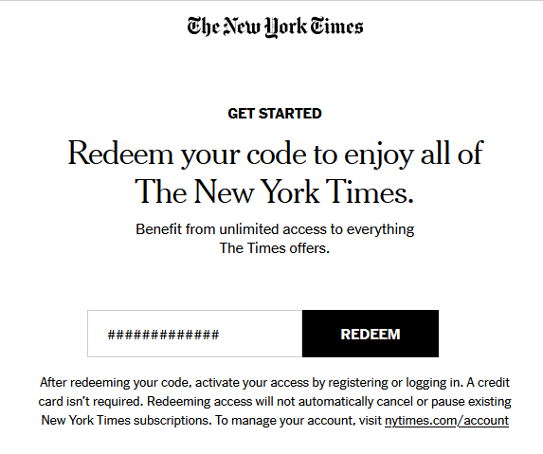

- You will need to either register for a free account or log in to your existing account.
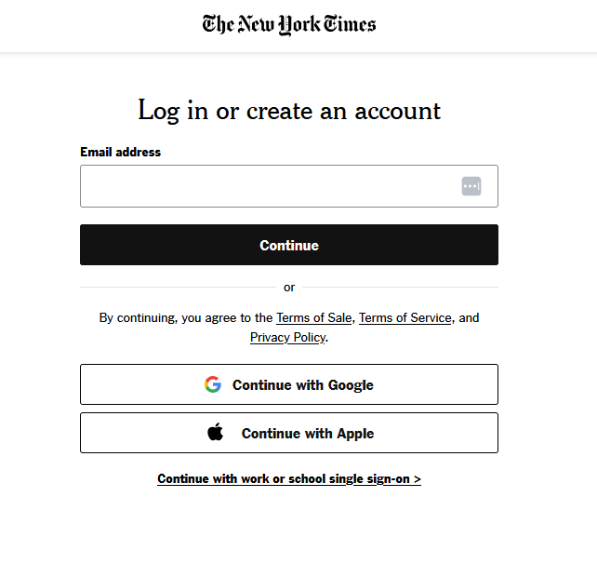

- On the screen shown above, you can enter the email address you want to use, or have already used, to create a New York Times account – then click “Continue.”
- If you are on a device that is already logged into Google or Apple, you may use those options, instead.
- If this is the first time you are creating an account, you will see this screen with your email address filled in:

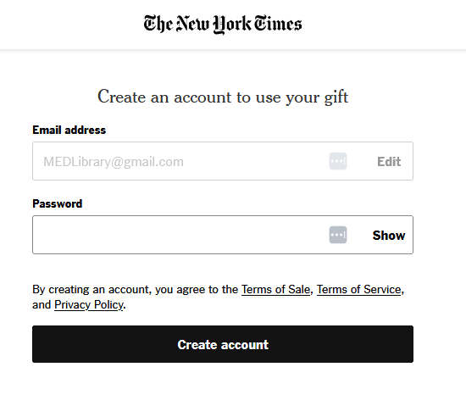

- Choose and enter a password. You will only enter it ONCE, so type carefully! Then Click “Create Account.”
- If you have previously created a NYTimes account and are logging in again, you will see this screen with your email address filled in:

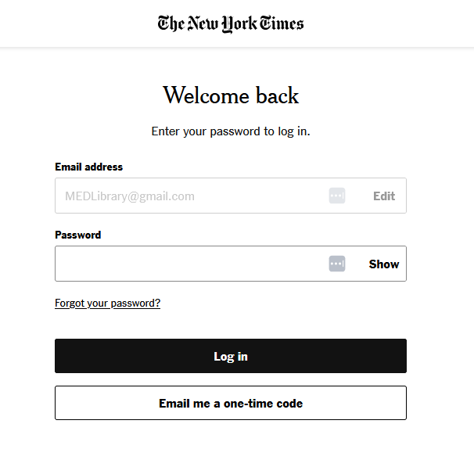

- Enter your password and Click “Log In.”
- You will receive a screen that looks like the one below that shows when your access will expire. This screenshot was taken on March 30, 2026, so the expiration is March 31, 2026.

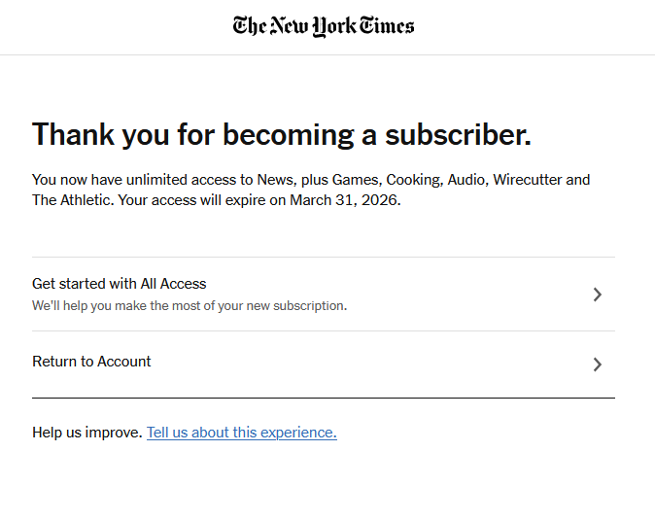

- After receiving confirmation that your access code is valid, you will have complimentary access to The New York Times and any relevant apps for 24 hours.
- Once your access code expires, you can simply repeat the process from Step 1 to redeem the code again.

TROUBLESHOOTING:

If you try to redeem the code and see the screen below, your access from the previous day has not yet expired. You can log in and access NYTimes.com or
the app directly.

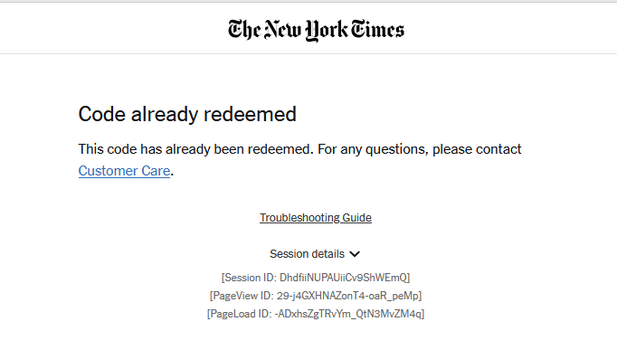

Instructions for using NYTIMES.COM APP – from ANYWHERE:
  - Download the NYTimes app from your device’s app store.
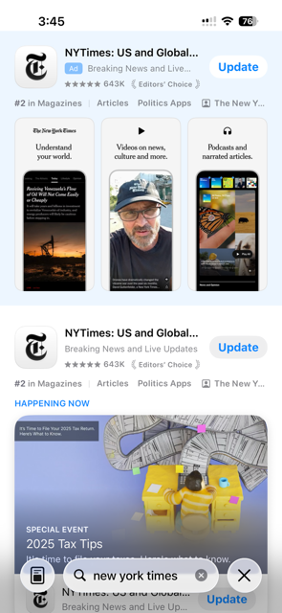

This screenshot of the search results in the Apple App Store shows the “Update” button, because the app is already installed on this device. If you are installing for the first time, the button will say “Get” instead of “Update.”
  - Follow the “Instructions for using NYTIMES.COM website from Home – or ANYWHERE,” to redeem a code and log in to the NYTimes website.
  - Switch back to the app, and log in to the NYTimes app, if necessary. You may stay logged into the app. If so, you must redeem the code and log in to the website, but then the app is ready for use.
  - You now have access to the NY Times content via the app for 24 hours.

