Pine Bush Area Public Library July 2020
News Bulletin

A note from the Director:
Our Library hours are 10:00 am - 4:00 pm Monday through Friday until we open to the Public! No Saturday hours.
Patrons can now reserve materials online or by phone for curbside pick-up (limited inter-library loans will be available on Monday, July 13th). Special services such as faxing, copying, computer use or notarizing or help with your device to download your ebooks, are by appointment only!

Desperate to read?
FREE FREE FREE books on the porch and in the benches for
both adults and children
,
PLEASE RETURN ANY BOOKS ON LOAN YOU MAY HAVE FROM OUR QUARANTINE TIME, AS SOON AS POSSIBLE, SO THEY CAN BE PUT BACK IN CIRCULATION..

Have you been counted yet for the 2020 Census? Why is this important? It brings more Federal money to our community based on population. If you need help to do your census on the computer, please call and make an appointment with us and we will get your started. (845) 744-4265 ext.#2

From the Children's Library:
IMAGINE YOUR STORY, 2020 Summer Reading Program has some online activities for children to earn digital badges to print at home.
All registered participants who complete the missions will receive a FREE ICE CREAM Certificate for Stewart's Shops.
pinebushlibraryny14„readsquared.com



SPLASH OF MATH, Add a little Splash of Math to your summer with Crazy 8 ‘s Bedtime Math.
Bedtimemath.org/splash-of-math-at-the-library
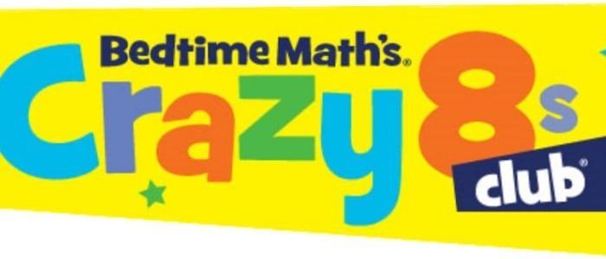

The library has some TAKE AND MAKE activity bags available at the Children's Lower Level Entrance.... Toddler, Preschool and Elementary ages. We are waiting for your pictures of the projects you have done at home.
Please email your photo to: PBL@rcls.org
Please one bag per child!

stay tuned for a SCIENCE GROW YOUR OWN AVOCADO PLANT demo!!!
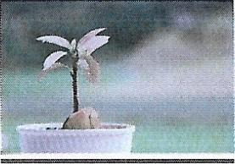

The Summer reading list for Pine Bush Schools is now available online. Just give us a call to place your hold between 10:00 am — 3:30 pm Monday — Friday.
NOTE: Only items from PINE BUSH LIBRARY are available at this time.
Any questions feel free to call us at 744-3375. Thanks!

Free digital resources to use during social distancing:
(Here are just a few children’s activities from the list)

https://libraryaware.com/225453?SID=1e5d2b90-2364-4483-8cdc-d8d9bb6faa63

https://youtu.be/YKmRB2Z3g2s
Cosmic Kids Yoga

Storytime Online Resources
by Lindsey Krabbenhoft
This is an evolving list of online storytime resources for families, preschools, and day cares. It includes videos, websites, and podcasts to support those who cannot make it to the library for any reason. The focus is on early literacy support online – songs, rhymes, movement, and stories. You can also follow the hashtag #kidlitquatantine on Twitter for updates on emerging resources specifically around children’s literature.

https://jbrary.com/storytime-online/
Miss Lucy will be doing live storytime outside on the Library’s lawn on Mondays starting July 20th at 10:00 am. Miss Lucy will read some stories and the children will be sent home with a craft project. Each family must bring their own blanket, mask and practice social distancing. This program is limited to 6 families so hurry and get on the list. Please call (845) 744-5295 press #3 to register. The Rain date is Monday, July 27th.

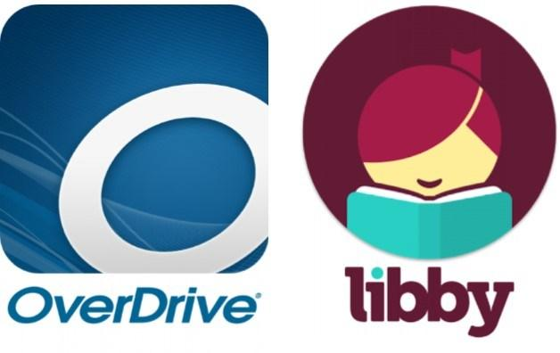

You can access hundreds of ebooks, audiobooks, videos, and more.
Visit https://rcls.overdrive.com/ to explore!

Join the Pine Bush Library FitNiks for a leisurely 40 minute walk around Pine Bush at 10:30 am on Tuesdays (Wednesdays will be the rain date!). Bring your picnic lunch and stay for an extra activity...Simon Says, Trivia, Yoga and the like!
Call (845)744-4265 to sign up
(We do social distancing and wear masks)

Remember, you are welcomed to sit in your car or sit on our porch to use the Library’s Wi-Fi for free.

Please be safe and social distance yourself from others and wear your masks. Wash your hands frequently or at least use sanitizer when soap and water aren’t available.
