Pine Bush Area Public Library June 2020 Bulletin

From the Children’s Library:

IMAGINE YOUR STORY, 2020 Summer Reading Program has some online activities for children to earn digital badges to print at home.
All registered participants who complete the missions will receive a
FREE ICE CREAM Certificate for Stewart's Shops.


SPLASH OF MATH, Add a little Splash of Math to your summer
with Crazy 8's Bedtime Math.

The library has some TAKE AND MAKE activity bags available at the Children's Lower Level Entrance....Toddler, Preschool and Elementary ages.
Please one bag per child.

Stay tuned for a SCIENCE GROW YOUR OWN AVOCADO PLANT demo!!!



PLEASE DO NOT LEAVE YOUR USED BOOKS
AT THE LIBRARY DOORSTEPS!

OUR LIBRARY ITEMS HAVE BEEN QUARANTINED AND WE DO NOT HAVE THE SPACE TO TAKE IN ANY USED BOOKS AT THIS TIME.

Thank you for your understanding and patience!


From the Director, Doris Callan:

Please return all books that were held over from the closure by
June 30th for them to be “fine free”.
Drop them in the book drop as they have to be quarantined.

The Talking Book and Braille Library’s customer service call center is open Monday-Thursday. They are taking new requests and sending materials by mail. (800-342-3688)

Your materials from the library can be reserved online now. Curbside pick up is down the driveway at the back door.

All AARP Safety Driver Classes have been canceled for the rest of this year nationwide. An Online course is being offered at 25% off. The library will help you do it online. You have about a month to complete the six classes.
Please call and set up an appointment. 744-4265.
Each class takes about an hour. www.AARP.com/safety

There are free books on the porch for both children and adults.
We are planning to be at the Farmers Market on Saturdays.

No definite plan yet for the AARP Taxes.
********************************************************************************

From the Federal Trade Commission:

AVOID CORONAVIRUS SCAMS
- Don’t respond to texts, emails or calls about checks from the government.

- Here’s what you need to know.

- Ignore offers for vaccinations and home test kits. Scammers are selling products to treat or prevent COVID-19 without proof that they work.

- Be wary of ads for test kits. Most test kits being advertised have not been approved by the FDA, and aren’t necessarily accurate.

- Hang up on robocalls. Scammers are using illegal robocalls to pitch everything from low-priced health insurance to work-at-home schemes.

- Watch for emails claiming to be from the CDC or WHO. Use sites like coronavirus.gov and usa.gov/coronavirus to get the latest information.

- And don’t click on links from sources you don’t know.

- Do your homework when it comes to donations. Never donate in cash, by gift card, or by wiring money.

- More Tips from the Federal Trade Commission

- How to Spot, Avoid and Report
- CORONAVIRUS SCAMS

- Scammers are taking advantage of fears surrounding the
- Coronavirus. The Federal Trade Commission (ftc.gov/coronavirus)
- offers these tips to help you fight back.

- Treatments & Cures
- Ignore online offers for vaccinations and home test kits. If you see ads touting prevention, treatment, or cure claims for the Coronavirus, stop. If there’s a medical breakthrough, you’re not going to hear about it for the first time from an ad or sales pitch.
- At this time, there also are no FDA-authorized home test
- kits for the Coronavirus.

- Email and Text Scams
- Don’t click on links from sources you don’t know. It could download a virus onto your computer or device. Make sure the antimalware
- and anti-virus software on your computer is up to date.

- Robocalls

- Hang up on illegal robocallers. Don’t press any numbers. The recording might say that pressinga number will let you speak to a live operator or
- remove you from their call list, but it might lead to more robocalls, instead.

- Government Relief Checks

Expect scammers to take advantage of
this. Here’s what you need to know: Thegovernment will not ask you to pay anything upfront to get this money. The government will not
call to ask for your Social Security number, bank
account, or credit card number. Anyone who does is a scammer.

- Fake Charities

- Do your homework when it comes to donations.
- Use the organizations listed at ftc.gov/charity to
- help you research charities. If someone wants
- donations in cash, by gift card, or by wiring
- money, don’t do it.

- Misinformation & Rumors

- Before you pass on any messages, do some
- fact checking by contacting trusted sources.
- Visit usa.gov/coronavirus for links to federal state and
- local government agencies.

- Stay informed:
- Visit:
- • ftc.gov/coronavirus
- • coronavirus.gov
- • usa.gov/coronavirus
- Report suspicious claims or questionable practices to the FTC at
- ftc.gov/complaint.
- Keep up with the latest scams.
- Sign up for the FTC’sConsumer Alerts atftc.gov/subscribe.

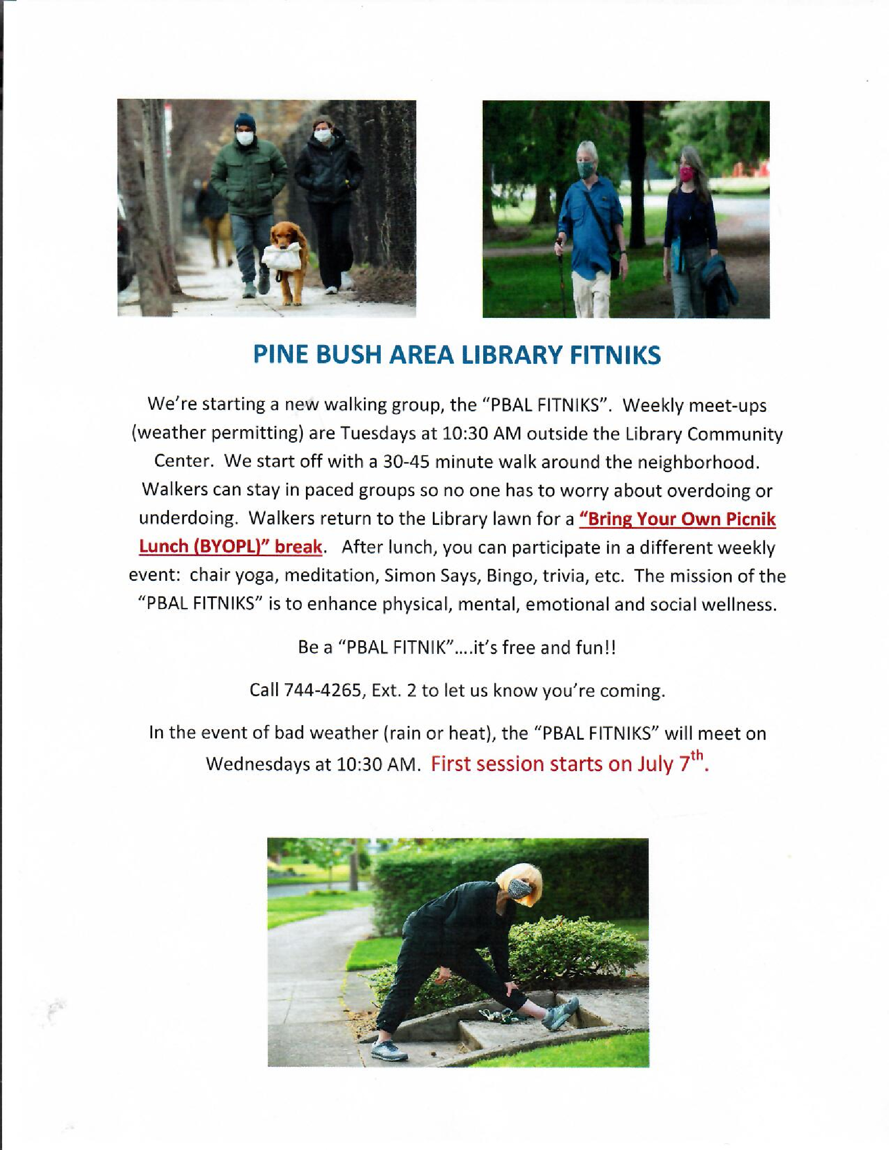
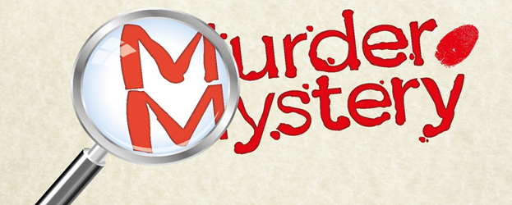
IMAGINE YOUR STORY….A MURDER MYSTERY!!
A summer reading program theme at the Pine Bush Area Library
If you have the imagination, we have the “CLUES” and; we’re offering you a writing challenge. Write a short creative murder mystery with the 15 clues we will provide. Your cleverly written “who done it” must contain the 15 clues. One catch…...you, the writer, will be the only one who will know the who, what, why, when and where of the crime. These facts will be contained in a sealed envelope you will also submit with your story. Our “detective” judges will read all the stories, try to solve the case and, then open your envelope to see how good their sleuthing skills were. (Even our judges will be kept in the dark guessing!!) Your story will be judged on creativity, suspense, and the completely plausible hints in the story that lead to the solving of the crime! A Grand Prize for the “Best Murder Mystery” will be awarded!
Deadline for Submissions: Friday, July 31, 2020. Join the Challenge!
Please call 744-4265, Ext 2 for more details and to pick up your “Clues

