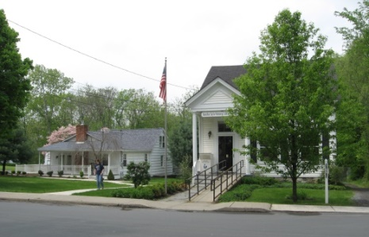
PINE BUSH AREA PUBLIC LIBRARY
NEWSLETTER – FEBRUARY 2020
‘WHERE THE COMMUNITY CONNECTS’
223-227 Maple Ave, PO Box 63, Pine Bush, NY 12566
845-744-3375, 845-744-5295, 845-744-4265
Fax 845-744-3377
Adult Services – Ext. 1
Community Center – Ext. 2
Children’s Services – Ext. 3
www.pinebusharealibrary.org

LIBRARY HOURS:
MON & WED 9-7
TUE & THUR 11-7
FRI 9-5 SAT 10-2

COMMUNITY CENTER:
MON - THURS 10 AM – 6 PM
FRI 10 AM-5PM
SAT 10 AM-2 PM

BOARD OF TRUSTEES – MEETING TIME - SECOND WEDNESDAY OF EACH MONTH 7:00 PM
IN THE LIBRARY COMMUNITY CENTER
BOARD OF TRUSTEES - Sharon Tarolli-President, Lisa Cannon-Vice President,
Gloria Winter-Secretary, Matthew Watkins –Treasurer
TRUSTEES - Peter Eriksen, Senta Curran, John Russell, Joseph Britto, Coby Low.
Director- Doris Callan
PLEASE NOTE:
THE PINE BUSH AREA PUBLIC LIBRARY WILL BE CLOSED ON FEBRUARY 17TH
TO CELEBRATE PRESIDENTs’ DAY!

The Pine Bush Library has an annual fund raiser at the end of each year. Donation letters have been mailed. If you have not received one, please contact the library or
make your donation out to the address above.
Thank you!
*******************************************
Come visit the Pine Bush Library to:
Buy books
Buy CDs, DVDs, Records, Audio books
Purchase greeting cards
*Get one on one Computer tutoring
Attend exciting events
Play cards, Scrabble, Chess, Pinochle


*Come to the Pine Bush Library and meet LibTecEd – he is our computer Ace! He will tutor you one on one or you can attend one of his classes. The classes will be listed here in the newsletter and on the website, as well. If you want to schedule a one on one with LibTecEd, please email him at: Libteced@gmail.com or call the Community Room (845) 744-4265 x2.
************************************************************************************************************
 CHESS…CHESS…CHESS
Tuesday is Chess Day! Come to the Community Room at 1:00 pm…
All are welcome… beginners – Joe Britto will teach you how to play chess!
Give us a call to tell us you are coming!
Pine Bush Library Community Room 845 744-4265 ext. 2
****************************
We are looking for new Bridge players for our Thursday morning Bridge games. Come to the Library Community Room at 10:00 am and join the game!
****************************
Do you play Mah Jong?
We are looking for Mah Jong players for our Mah Jong games.
Beginners are welcome!
If you are interested, please contact us at 744-4265 x2.

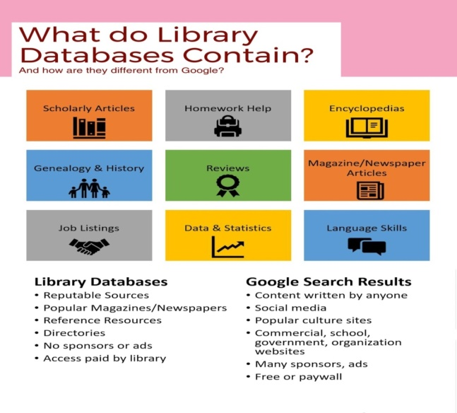
Here are a few examples of what you can find in our databases:
Newspapers
Pine Bush Local History
A guide to published and un-published works related to the history of Pine Bush,
The Town of Crawford and the Hudson Valley Region.
Collated by the Pine Bush Area Public Library
Job/Careers
History & Geneology
Science & Health
Are you looking to purchase a new refrigerator, washer/dryer, auto, snow blower, etc.?
Go to Consumer Reports under the research section on the website,
click on the alphabet – letter “C” and find Consumer Reports.
******************
Want more e-books to read? Come in to the Library Community Room and Ed, our IT guy,
will instruct you where and how to get more!

HUDSON RIVER VALLEY HISTORY
If you would like to learn more about our Hudson River Valley, then you must sign into “Hudson River Valley Heritage” (HRVH.ORG)
You can discover newspapers, diaries, photographs and more that contributes to the story of the people and places that makes the Hudson River Valley exceptional!!
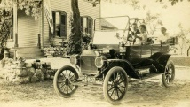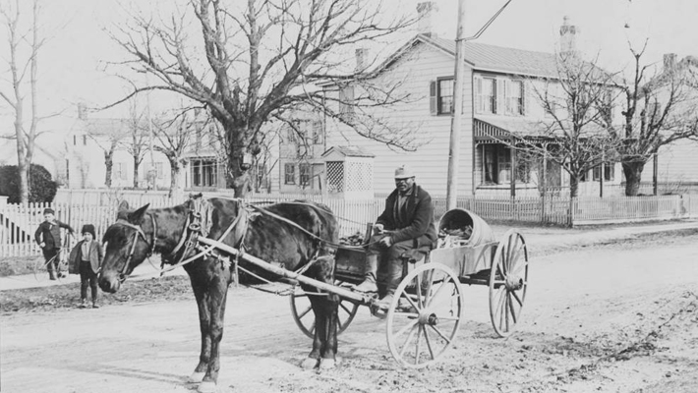

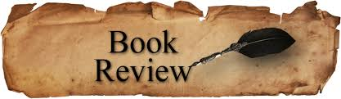
PLEASE CHECK OUR WEBSITE (www.pinebusharealibrary.org)
FOR A NEW MONTHLY BOOK REVIEW
BY OUR OWN
JEAN E. EUSTANCE!
ART ON THE LIBRARY WALLS 
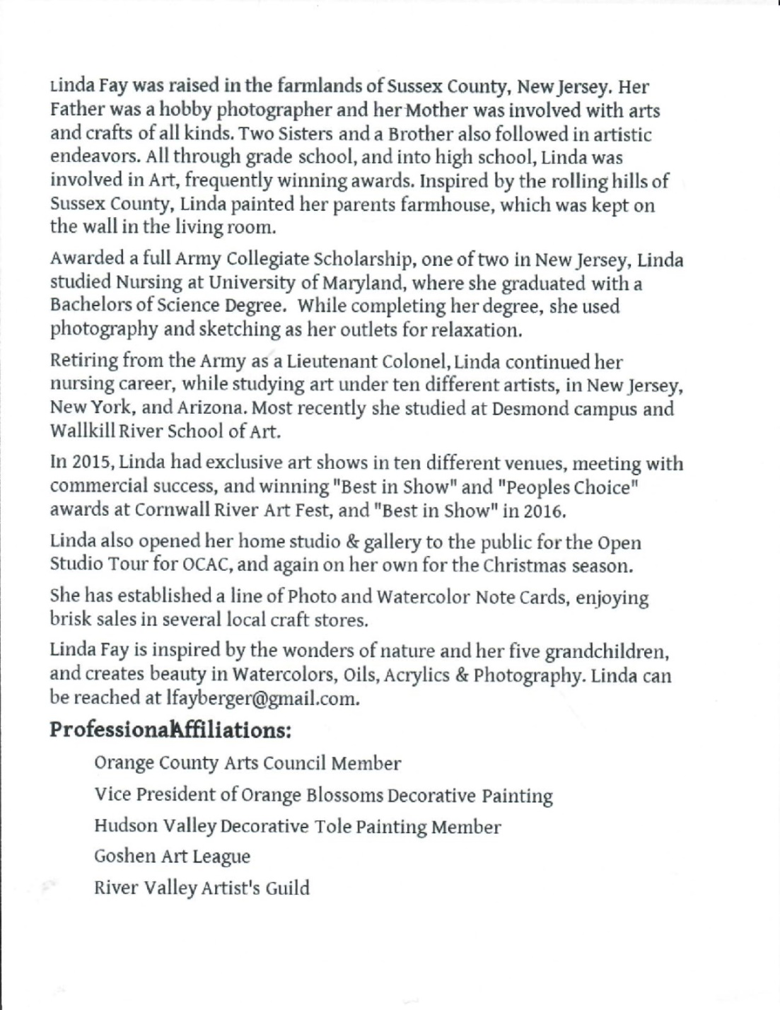

The Pine Bush Area Arts Council is calling all artists:
If you would like to exhibit your artwork in the Pine Bush Library,
Please contact Dick Reich
845 744-3781

Did you know you can get your voter registration here at the Library?
****************************************
THE 2020 CENSUS

Every 10 years, the US Constitution requires a count of every person living in the US. 2020 is a Census year.
Why is it important to be counted? If the Census misses people, the uncounted communities won’t get their fair funding and won’t get fair representation in congress, as well.

Starting in March, The Pine Bush Area Public Library will be providing computers for you to fill out the questionnaire online.

Your library can provide help for any questions or concerns you have regarding the 2020 Census.
MAKE SURE YOU GET COUNTED!!



We now have a One-day Empire Pass for use by our Pine Bush Area Public Library cardholders that can be shared. It's a family-friendly alternative to the traditional window decal and not assigned to a specific vehicle. The Empire Pass is your key to all-season enjoyment at New York State Parks. It provides unlimited day-use for one carload to most facilities operated by New York State Parks and the State Dept. of Environmental Conservation including forests, beaches, trails and more. For more information or ticket availability, please call the Library at 845 744-3375 ext. 1
or check their website: http://www.dec.ny.gov
Please pick up tickets at the Main Library desk!
(This pass can be checked out for 3 days at a time only!)

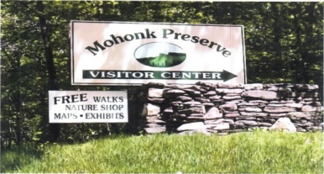

FREE MOHONK PRESERVE PASSES

(NOT THE MOHONK MOUNTAIN HOUSE!)

Available to Patrons of the Pine Bush Area Public Library
Please pick up tickets at the Main Library desk!
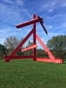The Pine Bush Library now has 2 free passes to: 
Storm King Art Center.
1 Museum Rd
New Windsor, NY 12553

Each pass is for 1 adult and 2 children under the age of 18.
There are many programs and activities for families and individuals of all ages!!
Please pick up the tickets at the Main Library desk!
PROGRAMS
ADULT PROGRAMS FOR FEBRUARY 2020

JOIN US FOR A
COMMUNITY PROJECT!!!
WE’RE MAKING VALENTINE’S DAY CARDS FOR SENIOR SHUT-INS!!
PINE BUSH AREA LIBRARY
COMMUNITY CENTER
TUESDAY, FEBRUARY 4TH AT 1 PM

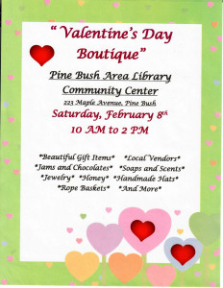
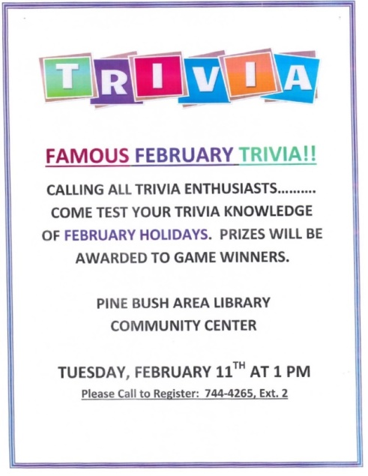

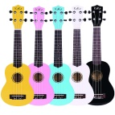Ukulele Strumming
Tuesday, February 18th
7:00 – 9:00 PM (CC)
**********************************************

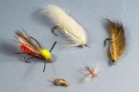
Southern Catskill Anglers
Southern Catskill Anglers will be starting our fly tying program on Sunday, January 19th and continuing on January 26th, February 2nd and February 9th for beginners, ages 9 to adults. This program will run for four Sundays from 1:00 – 3:00 pm at the Pine Bush Are Public Library in the Community Center. Making your own flies to fish with is not hard at all. All you need to learn is a few basic steps and you will be successful. If you have never tied before, try it out with us!! This is a great activity for Fathers/Son/Daughters/Mother or even Grandparents to tie with a child. The first four Sundays will be for those who have not tied before. The cost is: youth $5 and adults $10 for the four weeks. You will leave each class with 2 flies that are usable for fishing.
Advanced classes will also be held, starting in February, on the 9th, 16th, 23rd and March 1st, also for 4 weeks.
The cost is $20.

Spread the news, bring a friend or two. You will have a fun time learning and creating!

Email me (Donna) at scanglers@gmail.com if you are interested!!

If you can’t commit to the four weeks but want to try it, the cost is just $5 a class. Payment is collected at the first class! Please show up 10 minutes early. Hope you can join us!!

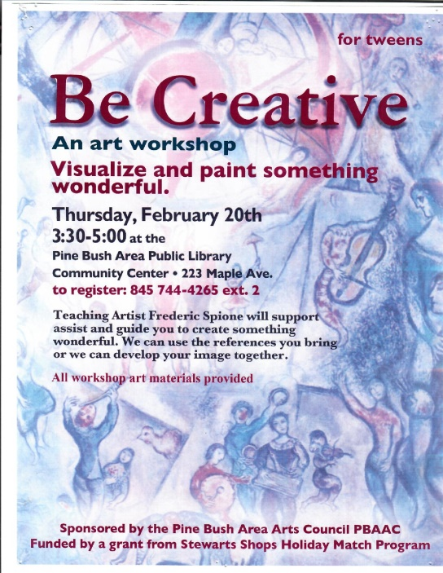



DO SOMETHING AMAZING FOR
YOURSELF THIS YEAR ON LEAP DAY, FEBRUARY 29!!
DON’T WASTE THIS DAY WHICH
COMES AROUND ONLY ONCE
EVERY FOUR YEARS!!!

ON THIS DAY, TAKE A “LEAP OF FAITH”
Set a Goal, Imagine New Possibilities, Envision Your Future, Fulfill a Dream,
Take a Risk!
Bring your sealed “Wish List” to the Pine Bush Area Library on Saturday, February 29, 2020 at 12:30 PM and watch as our “Leap Day Time Capsule” is sealed and placed underground until its reopening again next year on February 28, 2021!
Refreshments Provided!

CHILDREN’S PROGRAMS

(See the calendar for the ongoing programs)
 TODDLER TIME (2 - 3 years old) ML)
Mondays, February 3, 10, 24th (Closed the 17th)
10:00 - 11:00 AM

PRESCHOOL STORYTIME (3 - 5 years old) ML
Thursdays, February 6 – 27th
1:00 - 2:00 PM

R.E.A.D TO MOCHA (CC)
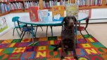
Reading Education Assistance Dog
Fridays, February 7th and 21st
This program is designed to help children with their read aloud skills.
Must register in advance for your one-on-one 15-minute session with MOCHA and Trainer, Wendy.

Music Time Tuesday with Miss Jill, February 11th at 1:00 -2:00 pm 
Family fun… Sing, dance and be silly!! All ages welcome!! (Children must be accompanied by a parent or guardian!)


LET’S BE NEIGHBORS “DROP IN” STORYTIME! (ALL AGES)
We’ll make Valentines for Nursing Home Residents
Wednesday, February 12th @ 10:00 – 11:00 AM


Notes:
PLEASE MAKE SURE YOU REGISTER IN ADVANCE FOR ANY OF OUR PROGRAMS. YOU CAN DO THIS BY CALLING 845 744-4265
Children’s Programs – please register by calling Ext. 3
Adult Programs – please register by calling Ext. 2
PLEASE NOTE: RENEWAL OF CIRCULATION ITEMS MUST BE DONE
VIA THE WEBSITE OR IN PERSON. WE CANNOT ACCEPT VOICE MAIL MESSAGES TO RENEW YOUR ITEMS.
Used Books, DVDs’, audio tapes, puzzles, games, greeting cards and more are for sale in the Community Center.
***Don’t forget to check out the books in our
“FREE LITTLE LIBRARY!” on the front porch….the books are FREE!!***
Free - computer and electronic device help, resume writing help, and a Notary Pubic available every day in the Community Center.
Please note: A message on the Library’s phone will make you aware of the library openings and closings.
If you miss seeing any program flyers, go to Facebook and LIKE US
(tell us why the Pine Bush Library is so great!) Or,
Visit our webpage at www.pinebusharealibrary.org.
Check out your local papers, bulletin boards in town, stop into the library for your newsletter or
provide us with your email address to receive it via email.
Want to attend an event but do not have transportation?
Call Dial-A-Bus
TOWNS OF MONTGOMERY & CRAWFORD
Service provided Monday thru Friday. Hours of operation: 7:45am to 4:00pm. Reservations accepted Monday thru Friday 9:00am to 12:00pm. Regular Fare: $1.00 one-way • Children under 10 ride free when accompanied by an adult • Senior/disabled citizens and Medicare cardholders: 50¢ one-way.
Please call 845-457-2622

