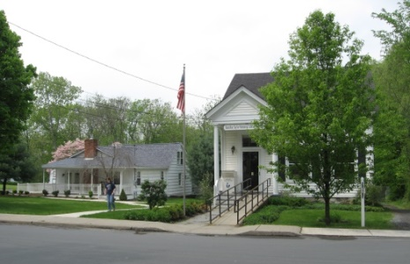
PINE BUSH AREA PUBLIC LIBRARY
NEWSLETTER – JANUARY 2020
‘WHERE THE COMMUNITY CONNECTS’
223-227 Maple Ave, PO Box 63, Pine Bush, NY 12566
845-744-3375, 845-744-5295, 845-744-4265
Fax 845-744-3377
Adult Services – Ext. 1
Community Center – Ext. 2
Children’s Services – Ext. 3
www.pinebusharealibrary.org

LIBRARY HOURS:
MON & WED 9-7
TUE & THUR 11-7
FRI 9-5 SAT 10-2

COMMUNITY CENTER:
MON - THURS 10 AM – 6 PM
FRI 10 AM-5PM
SAT 10 AM-2 PM

BOARD OF TRUSTEES – MEETING TIME - SECOND WEDNESDAY OF EACH MONTH 7:00 PM
IN THE LIBRARY COMMUNITY CENTER
BOARD OF TRUSTEES - Sharon Tarolli-President, Lisa Cannon-Vice President,
Gloria Winter-Secretary, Matthew Watkins –Treasurer
TRUSTEES - Peter Eriksen, Senta Curran, John Russell, Joseph Britto, Coby Low.
Director- Doris Callan
PLEASE NOTE:
We will be closed Wednesday, January 1st for New Years Day!
We will also be closed on the 20th of January to observe the birthday of Martin Luther King, Jr.
**************
HAPPY NEW YEAR TO ALL OUR PATRONS AND THEIR FAMILIES!!
THE FRIENDS OF THE PINE BUSH AREA PUBLIC LIBRARY WOULD LIKE TO THANK EVERYONE FOR THEIR GENEROUS SUPPORT AT OUR BAKE SALES.
THOSE THAT BAKED AND THOSE THAT BOUGHT!!
OUR THANKSGIVING BAKE SALE AND OUR COOKIE WALK
EACH BROUGHT IN $820+.
*************************************************************
The Pine Bush Library has an annual fund raiser at the end of each year. Donation letters have been mailed. If you have not received one, please contact the library or
make your donation out to the address above.
Thank you!
*******************************************
Come visit the Pine Bush Library to:
Buy books
Buy CDs, DVDs, Records, Audio books
Purchase greeting cards
*Get one on one Computer tutoring
Attend exciting events
Play cards, Scrabble, Chess, Pinochle
*Come to the Pine Bush Library and meet LibTecEd – he is our computer Ace! He will tutor you one on one or you can attend one of his classes. The classes will be listed here in the newsletter and on the website, as well. If you want to schedule a one on one with LibTecEd, please email him at: Libteced@gmail.com or call the Community Room (845) 744-4265 x2.
************************************************************************************************************

 CHESS…CHESS…CHESS
Tuesday is Chess Day! Come to the Community Room at 1:00 pm…
All are welcome… beginners – Joe Britto will teach you how to play chess!
Give us a call to tell us you are coming!
Pine Bush Library Community Room 845 744-4265 ext. 2
****************************
We are looking for new Bridge players for our Thursday morning Bridge games. Come to the Library Community Room at 10:00 am and join the game!
****************************
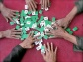Do you play Mah Jong?
We are looking for Mah Jong players for our Saturday Mah Jong games.
This month the games will be played on January 11th and January 25th. Beginners are welcome!
If you are interested, please contact us at 744-4265 x2.

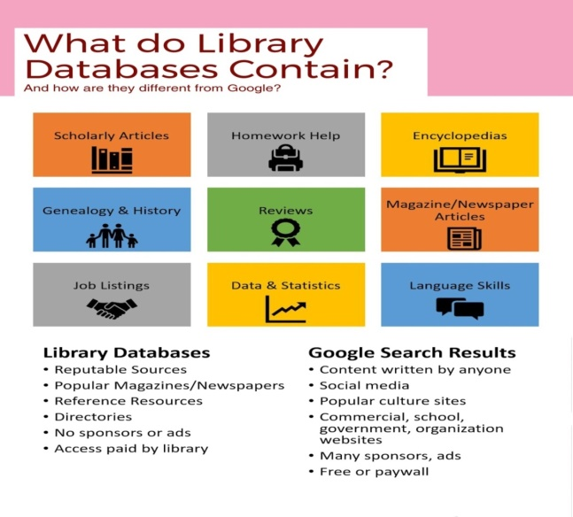
Here are a few examples of what you can find in our databases:
Newspapers
Pine Bush Local History
A guide to published and un-published works related to the history of Pine Bush,
The Town of Crawford and the Hudson Valley Region.
Collated by the Pine Bush Area Public Library
Job/Careers
History & Geneology
Science & Health
Are you looking to purchase a new refrigerator, washer/dryer, auto, snow blower, etc.?
Go to Consumer Reports under the research section on the website,
click on the alphabet – letter “C” and find Consumer Reports.

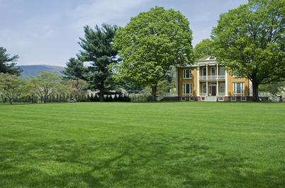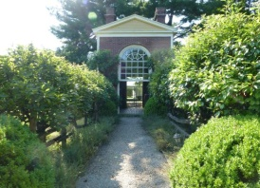
The Pine Bush Area Public Library now has a free pass to Boscobel!
Boscobel is a beautifully reassembled 1800’s neoclassical house in Garrison, NY. There are lush gardens, trails and magnificent Hudson Valley views. Boscobel is open for tours from April to December.
Pass is good for 4 people – one “MUST” be a Pine Bush Library card holder!
Please pick up tickets at the Main Library desk!
(You will be responsible for your own transportation to visit Boscobel House, Garrison, NY))
************************************************************************************************************


We now have a One-day Empire Pass for use by our Pine Bush Area Public Library cardholders that can be shared. It's a family-friendly alternative to the traditional window decal and not assigned to a specific vehicle. The Empire Pass is your key to all-season enjoyment at New York State Parks. It provides unlimited day-use for one carload to most facilities operated by New York State Parks and the State Dept. of Environmental Conservation including forests, beaches, trails and more. For more information or ticket availability, please call the Library at 845 744-3375 ext. 1
or check their website: http://www.dec.ny.gov
Please pick up tickets at the Main Library desk!
(This pass can be checked out for 3 days at a time only!)

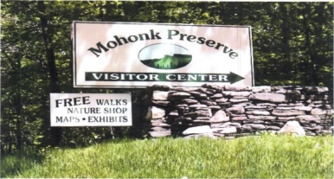

FREE MOHONK PRESERVE PASSES

(NOT THE MOHONK MOUNTAIN HOUSE!)

Available to Patrons of the Pine Bush Area Public Library
Please pick up tickets at the Main Library desk!
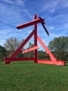The Pine Bush Library now has 2 free passes to: 
Storm King Art Center.
1 Museum Rd
New Windsor, NY 12553

Each pass is for 1 adult and 2 children under the age of 18.
There are many programs and activities for families and individuals of all ages!!
Please pick up the tickets at the Main Library desk!

ART ON THE LIBRARY WALLS
Artist: Richard J. Reich, Ed.D.
dreich10@gmail.com
845-744-3781
MEDIUM: Acrylic
SUBJECT MATTER: Landscapes, Abstracts
MEMBERSHIPS: Founding member and former Vice President of the Crawford
Arts Association, Member of the Middletown Art Group
ARTIST STATEMENT: Dick has been involved in some form of Art for many
years. His earlier interests include working with wood, fiber, 3 dimensional and
multimedia art. More recently his interests have centered on painting using
acrylics as his preferred medium. He has benefited from studying with
instructors from Mount Saint Mary College; Shawn Dell Joyce, Louise
McCutcheon and Nancy Reed Jones from the Wallkill River School, as well as
several independent artists. As an emerging artist Dick continues to seek
opportunities to grow in this avocational interest.
***************************************************************************
The Pine Bush Area Arts Council is calling all artists:
If you would like to exhibit your artwork in the Pine Bush Library,
Please contact Dick Reich (845) 744-3781

PROGRAMS
ADULT PROGRAMS FOR 2020

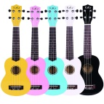Ukulele Strumming (CC)
Tuesday, January 14
7:00 – 9:00 PM
**********************************************
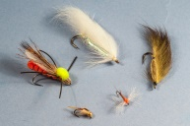**************
Southern Catskill Anglers
Southern Catskill Anglers will be starting our fly tying program on Sunday, January 19th and continuing on January 26th, February 2nd and February 9th for beginners, ages 9 to adults. This program will run for four Sundays from 1:00 – 3:00 pm at the Pine Bush Are Public Library in the Community Center. Making your own flies to fish with is not hard at all. All you need to learn is a few basic steps and you will be successful. If you have never tied before, try it out with us!! This is a great activity for Fathers/Son/Daughters/Mother or even Grandparents to tie with a child. The first four Sundays will be for those who have not tied before. The cost is: youth $5 and adults $10 for the four weeks. You will leave each class with 2 flies that are usable for fishing.
Advanced classes will also be held, starting in February, on the 9th, 16th, 23rd and March 1st, also for 4 weeks.
The cost is $20.

Spread the news, bring a friend or two. You will have a fun time learning and creating!

Email me (Donna) at scanglers@gmail.com if you are interested!!
If you can’t commit to the four weeks but want to try it, the cost is just $5 a class. Payment is collected at the first class! Please show up 10 minutes early. Hope you can join us!!
The Holiday shop in the Community Center is still open!!
All items are half price or free….come shop!!
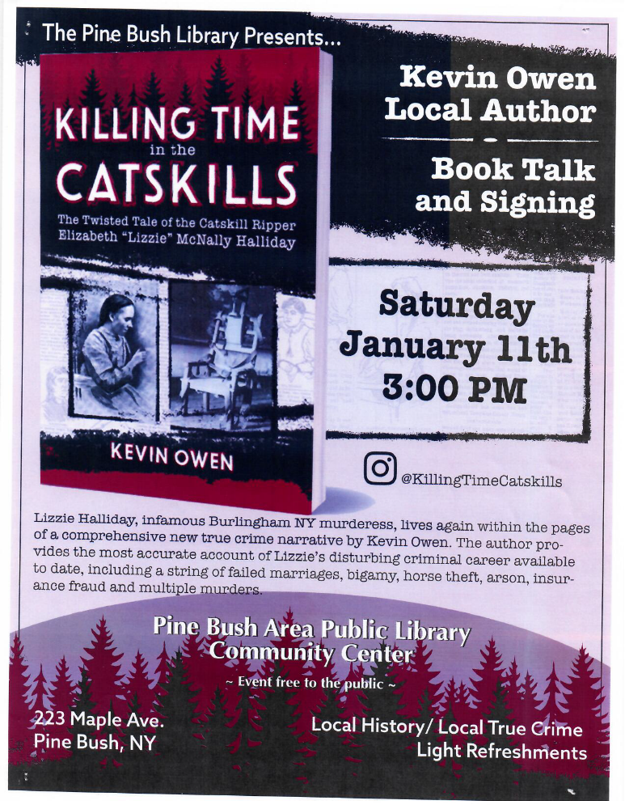

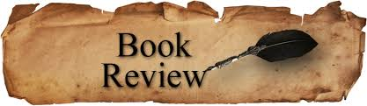
PLEASE CHECK OUR WEBSITE (www.pinebusharealibrary.org)
FOR A NEW MONTHLY BOOK REVIEW
BY OUR OWN
JEAN E. EUSTANCE!
CHILDREN’S PROGRAMS

(See the calendar for the ongoing programs)
 TODDLER TIME (2 - 3 years old) ML
Mondays, January 6, 13 and 27th
10:00 - 11:00 AM

PRESCHOOL STORYTIME (3 - 5 years old) ML
Thursdays, January 9 – 30th
1:00 - 2:00 PM
AFTERSCHOOL DROP-IN CHESS/CHECKERS
Drop in for a game…all grades
Fridays, January 10 – 31st
3:00 – 4:30 PM

R.E.A.D WITH MOCHA (CC)
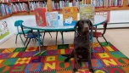
Reading Education Assistance Dog
Wednesday, January 15th
3:30 - 4:30 PM

Wednesday, January 29th
3:30 – 4:30 PM
This program is designed to help children with their read aloud skills.
Must register in advance for your one-on-one 15-minute session with MOCHA and Trainer, Wendy.

Notes:
PLEASE MAKE SURE YOU REGISTER IN ADVANCE FOR ANY OF OUR PROGRAMS. YOU CAN DO THIS BY CALLING 845 744-4265
Children’s Programs – please register by calling Ext. 3
Adult Programs – please register by calling Ext. 2
PLEASE NOTE: RENEWAL OF CIRCULATION ITEMS MUST BE DONE
VIA THE WEBSITE OR IN PERSON. WE CANNOT ACCEPT VOICE MAIL MESSAGES TO RENEW YOUR ITEMS.
Used Books, DVDs’, audio tapes, puzzles, games, greeting cards and more are for sale in the Community Center.
***Don’t forget to check out the books in our
“FREE LITTLE LIBRARY!” on the front porch….the books are FREE!!***
Free - computer and electronic device help, resume writing help, and a Notary Pubic available every day in the Community Center.
Please note: A message on the Library’s phone will make you aware of the library openings and closings.
If you miss seeing any program flyers, go to Facebook and LIKE US
(tell us why the Pine Bush Library is so great!) Or,
Visit our webpage at www.pinebusharealibrary.org.
Check out your local papers, bulletin boards in town, stop into the library for your newsletter or
provide us with your email address to receive it via email.
Want to attend an event but do not have transportation?
Call Dial-A-Bus
TOWNS OF MONTGOMERY & CRAWFORD
Service provided Monday thru Friday. Hours of operation: 7:45am to 4:00pm. Reservations accepted Monday thru Friday 9:00am to 12:00pm. Regular Fare: $1.00 one-way • Children under 10 ride free when accompanied by an adult • Senior/disabled citizens and Medicare cardholders: 50¢ one-way.
Please call 845-457-2622

