PINE BUSH AREA PUBLIC LIBRARY
January 2020

Sun | Mon | Tue | Wed | Thu | Fri | Sat
 |  |  | 1 | 2 | 3 | 4
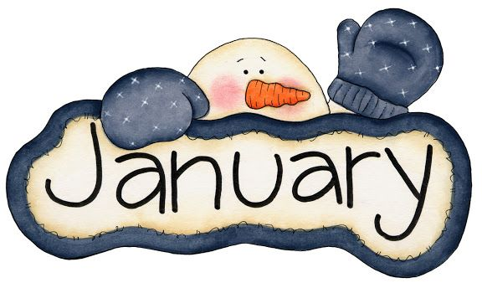 |  |  | New Years’ Day!  LIBRARY IS CLOSED | Bridge 10:00 am (CC) |  | Book sale 10:00 am – 2:00 pm (CC)  Holiday Sale continues – free & ½ price items (CC)
5 | 6 | 7 | 8 | 9 | 10 | 11
 | Pinochle 10:00 am (CC)  Toddler Time 10:00 – 11:00 am (ML) | Scrabble 10:00 am (CC)  Chess 1:00 pm (CC) | Library Board Mtg.  7:00 pm (CC) | Bridge 10:00 am (CC)  Pre-school Story Time  1:00 – 2:00 pm (ML)  Circle of Friends 1:00 (CC) | After school Drop In Chess/Checkers  3:00 – 4:30 PM (ML) | Book sale 10:00 am – 2:00 pm (CC)  Book Discussion/signing  Killing Time in the Catskills 3:00 PM (CC)  Mah Jong 10:00 AM (CC)
12 | 13 | 14 | 15 | 16 | 17 | 18
 | Pinochle 10:00 am (CC)  Toddler Time 10:00 – 11:00 am (ML)  Legal Docs 1:00 PM (CC) | Scrabble 10:00 am (CC)  Chess 1:00 pm (CC)  Happy Bookers 1:00 pm  Ukulele 7:00 – 9:00 PM (CC) | Bag Ladies 10:00 am (CC)  R.E.A.D. w/Mocha 3:30 – 4:30 PM (CC)  Bookies 6:00 pm (CC) | Bridge 10:00 am (CC)  Pre-school Story Time  1:00 – 2:00 pm (ML) | After school Drop in Chess/Checkers  3:00 – 4:30 PM (ML) | Book sale 10:00 am – 2:00 pm (CC)
19 | 20 | 21 | 22 | 23 | 24 | 25
Fly Tying 1:00 – 3:00 PM (CC) | Martin Luther King Jr. Day  LIBRARY IS CLOSED | Scrabble 10:00 am (CC)  Chess 1:00 pm (CC) |  | Bridge 10:00 am (CC)  Pre-school Story Time  1:00 – 2:00 pm (ML)  Page Turners 1:00 PM (CC) | After school Drop in Chess/Checkers  3:00 – 4:30 PM (ML) | Chinese New Year – Year of the Rat  Book sale 10:00 am – 2:00 pm (CC)  Mah Jong 10:00 PM (CC)
26 | 27 | 28 | 29 | 30 | 31
Fly Tying 1:00 – 3:00 PM (CC) | Pinochle 10:00 am (CC)  Toddler Time 10:00 – 11:00 am (ML) | Scrabble 10:00 am (CC)  Chess 1:00 pm (CC) | R.E.A.D. w/Mocha 3:30 – 4:30 PM (CC) | Bridge 10:00 am (CC)  Pre-school Story Time  1:00 – 2:00 pm (ML) | After school Drop in Chess/Checkers  3:00 – 4:30 PM (ML) | 