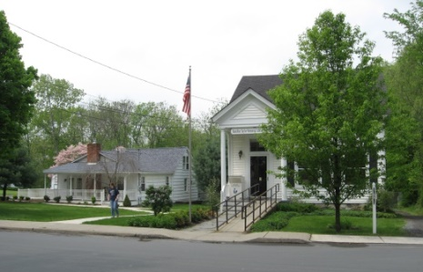
PINE BUSH AREA PUBLIC LIBRARY
NEWSLETTER – DECEMBER 2019
‘WHERE THE COMMUNITY CONNECTS’
223-227 Maple Ave, PO Box 63, Pine Bush, NY 12566
845-744-3375, 845-744-5295, 845-744-4265
Fax 845-744-3377
Adult Services – Ext. 1
Community Center – Ext. 2
Children’s Services – Ext. 3
www.pinebusharealibrary.org

LIBRARY HOURS:
MON & WED 9-7
TUE & THUR 11-7
FRI 9-5 SAT 10-2

COMMUNITY CENTER:
MON - THURS 10 AM – 6 PM
FRI 10 AM-5PM
SAT 10 AM-2 PM

BOARD OF TRUSTEES – MEETING TIME - SECOND WEDNESDAY OF EACH MONTH 7:00 PM
IN THE LIBRARY COMMUNITY CENTER
BOARD OF TRUSTEES - Sharon Tarolli-President, Lisa Cannon-Vice President,
Gloria Winter-Secretary, Matthew Watkins –Treasurer
TRUSTEES - Peter Eriksen, Senta Curran, John Russell, Joseph Britto, Coby Low.
Director- Doris Callan
PLEASE NOTE: THE PINE BUSH LIBRARY WILL BE CLOSED DECEMBER 24TH, 25TH AND 26TH .
WE WILL BE CLOSING EARLY (5:00 pm) ON DECEMBER 31ST
We will be closed New Years Day!
**************
The Pine Bush Library has an annual fund raiser at the end of each year. Donation letters have been mailed. If you have not received one, please contact the library or
make your donation out to the address above.
Thank you!
VISIT THE LIBRARY’S CHRISTMAS SHOP
at the Community Room

Check out all the gift items we have for sale…
Lots of bargains!
Check out the beautiful gift baskets at the Main library. The winning raffle tickets will be selected on December 21st.
*********************************************************
The Cookie Walk
Sponsored by The Friends of the Pine Bush Library
December 21st
9:00 am until sold out!
At the Community Room
A fabulous assortment of home baked cookies and more……$6.50/pound
Holiday Boutique
Don’t miss this opportunity to purchase fabulous gift items at our Holiday Boutique for your last minute gifts!!
Breads & Jams, herbal soaps, coiled rope art, stained glass, Jewelry….and more!

PLEASE NOTE: THE PINE BUSH LIBRARY WILL BE CLOSED DECEMBER 24TH, 25TH AND 26TH .
WE WILL BE CLOSING EARLY (5:00 pm) ON DECEMBER 31ST
Medicare Open Enrollment period - October 15 and continues until December 7

Come visit the Pine Bush Library to:
Buy books
Buy CDs, DVDs, Records, Audio books
Purchase greeting cards
*Get one on one Computer tutoring
Attend exciting events
Play cards, Scrabble, Chess, Pinochle

*Come to the Pine Bush Library and meet LibTecEd – he is our computer Ace! He will tutor you one on one or you can attend one of his classes. The classes will be listed here in the newsletter and on the website, as well. If you want to schedule a one on one with LibTecEd, please email him at: Libteced@gmail.com or call the Community Room (845) 744-4265 x2.
************************************************************************************************************
 CHESS…CHESS…CHESS
Tuesday is Chess Day! Come to the Community Room at 1:00 pm…
All are welcome… beginners – Joe Britto will teach you how to play chess!
Give us a call to tell us you are coming!
Pine Bush Library Community Room 845 744-4265 ext. 2
****************************
We are looking for new Bridge players for our Thursday morning Bridge games. Come to the Library Community Room at 10:00 am and join the game!
Do you play Mah Jong?
We are also looking for Mah Jong players for our weekly Mah Jong games.
Fridays and/or Saturdays
If you are interested, please contact us at 744-4265 x2.

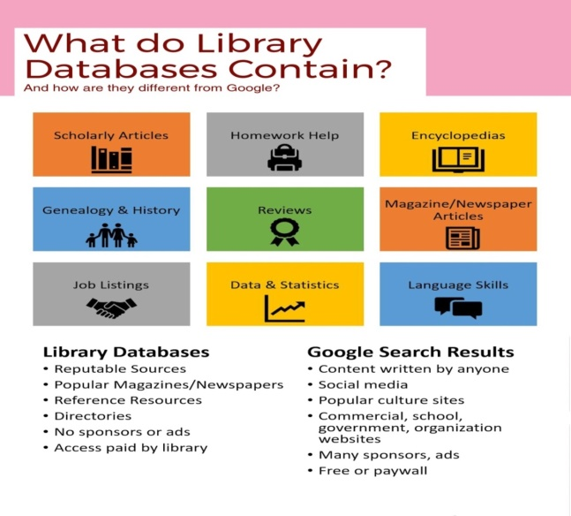
Here are a few examples of what you can find in our databases:
Newspapers
Pine Bush Local History
A guide to published and un-published works related to the history of Pine Bush,
The Town of Crawford and the Hudson Valley Region.
Collated by the Pine Bush Area Public Library
Job/Careers
History & Geneology
Science & Health
Are you looking to purchase a new refrigerator, washer/dryer, auto, snow blower, etc.?
Go to Consumer Reports under the research section on the website,
click on the alphabet – letter “C” and find Consumer Reports.

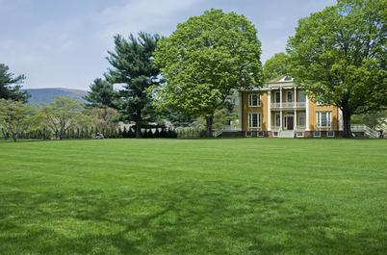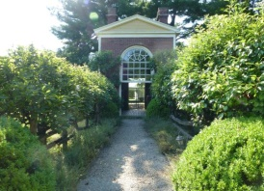
The Pine Bush Area Public Library now has a free pass to Boscobel!
Boscobel is a beautifully reassembled 1800’s neoclassical house in Garrison, NY. There are lush gardens, trails and magnificent Hudson Valley views. Boscobel is open for tours from April to December 2019.
Pass is good for 4 people – one “MUST” be a Pine Bush Library card holder!
Please pick up tickets at the Main Library desk!
(You will be responsible for your own transportation to visit Boscobel House, Garrison, NY))
************************************************************************************************************


We now have a One-day Empire Pass for use by our Pine Bush Area Public Library cardholders that can be shared. It's a family-friendly alternative to the traditional window decal and not assigned to a specific vehicle. The Empire Pass is your key to all-season enjoyment at New York State Parks. It provides unlimited day-use for one carload to most facilities operated by New York State Parks and the State Dept. of Environmental Conservation including forests, beaches, trails and more. For more information or ticket availability, please call the Library at 845 744-3375 ext. 1
or check their website: http://www.dec.ny.gov
Please pick up tickets at the Main Library desk!
(This pass can be checked out for 3 days at a time only!)

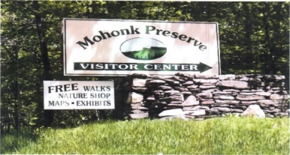

FREE MOHONK PRESERVE PASSES

(NOT THE MOHONK MOUNTAIN HOUSE!)

Available to Patrons of the Pine Bush Area Public Library
Please pick up tickets at the Main Library desk!
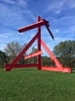The Pine Bush Library now has 2 free passes to: 
Storm King Art Center.
1 Museum Rd
New Windsor, NY 12553

Each pass is for 1 adult and 2 children under the age of 18.
There are many programs and activities for families and individuals of all ages!!
Please pick up the tickets at the Main Library desk!

PROGRAMS
ADULT PROGRAMS FOR DECEMBER 2019
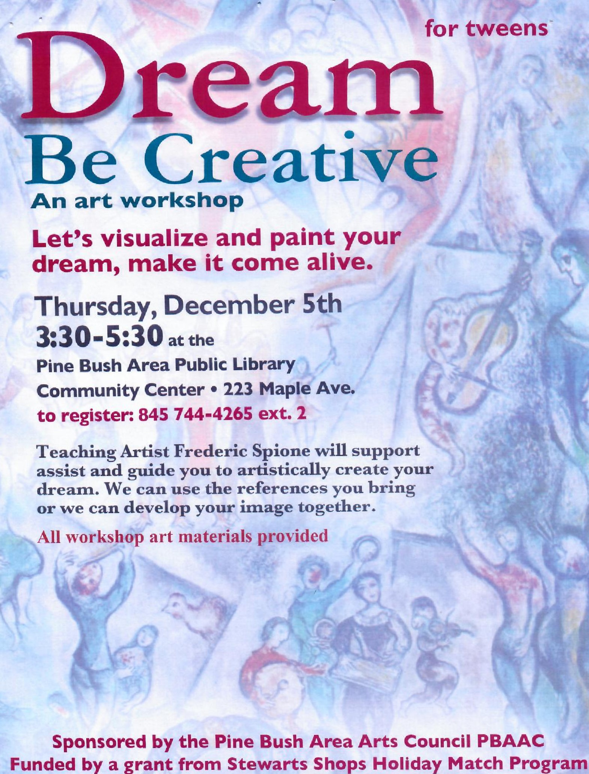

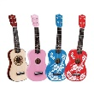UKULELE CAROLING 
Tuesday, Dec. 17th
7:00 - 9:00 PM
Community Room
Join us as we celebrate the HOLIDAY SEASON...with ukuleles!
Extra ukes on hand...come sing and strum along!
*******************************************************
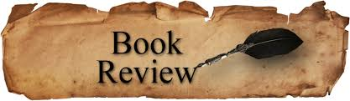
PLEASE CHECK OUR WEBSITE (www.pinebusharealibrary.org)
FOR A NEW MONTHLY BOOK REVIEW
BY OUR OWN
JEAN E. EUSTANCE!
ART ON THE LIBRARY WALLS
Keep your eyes peeled for a meet and greet with our December artist, Robert Theriot
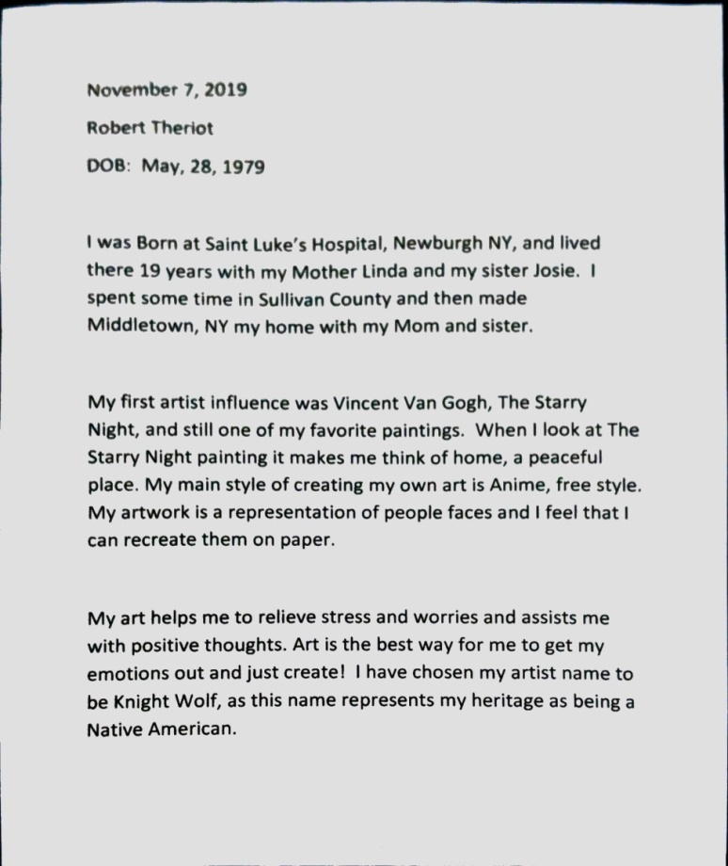
********************************************************************
The Pine Bush Area Arts Council is calling all artists:
If you would like to exhibit your artwork in the Pine Bush Library,
Please contact Dick Reich (845) 744-3781

CHILDREN’S PROGRAMS

(See the calendar for the ongoing programs)
TODDLER TIME TODDLER TIME (2 - 3 years old) ML
Mondays Dec. 2 - 30
10:00 - 11:00 AM

PRESCHOOL STORYTIME (3 - 5 years old) ML
Thursday Dec. 5, 12, 19
1:00 - 2:00 PM
MUSIC TIME WITH MISS JILL (all ages with parent/guardian) ML
Come sing and dance and play some musical instruments.
Tuesday Dec. 17
11:30 AM - 12:30 PM

 HOLIDAY FAMILY FUN DAY CC
Come join us for some Holiday Cheer for the WHOLE FAMILY...children must be accompanied by adult!
Craft time and hot cocoa, too!!!
Saturday Dec. 14
10:30 AM - 1:00 PM

R.E.A.D WITH MOCHA (CC)
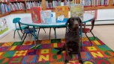
Reading Education Assistance Dog
Friday Dec. 13
3:30 - 4:30 PM

Monday Dec. 30
12:30 - 1:30 PM
This program is designed to help children with their read aloud skills.
Must register in advance for your one-on-one 15-minute session with MOCHA and Trainer, Wendy.

LET'S MAKE PAPER SNOWFLAKES ML
Friday Dec. 27
Drop in anytime 11:00 AM - 3:00 PM
All children must be accompanied by a parent/guardian!

Notes:
PLEASE MAKE SURE YOU REGISTER IN ADVANCE FOR ANY OF OUR PROGRAMS. YOU CAN DO THIS BY CALLING 845 744-4265
Children’s Programs – please register by calling Ext. 3
Adult Programs – please register by calling Ext. 2
PLEASE NOTE: RENEWAL OF CIRCULATION ITEMS MUST BE DONE
VIA THE WEBSITE OR IN PERSON. WE CANNOT ACCEPT VOICE MAIL MESSAGES TO RENEW YOUR ITEMS.
Used Books, DVDs’, audio tapes, puzzles, games, greeting cards and more are for sale in the Community Center.
***Don’t forget to check out the books in our
“FREE LITTLE LIBRARY!” on the front porch….the books are FREE!!***
Free - computer and electronic device help, resume writing help, and a Notary Pubic available every day in the Community Center.
Please note: A message on the Library’s phone will make you aware of the library openings and closings.
If you miss seeing any program flyers, go to Facebook and LIKE US
(tell us why the Pine Bush Library is so great!) Or,
Visit our webpage at www.pinebusharealibrary.org.
Check out your local papers, bulletin boards in town, stop into the library for your newsletter or
provide us with your email address to receive it via email.
Want to attend an event but do not have transportation?
Call Dial-A-Bus
TOWNS OF MONTGOMERY & CRAWFORD
Service provided Monday thru Friday. Hours of operation: 7:45am to 4:00pm. Reservations accepted Monday thru Friday 9:00am to 12:00pm. Regular Fare: $1.00 one-way • Children under 10 ride free when accompanied by an adult • Senior/disabled citizens and Medicare cardholders: 50¢ one-way.
Please call 845-457-2622

