Pine Bush Area Public Library
December 2019

Sun | Mon | Tue | Wed | Thu | Fri | Sat
1 | 2 | 3 | 4 | 5 | 6 | 7
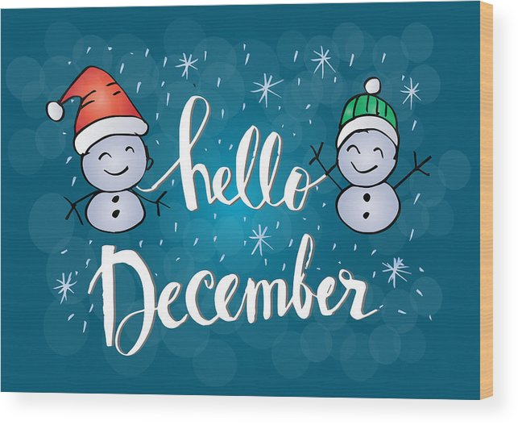 | Pinochle 10:00 am (CC)  Toddler Time 10:00 – 11:00 am (ML) | Scrabble 10:00 am (CC)  Chess 1:00 pm (CC) |  | Bridge 10:00 am (CC)  Pre-school Story Time  1:00 – 2:00 pm (ML)  DREAM 3:30 – 5:30 (CC) |  | Book sale 10:00 am – 2:00 pm (CC)
8 | 9 | 10 | 11 | 12 | 13 | 14
 | Pinochle 10:00 am (CC)  Toddler Time 10:00 – 11:00 am (ML) | Scrabble 10:00 am (CC)  Chess 1:00 pm (CC)  Happy Bookers 1:00 pm | Library Board Meeting 7:00 pm (CC) | Bridge 10:00 am (CC)  Pre-school Story Time  1:00 – 2:00 pm (ML)  Circle of Friends 1:00 (CC)  Friends of the Library 2:00 (CC) | R.E.A.D. w/Mocha 3:30 – 4:30 (CC) | Book sale 10:00 am – 2:00 pm (CC)  Holiday Family Fun Day 10:30 – 1:00 pm (CC)
15 | 16 | 17 | 18 | 19 | 20 | 21
 | Pinochle 10:00 am (CC)  Toddler Time 10:00 – 11:00 am (ML) | Scrabble 10:00 am (CC)  Chess 1:00 pm (CC  Music w/Jill 11:30 – 12:30 (ML))  Ukulele Caroling 7:00 – 9:00 pm (CC) | Bag Ladies 10:00 am (CC)  Bookies 6:00 pm (CC) | Bridge 10:00 am (CC)  Pre-school Story Time  1:00 – 2:00 pm (ML) |  | Cookie Walk & Holiday Boutique  9:00 to sold out (CC)
22 | 23 | 24 | 25 | 26 | 27 | 28
First Night of Hanukah  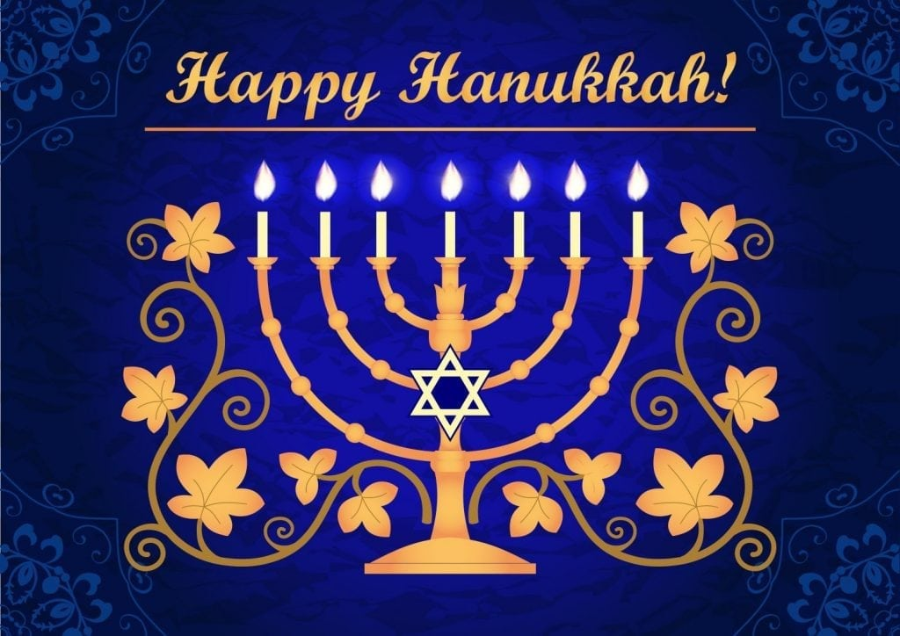 | Pinochle 10:00 am (CC)  Toddler Time 10:00 – 11:00 am (ML) | LIBRARY IS CLOSED FOR CHRISTMAS EVE | LIBRARY IS CLOSED FOR CHRISTMAS   | LIBRARY IS CLOSED FOR CHRISTMAS   | Paper Snowflakes 11:00 – 3:00 pm (ML) | Book sale 10:00 am – 2:00 pm (CC)
29 | 30 | 31 |  |  |  | 
 | Pinochle 10:00 am (CC)  Toddler Time 10:00 – 11:00 am (ML)  R.E.A.D. w/Mocha 12:30 – 1:30 pm (CC) | Scrabble 10:00 am (CC)  Chess 1:00 pm (CC)  LIBRARY CLOSING EARLY FOR NEW YEAR”S EVE 5:00 pm | 

