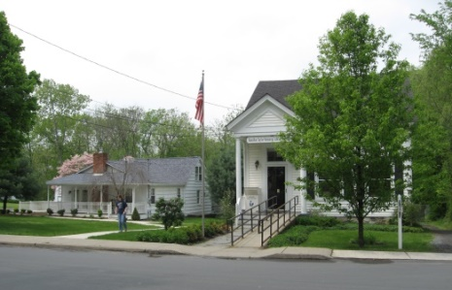
PINE BUSH AREA PUBLIC LIBRARY
NEWSLETTER – November 2019
‘WHERE THE COMMUNITY CONNECTS’
223-227 Maple Ave, PO Box 63, Pine Bush, NY 12566
845-744-3375, 845-744-5295, 845-744-4265
Fax 845-744-3377
Adult Services – Ext. 1
Community Center – Ext. 2
Children’s Services – Ext. 3
www.pinebusharealibrary.org

LIBRARY HOURS:
MON & WED 9-7
TUE & THUR 11-7
FRI 9-5 SAT 10-2

COMMUNITY CENTER:
MON - THURS 10 AM – 6 PM
FRI 10 AM-5PM
SAT 10 AM-2 PM

BOARD OF TRUSTEES – MEETING TIME - SECOND WEDNESDAY OF EACH MONTH 7:00 PM
IN THE LIBRARY COMMUNITY CENTER
BOARD OF TRUSTEES - Sharon Tarolli-President, Lisa Cannon-Vice President,
Gloria Winter-Secretary, Matthew Watkins –Treasurer
TRUSTEES - Peter Eriksen, Senta Curran, John Russell, Joseph Britto, Coby Low.
Director- Doris Callan
The Library will be closed November 11th for Veterans Day 

The Library will be closed early (5:00 pm) November 27th
and be closed November 28th and 29th for Thanksgiving!
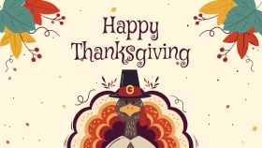

Medicare Open Enrollment period - October 15 and continues until December 7


Come visit the Pine Bush Library to:
Buy books
Buy CDs, DVDs, Records, Audio books
Purchase greeting cards
*Get one on one Computer tutoring
Attend exciting events
Play cards, Scrabble, Chess

*Come to the Pine Bush Library and meet LibTecEd – he is our computer Ace! He will tutor you one on one or you can attend one of his classes. The classes will be listed here in the newsletter and on the website, as well. If you want to schedule a one on one with LibTecEd, please email him at: Libteced@gmail.com or call the Community Center (845) 744-4265 x2.
************************************************************************************************************
Thank you to our patrons who donated goods to the Pine Bush Ecumenical Food Pantry for the “Give Back” program.
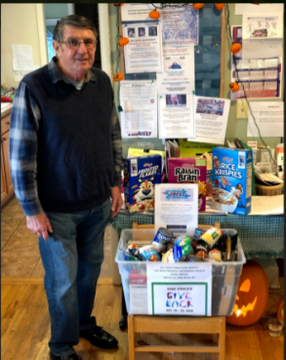
Bob Gillespie (pictured below), one of the many volunteeers at the food pantry, collected several bins of donated goods from the Library and transported them to the food pantry.

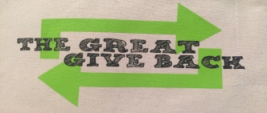
SATURDAY, OCTOBER 19TH TO FRIDAY, OCTOBER 25TH
THE PINE BUSH AREA PUBLIC LIBRARY IS PARTICIPATING IN “THE GREAT GIVE BACK”
A DAY OF OPPORTUNITIES FOR THE PATRONS
OF NYS PUBLIC LIBRARIES TO PARTICIPATE IN MEANINGFUL, SERVICE-ORIENTED EXPERIENCES.
AS PART OF “THE GREAT GIVE BACK”, THE PINE BUSH AREA LIBRARY HAS CHOSEN TO COLLECT NON-PERISHABLE FOOD ITEMS FOR
THE NEW PROSPECT CHURCH FOOD PANTRY, ROUTE 52, PINE BUSH, NY.
DONATIONS CAN BE BROUGHT TO THE MAIN LIBRARY BUILDING OR LIBRARY COMMUNITY CENTER FROM
OCTOBER 19TH TO OCTOBER 25^{TH.} DURING DAILY HOURS OF OPERATION.

***************************************************************************
CHESS…CHESS…CHESS
Tuesday is Chess Day! Come to the Community Center at 1:00 pm…
All are welcome… beginners – Joe Britto will teach you how to play chess!
Give us a call to tell us you are coming!
Pine Bush Library Community Center 845 744-4264 ext. 2



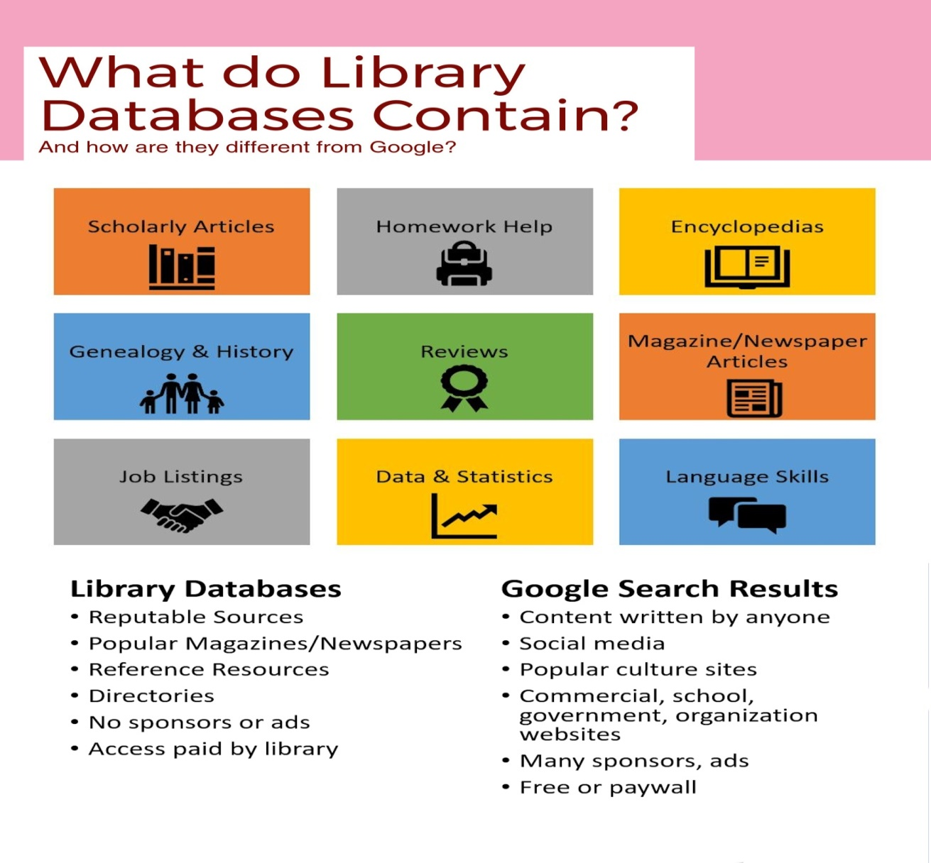
Here are a few examples of what you can find in our databases:
Newspapers
Pine Bush Local History
A guide to published and un-published works related to the history of Pine Bush,
The Town of Crawford and the Hudson Valley Region.
Collated by the Pine Bush Area Public Library
Job/Careers
History & Geneology
Science & Health
Are you looking to purchase a new refrigerator, washer/dryer, auto, snow blower, etc.?
Go to Consumer Reports under the research section on the website,
click on the alphabet – letter “C” and find Consumer Reports.

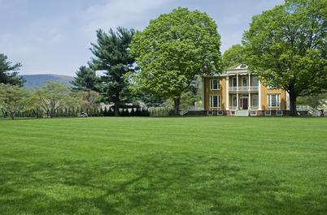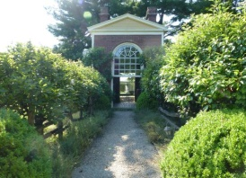
The Pine Bush Area Public Library now has a free pass to Boscobel!
Boscobel is a beautifully reassembled 1800’s neoclassical house in Garrison, NY. There are lush gardens, trails and magnificent Hudson Valley views. Boscobel is open for tours from April to December 2019.
Pass is good for 4 people – one “MUST” be a Pine Bush Library card holder!
Please pick up tickets at the Main Library desk!
(You will be responsible for your own transportation to visit Boscobel House, Garrison, NY))
************************************************************************************************************


We now have a One-day Empire Pass for use by our Pine Bush Area Public Library cardholders that can be shared. It's a family-friendly alternative to the traditional window decal and not assigned to a specific vehicle. The Empire Pass is your key to all-season enjoyment at New York State Parks. It provides unlimited day-use for one carload to most facilities operated by New York State Parks and the State Dept. of Environmental Conservation including forests, beaches, trails and more. For more information or ticket availability, please call the Library at 845 744-3375 ext. 1
or check their website: http://www.dec.ny.gov
Please pick up tickets at the Main Library desk!
(This pass can be checked out for 3 days at a time only!)

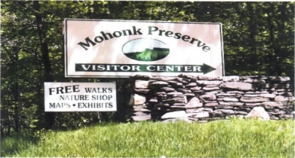

FREE MOHONK PRESERVE PASSES

(NOT THE MOHONK MOUNTAIN HOUSE!)

Available to Patrons of the Pine Bush Area Public Library
Please pick up tickets at the Main Library desk!
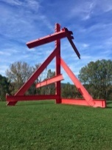 The Pine Bush Library now has 2 free passes to: 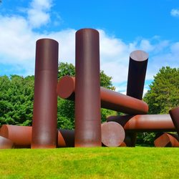
Storm King Art Center.
1 Museum Rd
New Windsor, NY 12553

Each pass is for 1 adult and 2 children under the age of 18.
There are many programs and activities for families and individuals of all ages!!
Please pick up the tickets at the Main Library desk!

PROGRAMS
ADULT PROGRAMS FOR NOVEMBER 2019



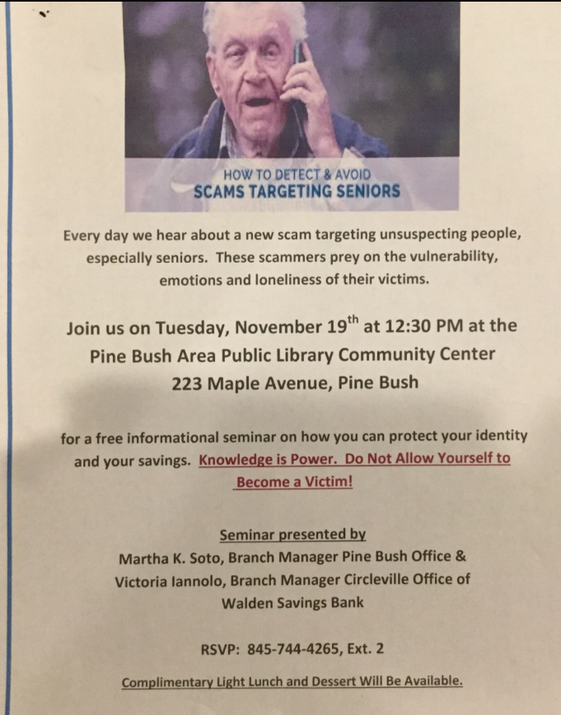

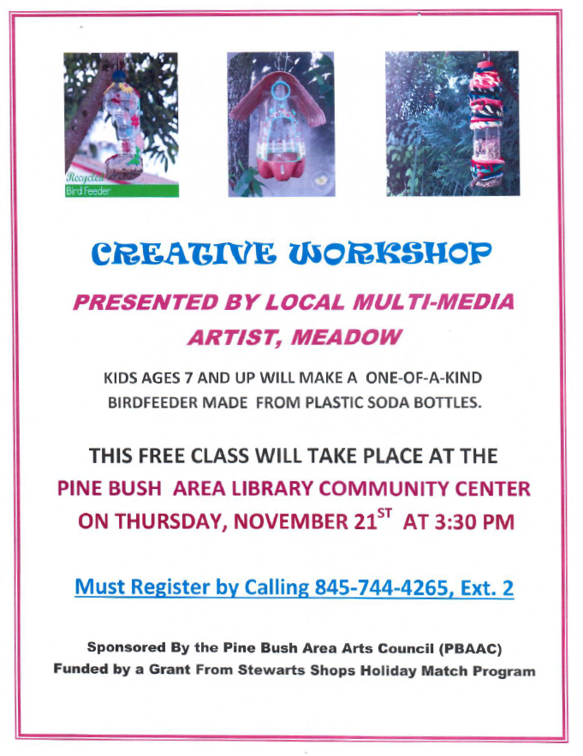

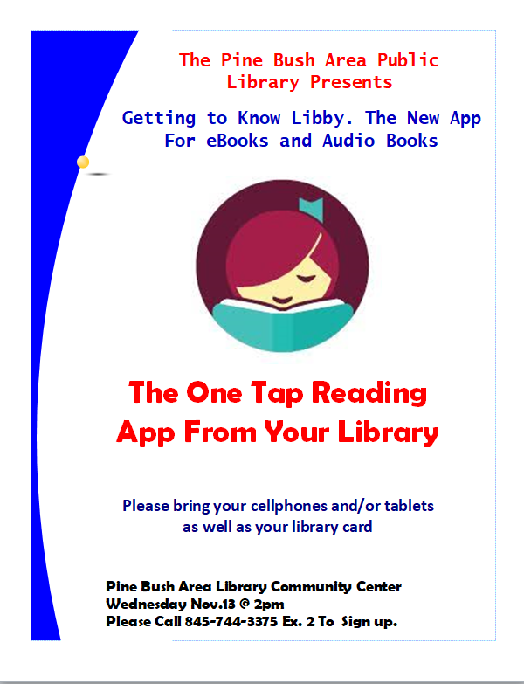

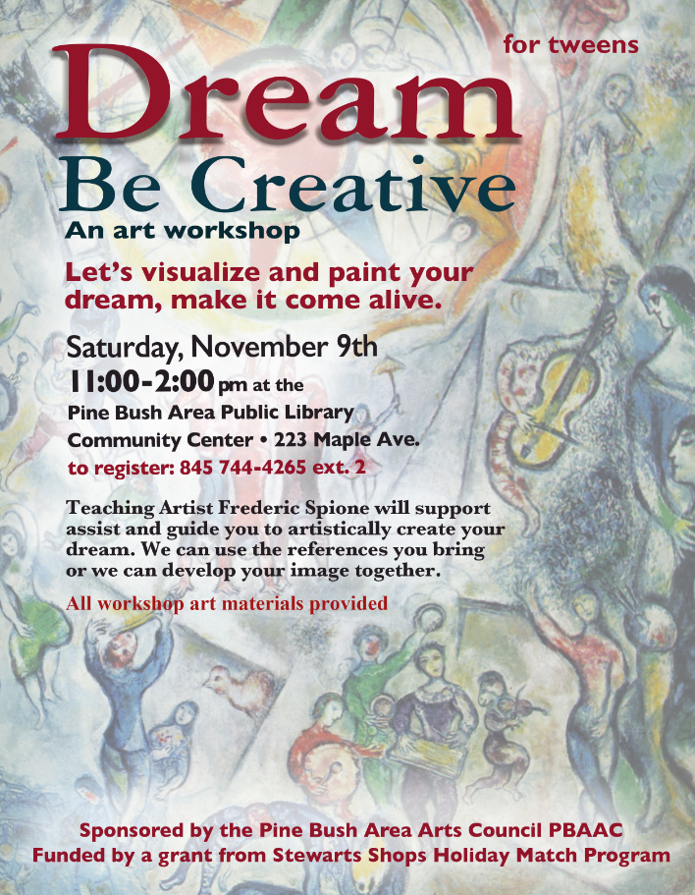

Ukulele Strumming - Tuesday, November 19th @ 7:00 - 9:00 pm at the Children’s room!
No experience necessary! Extra Ukes on hand!
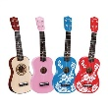
*******************************************************
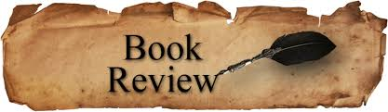
PLEASE CHECK OUR WEBSITE (www.pinebusharealibrary.org)
FOR A NEW MONTHLY BOOK REVIEW
BY OUR OWN
JEAN E. EUSTANCE!
********************************************************************
The Pine Bush Area Arts Council is calling all artists:
If you would like to exhibit your artwork in the Pine Bush Library,
Please contact Dick Reich
845 744-3781
********************************************************************
ART ON THE LIBRARY WALLS 
FREDERIC SPIONE
Frederic Spione has an extensive background as a successful commercial artist and illustrator in NYC. Relocating to Pine Bush, NY, Spione now works in his converted garage studio painting landscapes, abstract imagery and whimsical pictures inspired by his idyllic rural setting. For the last 20 years, Spione has also worked in the field of Creative Aging facilitating and training staff and older persons to share memories and life experiences through visual art. Spione facilitates creative workshops for adults, children and persons with dementia. He also provides private art lessons with a special focus on helping people overcome artistic blocks. Frederick Spione is a member of the Pine Bush Area Arts Council (PBAAC) and the Middletown Art Group (MAG). He was a featured exhibitor at the Crawford Gallery of Fine Art (CGFA).
“I discover a texture, see color and shapes or hear a melody that then awakens in me
a desire to create and capture mystifying understandings.”
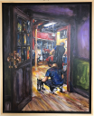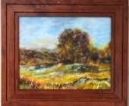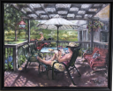

The Pine Bush Area Arts Council is calling all artists:
If you would like to exhibit your artwork in the Pine Bush Library,
Please contact Dick Reich (845) 744-3781

***************************************************************************

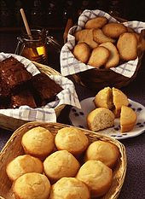
Thanksgiving Bake Sale
Wednesday, November 27th
9:00 am – sold out!!
Home Baked Pies, Cakes, Muffins, Breads, Cupcakes, etc.!
Sponsored by The Friends of The Pine Bush Area Public Library

CHILDREN’S PROGRAMS




(See the calendar for the ongoing programs)
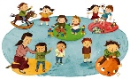TODDLER TIME (Ages 18 – 36 months with parent/caregiver) 
Mondays, November 4, 18 and 25 (closed Nov. 11th) 10:00 – 11:00 am
PRESCHOOL (Ages 3 – 5 years old with parent/caregiver)
Thursdays, November 7 – 21, 1:00 – 2:00 pm

- FAMILY DROP IN COLORING (Children must be accompanied by an adult)
Wednesdays, November 6 – 27, 10:00 am – 12:00 noon
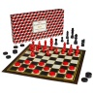AFTERSCHOOL CHESS/CHECKERS (Grades 5 and up)
Fridays, November 1 – 22, 3:00 – 4:30 pm

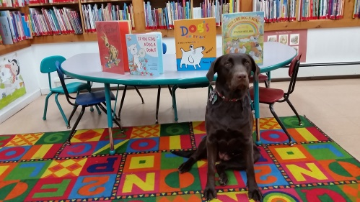
MEET MOCHA!
Stop in to meet and greet MOCHA, our new R. E. A. D. (READING EDUCATION ASSISTANCE DOG) with trainer, Wendy.
Mocha and trainer will be visiting the Pine Bush Library on Tuesday, November 5th from 11:30 am – 12:30 pm.
as we get ready for our regular R.E.A.D. WITH MOCHA sessions.
R.E.A.D. sessions are designed to help children with their read aloud skills and registration is required.
R.E.A.D. sessions will be on Friday, November 6th and 22nd at 3:30 – 4:30 pm. Children can bring their own special book to read or you can choose one from the library collection. All sessions are 15 minutes each and will be held in the Library Community Center. If you have any questions, please call Miss Vicki in the Children’s Library (845) 744-3375 ext. 3.

**************************************************

FRIENDSGIVING FAMILY FUN STORYTIME (children's section)

SATURDAY, NOVEMBER. 16
11:00 AM - 12:00 PM

Thanksgiving story time and craft...family fun!!!

NO DROP-OFFS...PARENTS MUST STAY!

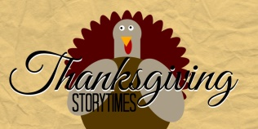
Notes:
PLEASE MAKE SURE YOU REGISTER IN ADVANCE FOR ANY OF OUR PROGRAMS. YOU CAN DO THIS BY CALLING 845 744-4265
Children’s Programs – please register by calling Ext. 3
Adult Programs – please register by calling Ext. 2
PLEASE NOTE: RENEWAL OF CIRCULATION ITEMS MUST BE DONE
VIA THE WEBSITE OR IN PERSON. WE CANNOT ACCEPT VOICE MAIL MESSAGES TO RENEW YOUR ITEMS.
Used Books, DVDs’, audio tapes, puzzles, games, greeting cards and more are for sale in the Community Center. Don’t forget to check out the books in our
“FREE LITTLE LIBRARY!” on the front porch….the books are FREE!!
Free - computer and electronic device help, resume writing help, and a Notary Pubic available every day in the Community Center.
Please note: A message on the Library’s phone will make you aware of the library openings and closings.
If you miss seeing any program flyers, go to Facebook and LIKE US
(tell us why the Pine Bush Library is so great!) Or,
Visit our webpage at www.pinebusharealibrary.org.
Check out your local papers, bulletin boards in town, stop into the library for your newsletter or
provide us with your email address to receive it via email.
Want to attend an event but do not have transportation?
Call Dial-A-Bus
TOWNS OF MONTGOMERY & CRAWFORD
Service provided Monday thru Friday. Hours of operation: 7:45am to 4:00pm. Reservations accepted Monday thru Friday 9:00am to 12:00pm. Regular Fare: $1.00 one-way • Children under 10 ride free when accompanied by an adult • Senior/disabled citizens and Medicare cardholders: 50¢ one-way.
Please call 845-457-2622

