Pine Bush Area Public Library
November 2019

Sun | Mon | Tue | Wed | Thu | Fri | Sat
 |  |  |  |  | 1 | 2
 |  |  |  |  | Mah Jong 10:00 am (CC)  Drop in afterschool chess/checkers 3:00 – 4:30 pm (ML) | Book sale 10:00 am – 2:00 pm (CC)
3 | 4 | 5 | 6 | 7 | 8 | 9
 | Pinochle 10:00 am (CC)  Toddler Time 10:00 – 11:00 am (ML)  Medicare program 1:00 pm (CC) | Scrabble 10:00 am (CC)  Chess 1:00 pm (CC)  WWII 6:30 pm (CC)  Meet “Mocha”  11:30am – 12:30 pm (CC) | Family Drop In Coloring 10:00 am (ML) | Bridge 10:00 am (CC)  Pre-school Story Time 1:00 – 2:00 pm (ML) | Drop in afterschool chess/checkers 3:00 – 4:30 pm (ML)  R.E.A.D. with “Mocha”  3:30 – 4:30 pm (CC) | Book sale 10:00 am – 2:00 pm (CC)  Dream  Art Workshop  11:00 am – 2:00 pm  (CC)
10 | 11 | 12 | 13 | 14 | 15 | 16
 | Library will be closed for Veterans Day   | Scrabble 10:00 am (CC)  Happy Bookers 1:00 pm (CC)  Chess 1:00 pm (CC)  WWII 6:30 pm (CC) | Family Drop In Coloring 10:00 am (ML)  Libby 2:00 pm (CC)  Library Board Mtg.  7:00 pm (CC) | Bridge 10:00 am (CC)  Circle of Friends 1:00 pm (CC)  Pre-school Story Time  1:00 – 2:00 pm (ML)  Friends 2:00 pm (CC) | Drop in afterschool chess/checkers 3:00 – 4:30 pm (ML) | Book sale 10:00 am – 2:00 pm (CC)  Friendsgiving Family Fun Story Time 11:00 am – 12:00 noon (CC)
17 | 18 | 19 | 20 | 21 | 22 | 23
 | Pinochle 10:00 am (CC)  Toddler Time 10:00 – 11:00 am (ML) | Scrabble 10:00 am (CC)  Chess 1:00 pm (CC)  Scams Targeting Seniors. 12:30 pm  WWII 6:30 pm (CC)  Ukulele Strumming 7:00 pm (ML) | Bag Ladies 10:00 am (CC)  Family Drop In Coloring 10:00 am (ML)  Bookies 7:00 pm (CC) | Bridge 10:00 am (CC)  Page Turners 1:00 pm  Pre-school Story Time 1:00 – 2:00 pm (ML)  Bird Feeders 3:30 pm (CC) | Drop in afterschool chess/checkers 3:00 – 4:30 pm (ML)  R.E.A.D. with “Mocha”  3:30 – 4:30 pm (CC) | Book sale 10:00 am – 2:00 pm (CC)
24 | 25 | 26 | 27 | 28 | 29 | 30
 | Pinochle 10:00 am (CC)  Toddler Time 10:00 – 11:00 am (ML) | Scrabble 10:00 am (CC)  Chess 1:00 pm (CC) | Thanksgiving Bake Sale 9:00 am – sold out!  The Library will be closing early (5:00 pm) for Thanksgiving! | The Library is closed for Thanksgiving!  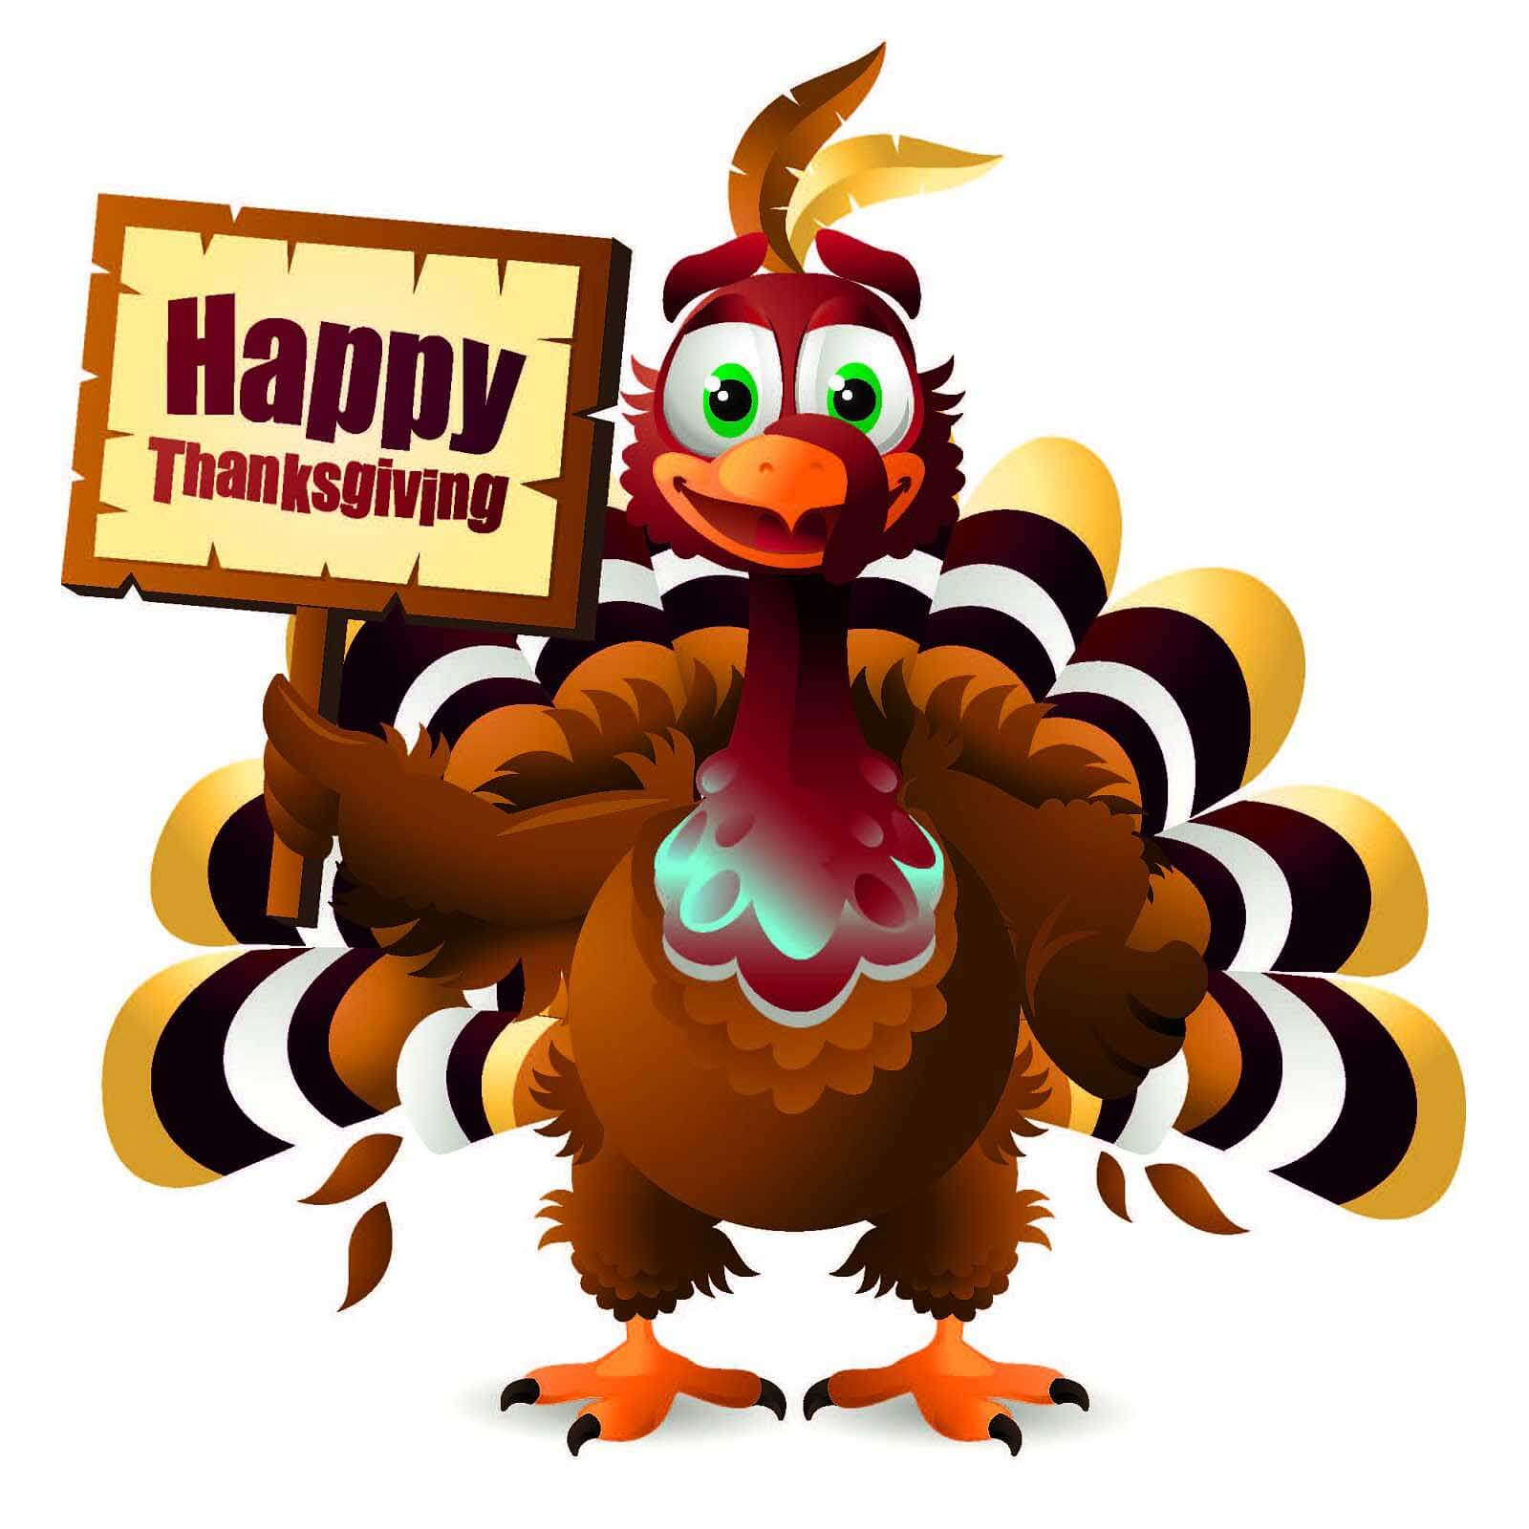 | The Library is closed for Thanksgiving! | Book sale 10:00 am – 2:00 pm (CC)

