Pine Bush Area Public Library October 2019 Calendar
Sun | Mon | Tue | Wed | Thu | Fri | Sat
 |  | 1 | 2 | 3 | 4 | 5
 |  | Scrabble 10:00 am (CC)  Chess 1:00 pm (CC) | Family drop-in coloring 10:00 am - 12:00 (ML) | Bridge 10:00 am (CC)  Pre-school Story Time 1:00 – 2:00 pm (ML) | Drop in afterschool chess/checkers 3:00 – 4:30 pm (ML) | Book sale 10:00 am – 2:00 pm (CC)
6 | 7 | 8 | 9 | 10 | 11 | 12
 | Pinochle 10:00 am (CC) | Scrabble 10:00 am (CC)  Chess 1:00 pm (CC)  Happy Bookers 1:00 pm (CC) | Family drop-in coloring 10:00 am - 12:00 (ML)Library Board Mtg.  7:00 pm (CC) | Bridge 10:00 am (CC)Circle of Friends 1:00 pm (CC)  Pre-school Story Time 1:00 – 2:00 pm (ML)  Friends 2:00 pm (CC) | Drop in afterschool chess/checkers 3:00 – 4:30 pm (ML) | Book sale 10:00 am – 2:00 pm (CC)
13 | 14 | 15 | 16 | 17 | 18 | 19
 | Library Closed  Columbus Day  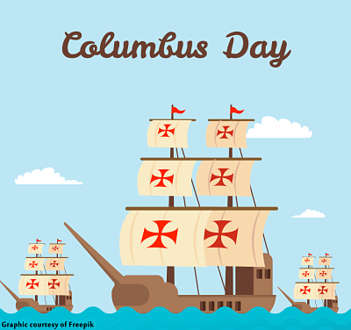 | Scrabble 10:00 am (CC)  Chess 1:00 pm (CC)  Ukulele 7:00pm (CC) | Family drop-in coloring 10:00 am - 12:00 (ML)Bag Ladies 10:00 am (CC)  Bookies 7:00 pm (CC) | Bridge 10:00 am (CC)  Pre-school Story Time 1:00 – 2:00 pm (ML) | Drop in afterschool chess/checkers 3:00 – 4:30 pm (ML) | AARP Safe Driver 9:00 – 4:30 pm  (CC)  Great Give Back  begins
20 | 21 | 22 | 23 | 24 | 25 | 26
 | Pinochle 10:00 am (CC)  Toddler Time 10:00 – 11:00 am (ML) | Scrabble 10:00 am (CC)  Chess 1:00 pm (CC) | Family drop-in coloring 10:00 am - 12:00 (ML) | Bridge 10:00 am (CC) Pre-school Story Time 1:00 – 2:00 pm (ML)  Page Turners 1:00 pm (CC) | Great Give Back ends  Drop in afterschool chess/checkers 3:00 – 4:30 pm (ML) | Book sale 10:00 am – 2:00 pm (CC)  Mah Jong 10:00 am – 12 noon (CC)
27 | 28 | 29 | 30 | 31
 | Pinochle 10:00 am (CC)  Toddler Time 10:00 – 11:00 am (ML) | Scrabble 10:00 am (CC)  Chess 1:00 pm (CC) | Family drop-in coloring 10:00 am - 12:00 (ML) | 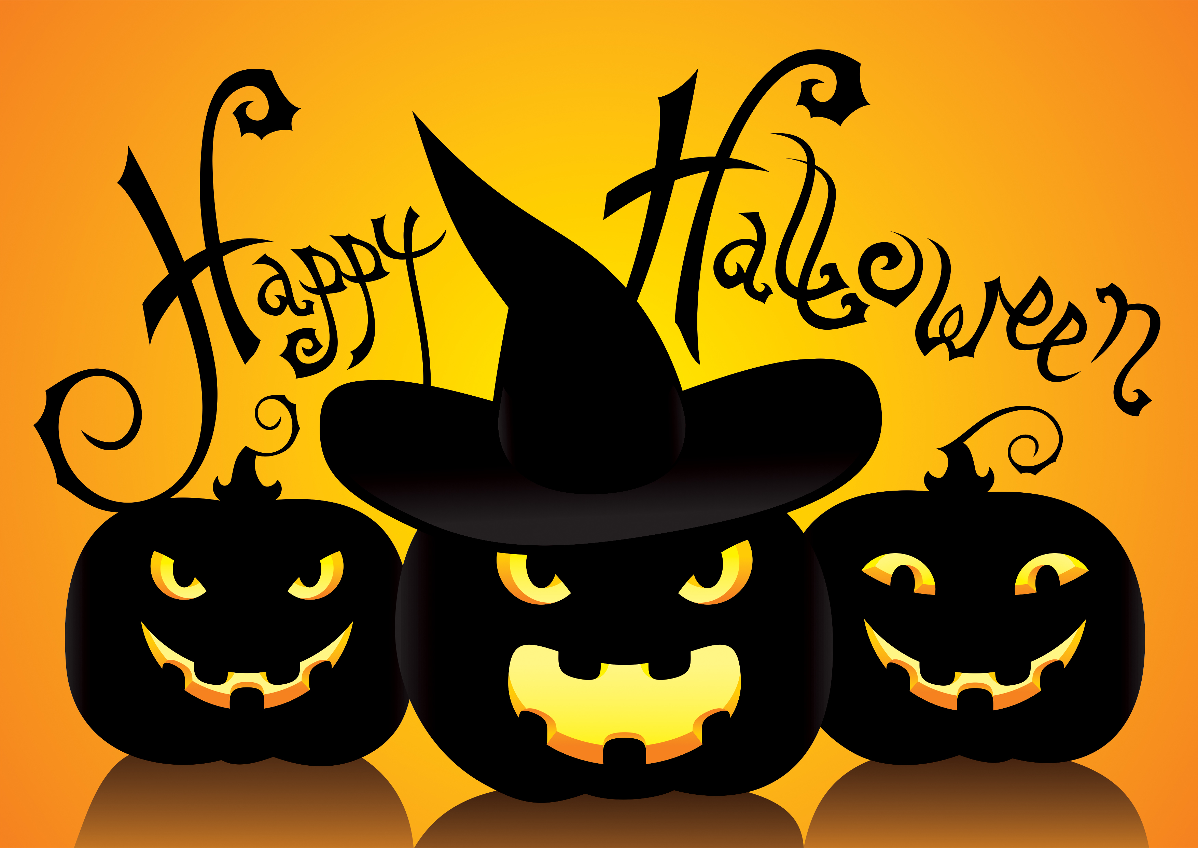  Library closing early 5:00 PM Halloween!  Bridge 10:00 am (CC) Pre-school Story Time 1:00 – 2:00 pm (ML) |  | 