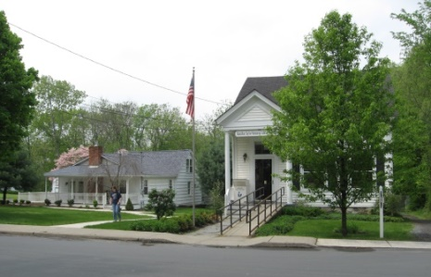
PINE BUSH AREA PUBLIC LIBRARY
NEWSLETTER – July 2019
‘WHERE THE COMMUNITY CONNECTS’
223-227 Maple Ave, PO Box 63, Pine Bush, NY 12566
845-744-3375, 845-744-5295, 845-744-4265
Fax 845-744-3377
Adult Services – Ext. 1
Community Center – Ext. 2
Children’s Services – Ext. 3
www.pinebusharealibrary.org

LIBRARY HOURS:
MON & WED 9-7
TUE & THUR 11-7
FRI 9-5 SAT 10-2

COMMUNITY CENTER:
MON - THURS 10 AM – 6 PM
FRI 10 AM-5PM
SAT 10 AM-2 PM

BOARD OF TRUSTEES – MEETING TIME - SECOND WEDNESDAY OF EACH MONTH 7:00 PM
IN THE LIBRARY COMMUNITY CENTER
BOARD OF TRUSTEES - Sharon Tarolli-President, Lisa Cannon-Vice President,
Gloria Winter-Secretary, Matthew Watkins –Treasurer
TRUSTEES - Peter Eriksen, Senta Curran, John Russell, Joseph Britto, Coby Low.
Director- Doris Callan
PLEASE NOTE: THE LIBRARY WILL BE CLOSED FOR
THE 4th OF JULY!!
July is:
July 2nd - World UFO Day 
July 4th – Independence Day!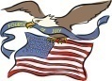
July 10th – National Kitten Day!

July 14th – Bastille Day! 

July 17th – National Hot Dog Day!

July 20th - National Moon Day!

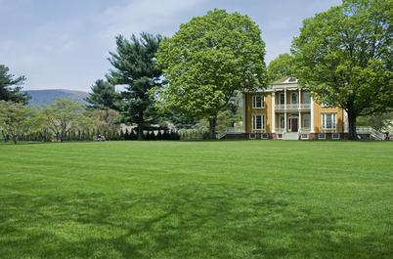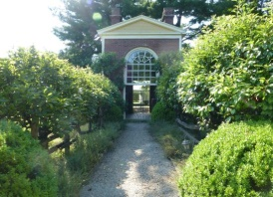
The Pine Bush Area Public Library now has a free pass to Boscobel!
Boscobel is a beautifully reassembled 1800’s neoclassical house in Garrison, NY. There are lush gardens, trails and magnificent Hudson Valley views. Boscobel is open for tours from April to December 2019.
Please come to the library to reserve the pass:
Pass is good for 4 people – one “MUST” be a Pine Bush Library card holder!
(845) 744-3375 ext. 1 to learn more info.
(You will be responsible for your own transportation to visit Boscobel House, Garrison, NY))
************************************************************************************************************


We now have a One-day Empire Pass for use by our Pine Bush Area Public Library cardholders that can be shared. It's a family-friendly alternative to the traditional window decal and not assigned to a specific vehicle. The Empire Pass is your key to all-season enjoyment at New York State Parks. It provides unlimited day-use for one carload to most facilities operated by New York State Parks and the State Dept. of Environmental Conservation including forests, beaches, trails and more. For more information or ticket availability, please call the Library at 845 744-3375 ext. 1
or check their website: http://www.dec.ny.gov
To reserve your pass, you must come into the Library, (This pass can be checked out for 3 days at a time only!)

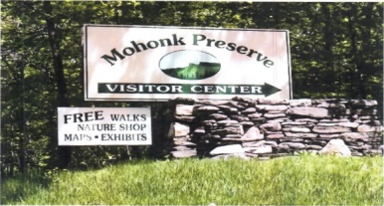

FREE MOHONK PRESERVE PASSES

(NOT THE MOHONK MOUNTAIN HOUSE!)

Available to Patrons of the Pine Bush Area Public Library

Ask For More Information at the Main Library 845 744-3375 ext. 1!
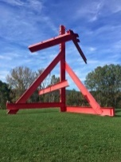 The Pine Bush Library now has 2 free passes to: 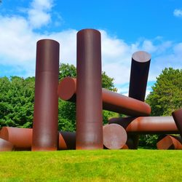
Storm King Art Center.
1 Museum Rd
New Windsor, NY 12553

Each pass is for 1 adult and 2 children under the age of 18.
There are many programs and activities for families and individuals of all ages!!
Please call the library at 845 744-3375 ext. 1 for ticket availability and more info. You must come into the library to reserve the tickets!
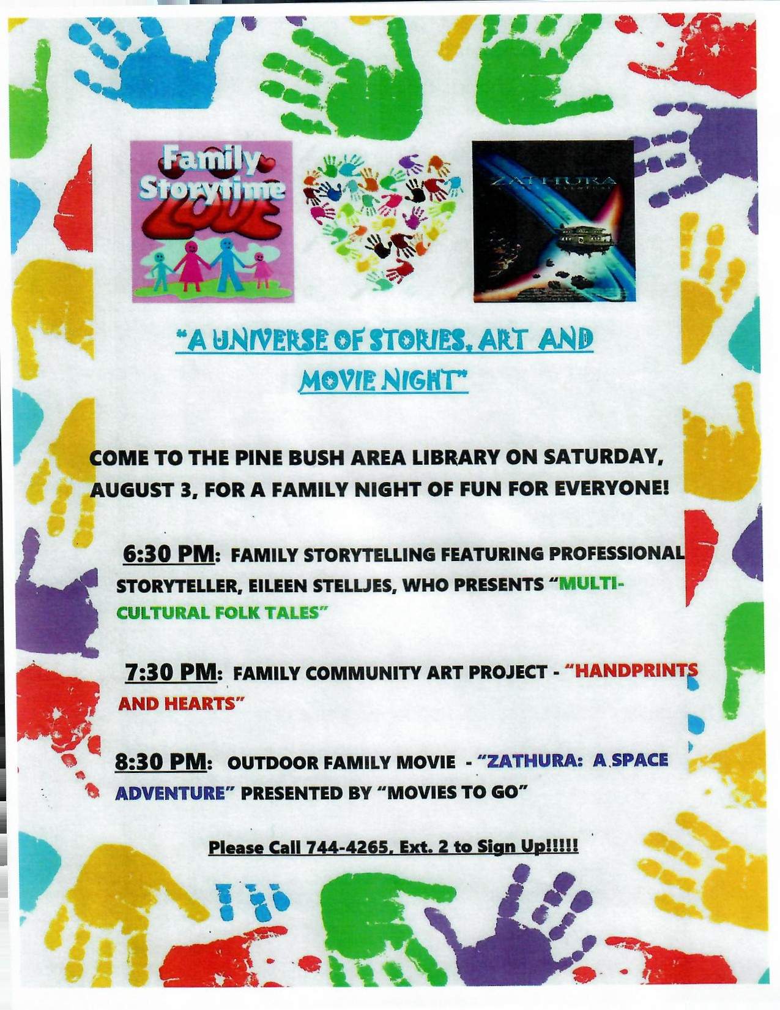
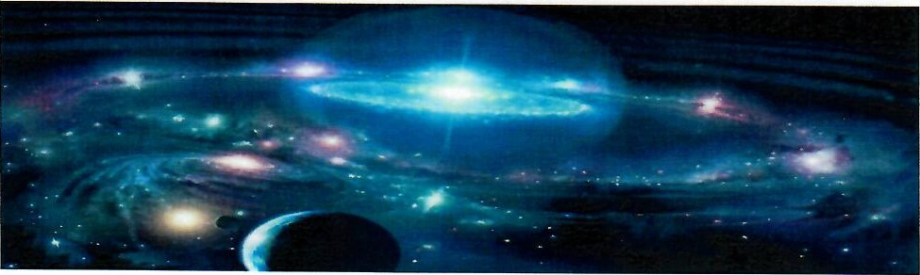
"A UNIVERSE OF STORIES"
THE ADULT READING PROGRAM THEME AT THE PINE BUSH AREA LIBRARY
CALLING ALL CREATIVE WRITERS!!
WE'RE LOOKING FOR ORIGINAL SHORT STORIES ABOUT LIFE ON ANOTHER PLANET, ON A DISTANT
ASTEROID, ON A FAR OFF GALAXY, OR ON ANY OTHER WORLD BEYOND OUR OWN SOLAR SYSTEM
THAT EXISTS IN THE WRITER'S IMAGINATION. WE WANT YOU TO DEFINE YOUR CHARACTERS,
PROVIDE NAMES, EXPLAIN LIFE FORMS, ATMOSPHERE, COLORS, LANGUAGE, INTELLIGENCE, FOOD,
ACTIVITIES, MODE OF TRAVEL, LEADERSHIP, ETC. ..... ALL THE THINGS THAT EXIST ON YOU
IMAGINARY WORLD.„.....AND, OF COURSE, EMBELLISH WHEREVER AND WHENEVER POSSIBLE!
RULES:
- WRITE YOUR NAME AND CONTACT INFORMATION ON A SEPARATE PIECE OF PAPER AND ATTACH IT TO YOUR FINISHED STORY
- SUBMIT YOUR STORY IN A SEALED ENVELOPE TO KAREN FOX AT THE PINE BUSH AREA LIBRARY
- STORIES MUST BE TYPE WRITTEN OR LEGIBLY HAND WRITTEN, DOUBLE SPACED, FRONT
AND BACK, ON NO MORE THAN THREE 8 "X 10" WHITE PAGES
- ONLY ADULTS AGE 18 AND OLDER ARE ELIGIBLE TO SUBMIT ENTRIES
- DEADLINE FOR SUBMISSION IS MONDAY JULY 22 2019 BEFORE 7:00 PM ATTHE PINE BUSH MAIN LIBRARY BUILDING
STORIES WILL BE REVIEWED BY A SELECT GROUP OF JUDGES WHO WILL NOT KNOW THE NAME OF
THE WRITERS OF THE SHORT STORIES. THIS IS TO ASSURE THAT THE BEST STORY CHOSEN IS BASED
ON MERIT. ONLY ONE STORY AND WRITER WILL BE SELECTED FOR A FIRST PLACE PRIZE, YET TO BE DETERMINED. AFTER THE JUDGING, A BOOKLET ENTITLED, "A UNIVERSE OF STORIES"
CONTAINING ALL SUBMITTED STORIES WITH THE NAME OF THE WRITER WILL BE AVAILABLE AT THE LIBRARY FOR EVERYONE'S READING ENJOYMENT.
THIS IS A FUN PROJECT ...NOT A CREATIVE WRITING CLASS! NO GRADES AND NO CRITIQUES.... JUST A PROJECT TO SEE WHO CAN IMAGINE THE MOST UNIQUE "OTHER" WORLD IN THE UNIVERSE!
**************************************************************************************
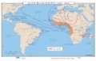
Slavery and World History
Joseph Britto, Adjunct Lecturer SUNY/Orange & Professor Emeritus SUNY/New Paltz, continues the
8 week history series on
Tuesday,
July 9th, 16th, 23rd and 30th @ 6:30 pm
“Where Slavery Died Hard”, an historical documentary showing evidence of enslaved African-Americans in Ulster County, NY around 1790, will be shown during the Tuesday, July 16th session at 6:30 pm at the Community Center.
PLEASE REGISTER BY CALLING 744-4265, EXT. 2


ALL POETS AND NON-POETS ARE INVITED. READ YOUR OWN SUMMER-INSPIRED WORK, READ SOME FAVORITE SUMMER-INSPIRED POEMS OF OTHERS, OR JUST COME AND LISTEN WHILE OTHERS READ.
Hosted by: Gloria Winter
PINE BUSH AREA LIBRARY COMMUNITY CENTER
Thursday, July 25th AT 7:00 PM
(PLEASE CALL THE LIBRARY AT 744-4265 ext. 2 to reserve your spot!)
******************************************************************************
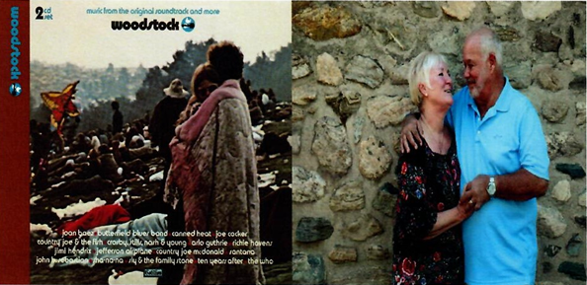
“A Universal Happening!”
THE 50TH ANNIVERSARY OF WOODSTOCK

Meet NICK AND BOBBIE ERCOLINE,
The Iconic Couple on the Cover of the Original Woodstock Album and Our Hometown Neighbors! Hear them tell what it was like to be at the Woodstock Festival in 1969 and how this "Universal Event" changed their lives.

PINE BUSH AREA LIBRARY COMMUNITY CENTER
THURSDAY, JULY 18, 2019 AT 7:00 PM
Please Call 744-4265 Ext. 2 to Reserve Your Seat.

Ukulele Strumming: Tuesday, July 16th at 7:00 pm – 9:00 pm in the Children’s section of the Main Library!
No experience necessary, extra ukes on hand!

AARP SMART DRIVER CLASS
GET A DISCOUNT ON YOUR AUTO INSURANCE AND/OR LOWER POINTS ON YOUR LICENSE!
SIGN UP NOW!!!
Wednesday, July 10th @ 9 AM TO 4:30 PM
PINE BUSH AREA LIBRARY COMMUNITY CENTER
$20 FOR AARP MEMBERS - $25 FOR
NON-AARP MEMBERS
(MUST REGISTER. CALL 744-4265 ext. 2)
Additional Smart Driver Classes coming up:
Wednesday, July 31st
Wednesday, August 28th
Wednesday, September 25th
Saturday, October 19th
***********************************************
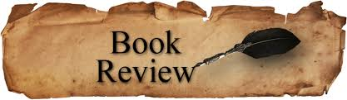
PLEASE CHECK OUR WEBSITE (www.pinebusharealibrary.org)
FOR A NEW MONTHLY BOOK REVIEW
BY OUR OWN
JEAN E. EUSTANCE!
********************************************************************
The Pine Bush Area Arts Council is calling all artists:
If you would like to exhibit your artwork in the Pine Bush Library,
Please contact Dick Reich
845 744-3781
********************************************************************

CHILDREN’S PROGRAMS





(See the calendar for the ongoing programs)

SUMMER READING PROGRAM
“A UNIVERSE OF STORIES”

TODDLER TIME (Ages 2 – 3) Mondays!
July 8 – 29th 
10:00 – 11:00 am
GOING INTO GRADES 1 - 3 Tuesdays!
July 9 – 30th
12:00 – 1:00 pm
PRESCHOOL (Ages 4 & 5) Wednesdays!
July 10 – 31st
10:00 – 11:00 am
GOING INTO GRADES 4 – 6 Fridays!
July 12 – Aug. 2nd
10:00 – 11:00 am
**************************************************

Make your own Tie Dye coaster
with Ms. Rebecca
Tuesday, July 9th at 11:00 am
at the Library Community Center
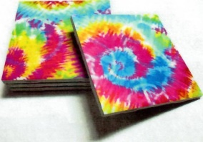
Call 845-744-4265 Ex. 2 to reserve your space

SPACE IS LIMITED!
*************************************************
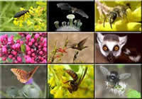
Special Children’s Program: “Making Space For Pollinators”
Monday, July 15th at 3:30 pm at the Community Center
A slide presentation of some of our local pollinators, by Jerry Schneider, creator of the award winning Butterfly Game. Audiences will learn how to build and maintain habitats that help our pollinator populations. After the slide show, children will create pollinator tee shirts. Children may purchase heavy cotton tee shirts for $4.00 or bring their own
Please call for more info and to reserve your spot: 744-4265 ext. 2
***********************************************
FREE CHILDRENS’ MIXED MEDIA WORKSHOPS WITH INSTRUCTOR/ARTIST “MEADOW”
AT THE PINE BUSH AREA LIBRARY COMMUNITY CENTER
IMAGINARY CLAY ANIMALS:
THURSDAY, JULY 11TH AT 1:00 PM
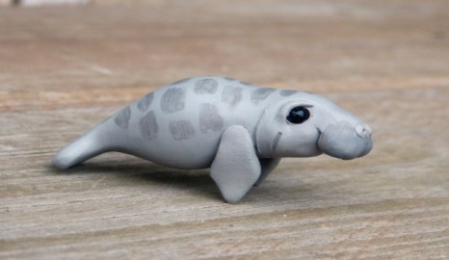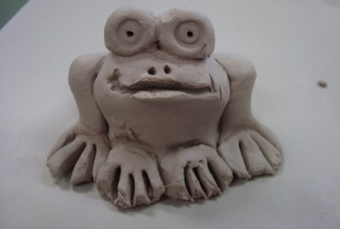
SOCK DOLLS: THURSDAY, JULY 25TH AT 1:00 PM
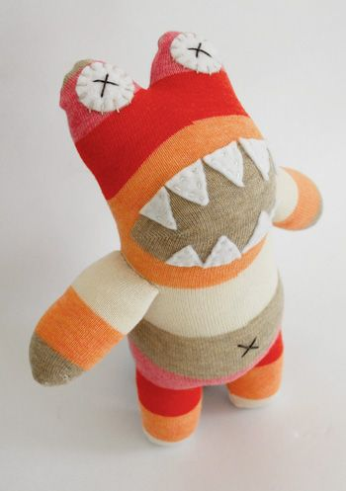__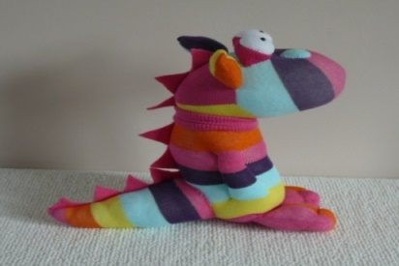
EACH WORKSHOP IS A GREAT WAY FOR KIDS TO
LET THEIR IMAGINATIONS RUN WILD!
NO PREVIOUS EXPERIENCE NEEDED! ALL SUPPLIES PROVIDED.
AGES 7 AND UP!
SIGN-UP REQUIRED AS SPACE AND SUPPLIES ARE LIMITED.
PLEASE CALL: 744-4265, EXT. 2
Notes:
PLEASE MAKE SURE YOU REGISTER IN ADVANCE FOR ANY OF OUR PROGRAMS YOU CAN DO THIS BY CALLING 845 744-4265
Children’s Programs – please register by calling Ext. 3
Adult Programs – please register by calling Ext. 2
PLEASE NOTE: RENEWAL OF CIRCULATION ITEMS MUST BE DONE
VIA THE WEBSITE OR IN PERSON. WE CANNOT ACCEPT VOICE MAIL MESSAGES TO RENEW YOUR ITEMS.
Used Books, DVDs’, audio tapes, puzzles, games, greeting cards and more are for sale in the Community Center. Don’t forget to check out the books in our “FREE LITTLE LIBRARY!” on the front porch….the books are FREE!!
Free - computer and electronic device help, resume writing help, and a Notary Pubic available every day in the Community Center.
Please note: A message on the Library’s phone will make you aware of the library openings and closings.
If you miss seeing any program flyers, go to Facebook and LIKE US
(tell us why the Pine Bush Library is so great!) or,
visit our webpage at www.pinebusharealibrary.org.
Check out your local papers, bulletin boards in town, stop into the library for your newsletter or provide us with your email address
to receive it via email.
Want to attend an event but do not have transportation?
Call Dial-A-Bus
TOWNS OF MONTGOMERY & CRAWFORD
Service provided Monday thru Friday. Hours of operation: 7:45am to 4:00pm. Reservations accepted Monday thru Friday 9:00am to 12:00pm. Regular Fare: $1.00 one-way • Children under 10 ride free when accompanied by an adult • Senior/disabled citizens and Medicare cardholders: 50¢ one-way. Please call 845-457-2622

