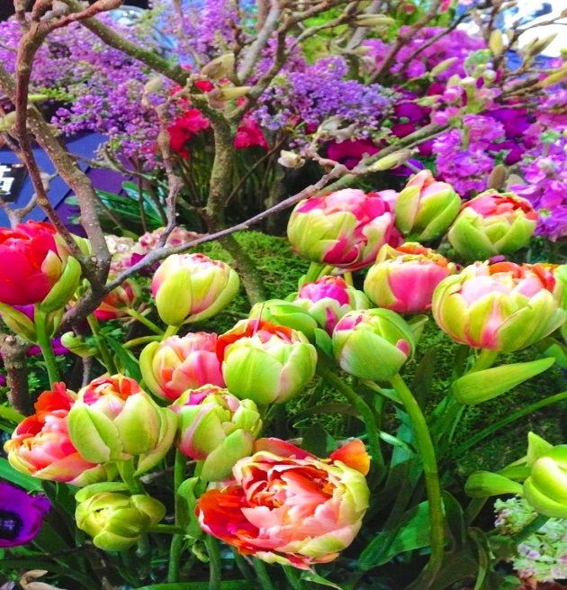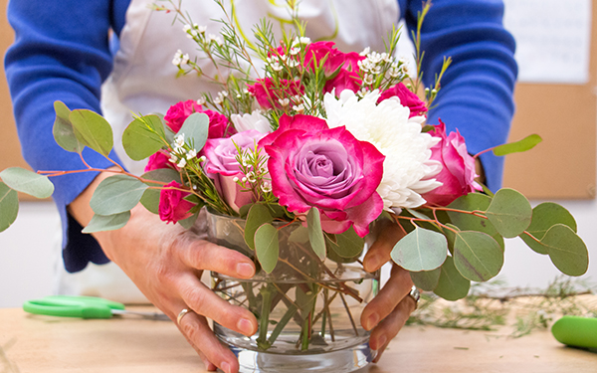
THE FLOWER ARRANGER’S GARDEN
THE CORNELL COOPERATIVE EXTENSION
MASTER GARDENERS
WILL TEACH YOU HOW TO PLANT AND NURTURE AND WHEN THE RIGHT TIME IS TO CUT FROM YOUR OWN GARDEN.
WITH LUSH BLOOMS IN HAND, YOU WILL DISCOVER HOW
TO CREATE STUNNING FLOWER ARRANGEMENTS FOR YOURSELF AND OTHERS. IF YOUR GARDEN HAS
ALREADY BEEN PLANTED, YOU CAN STILL COME AND LEARN
HOW TO ARRANGE LIKE AN EXPERT!

PINE BUSH AREA LIBRARY COMMUNITY CENTER
THURSDAY, AUGUST 8, 2019 – 1:00 PM

PLEASE CALL 744-4265, EXT. 2 TO SIGN UP.

