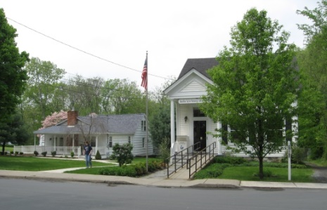
PINE BUSH AREA PUBLIC LIBRARY
NEWSLETTER – AUGUST 2019
‘WHERE THE COMMUNITY CONNECTS’
223-227 Maple Ave, PO Box 63, Pine Bush, NY 12566
845-744-3375, 845-744-5295, 845-744-4265
Fax 845-744-3377
Adult Services – Ext. 1
Community Center – Ext. 2
Children’s Services – Ext. 3
www.pinebusharealibrary.org

LIBRARY HOURS:
MON & WED 9-7
TUE & THUR 11-7
FRI 9-5 SAT 10-2

COMMUNITY CENTER:
MON - THURS 10 AM – 6 PM
FRI 10 AM-5PM
SAT 10 AM-2 PM

BOARD OF TRUSTEES – MEETING TIME - SECOND WEDNESDAY OF EACH MONTH 7:00 PM
IN THE LIBRARY COMMUNITY CENTER
BOARD OF TRUSTEES - Sharon Tarolli-President, Lisa Cannon-Vice President,
Gloria Winter-Secretary, Matthew Watkins –Treasurer
TRUSTEES - Peter Eriksen, Senta Curran, John Russell, Joseph Britto, Coby Low.
Director- Doris Callan

August is:

National Wellness Month

National Immunization Awareness Month
International Peace Month 

******************************************
You still have time to take part in this program to help the Library – it ends August 1st!

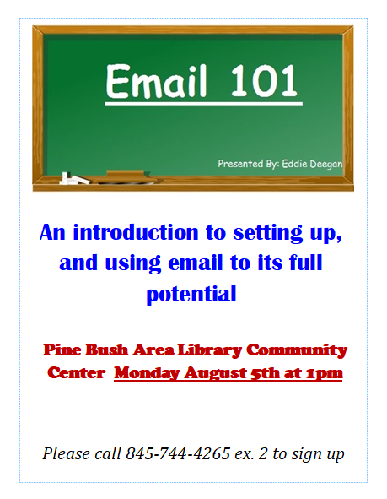

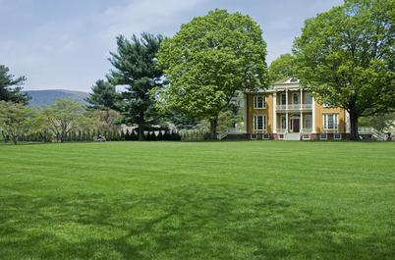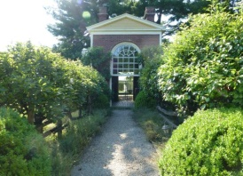
The Pine Bush Area Public Library now has a free pass to Boscobel!
Boscobel is a beautifully reassembled 1800’s neoclassical house in Garrison, NY. There are lush gardens, trails and magnificent Hudson Valley views. Boscobel is open for tours from April to December 2019.
Please come to the library to reserve the pass:
Pass is good for 4 people – one “MUST” be a Pine Bush Library card holder!
(845) 744-3375 ext. 1 to learn more info.
(You will be responsible for your own transportation to visit Boscobel House, Garrison, NY))


We now have a One-day Empire Pass for use by our Pine Bush Area Public Library cardholders that can be shared. It's a family-friendly alternative to the traditional window decal and not assigned to a specific vehicle. The Empire Pass is your key to all-season enjoyment at New York State Parks. It provides unlimited day-use for one carload to most facilities operated by New York State Parks and the State Dept. of Environmental Conservation including forests, beaches, trails and more. For more information or ticket availability, please call the Library at 845 744-3375 ext. 1
or check their website: http://www.dec.ny.gov
To reserve your pass, you must come into the Library, (This pass can be checked out for 3 days at a time only!)

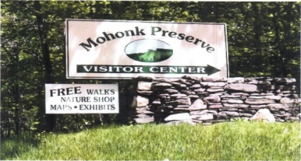

FREE MOHONK PRESERVE PASSES

(NOT THE MOHONK MOUNTAIN HOUSE!)

Available to Patrons of the Pine Bush Area Public Library

Ask For More Information at the Main Library 845 744-3375 ext. 1!
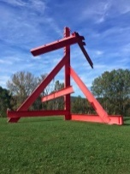 The Pine Bush Library now has 2 free passes to: 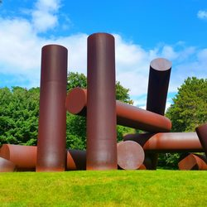
Storm King Art Center.
1 Museum Rd
New Windsor, NY 12553

Each pass is for 1 adult and 2 children under the age of 18.
There are many programs and activities for families and individuals of all ages!!
Please call the library at 845 744-3375 ext. 1 for ticket availability and more info. You must come into the library to reserve the tickets!
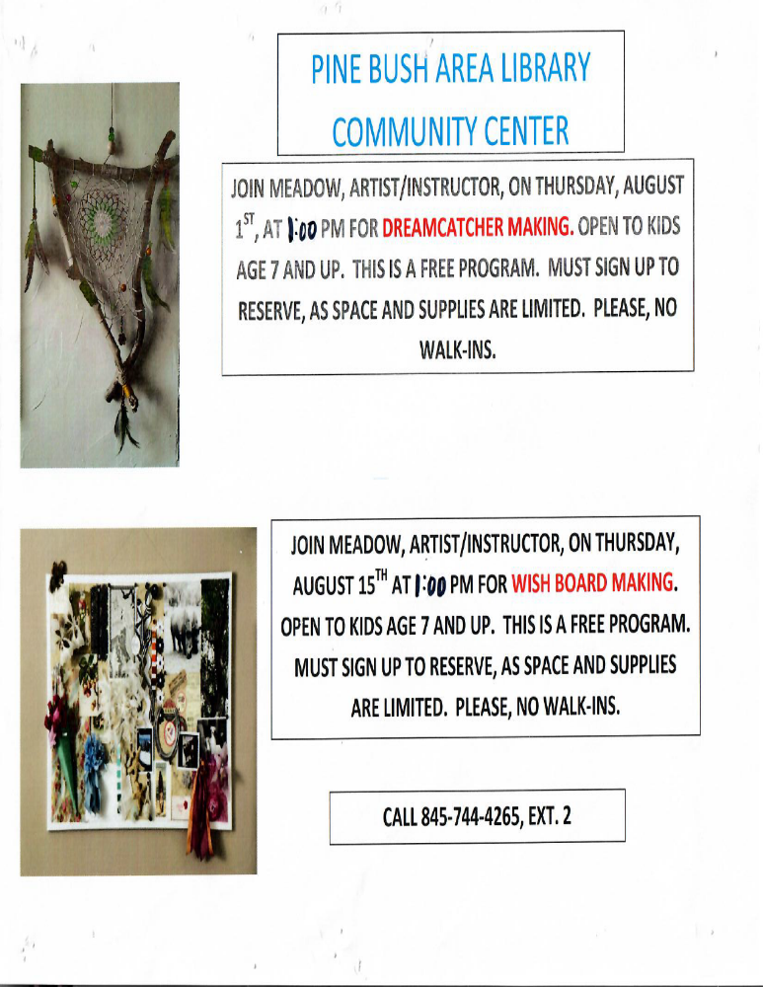
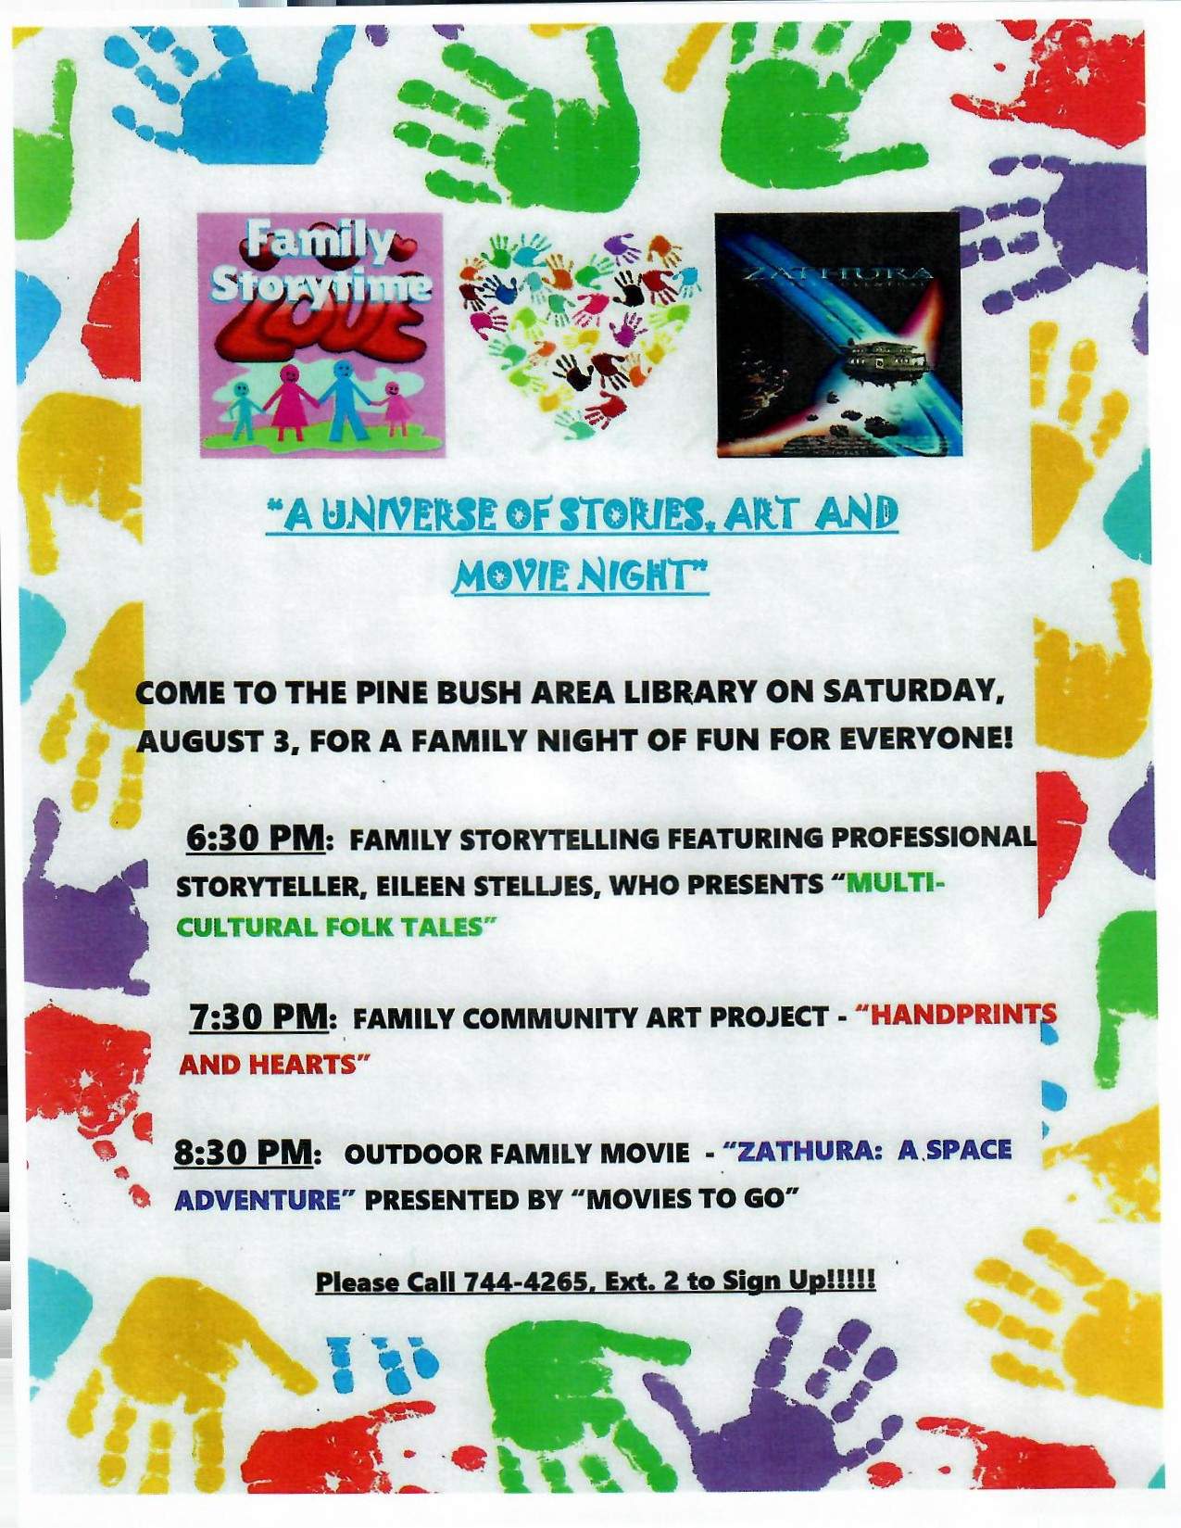


Ukulele Strumming: Tuesday, August 20th at 7:00 pm – 9:00 pm in
The Community Center!
No experience necessary, extra ukes on hand!
*********************************

AARP SMART DRIVER CLASS
GET A DISCOUNT ON YOUR AUTO INSURANCE AND/OR LOWER POINTS ON YOUR LICENSE!
SIGN UP NOW!!!
Wednesday, August 28th @ 9 AM TO 4:30 PM
PINE BUSH AREA LIBRARY COMMUNITY CENTER
$20 FOR AARP MEMBERS - $25 FOR
NON-AARP MEMBERS
(MUST REGISTER. CALL 744-4265 ext. 2)
Additional Smart Driver Classes coming up:
Wednesday, September 25th
Saturday, October 19th


PLEASE CHECK OUR WEBSITE (www.pinebusharealibrary.org)
FOR A NEW MONTHLY BOOK REVIEW
BY OUR OWN
JEAN E. EUSTANCE!

The Pine Bush Area Arts Council is calling all artists:
If you would like to exhibit your artwork in the Pine Bush Library,
Please contact Dick Reich
845 744-3781
********************************************************************

CHILDREN’S PROGRAMS



(See the calendar for the ongoing programs)

SUMMER READING PROGRAM
“A UNIVERSE OF STORIES”

Outdoor Movie nights for Children and their families!


The Pine Bush Area Arts Council is having 2 outdoor movie nights. August 9th at the Bullville Town Park
at approximately 8:30 pm, “Frozen” will be shown.
On August 16th at the Alice Court Park in Pine Bush, at approximately 8:30 pm, “Ice Age” will be shown.
Bring your blanket!!
**********************************
TODDLER TIME (ages 2 – 3 with parent/caregiver)
Mondays 10:00 – 11:00 am

DROP IN LEGO BUILDING (FAMILY FUN)
Tuesdays August 13th - 27th
12:00 - 2:00 pm

MUSIC TIME WITH MISS JILL (ALL AGES)
August 16th and 23rd
10:00 – 11:00 am
DROP IN CHESS/CHECKERS (FAMILY FUN)
Fridays August 16th – 30th
12:00 – 2:00 pm

Notes:
PLEASE MAKE SURE YOU REGISTER IN ADVANCE FOR ANY OF OUR PROGRAMS YOU CAN DO THIS BY CALLING 845 744-4265
Children’s Programs – please register by calling Ext. 3
Adult Programs – please register by calling Ext. 2
PLEASE NOTE: RENEWAL OF CIRCULATION ITEMS MUST BE DONE
VIA THE WEBSITE OR IN PERSON. WE CANNOT ACCEPT VOICE MAIL MESSAGES TO RENEW YOUR ITEMS.
Used Books, DVDs’, audio tapes, puzzles, games, greeting cards and more are for sale in the Community Center. Don’t forget to check out the books in our “FREE LITTLE LIBRARY!” on the front porch….the books are FREE!!
Free - computer and electronic device help, resume writing help, and a Notary Pubic available every day in the Community Center.
Please note: A message on the Library’s phone will make you aware of the library openings and closings.
If you miss seeing any program flyers, go to Facebook and LIKE US
(tell us why the Pine Bush Library is so great!) or,
visit our webpage at www.pinebusharealibrary.org.
Check out your local papers, bulletin boards in town, stop into the library for your newsletter or provide us with your email address
to receive it via email.
Want to attend an event but do not have transportation?
Call Dial-A-Bus
TOWNS OF MONTGOMERY & CRAWFORD
Service provided Monday thru Friday. Hours of operation: 7:45am to 4:00pm. Reservations accepted Monday thru Friday 9:00am to 12:00pm. Regular Fare: $1.00 one-way • Children under 10 ride free when accompanied by an adult • Senior/disabled citizens and Medicare cardholders: 50¢ one-way. Please call 845-457-2622

