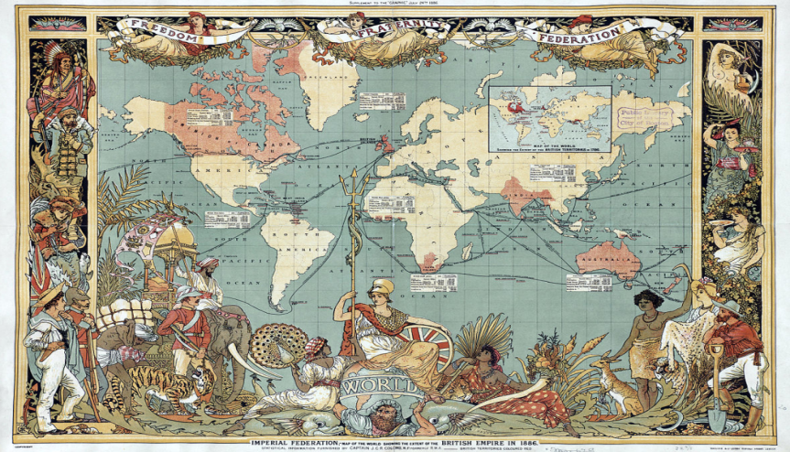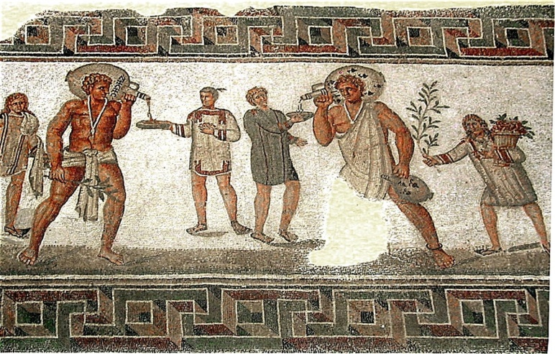
SLAVERY AND WORLD HISTORY
SLAVERY HAS EXISTED FOR NEARLY THE ENTIRE SPAN OF
HUMAN HISTORY. IT CAN BE TRACED AS FAR BACK AS 6,000 YEARS AGO.
PLEASE JOIN US FOR AN 8-WEEK LECTURE SERIES PRESENTED BY
JOSEPH BRITTO, ADJUNCT LECTURER SUNY/ORANGE AND PROFESSOR
EMERITUS SUNY/NEW PALTZ.

SLAVERY THROUGH THE CENTURIES WILL BE COVERED. 2 OR 3 SESSIONS WILL BE DEVOTED TO AFRICAN SLAVERY IN AMERICA.

LOCATION: PINE BUSH AREA LIBRARY
DATES: TUESDAYS JULY 9, 16, 23 & 30
TIME: 6:30 PM TO 8:00 PM
PLEASE JOIN US FOR AN 8-WEEK LECTURE SERIES PRESENTED BY
JOSEPH BRITTO, ADJUNCT LECTURER SUNY/ORANGE AND PROFESSOR
EMERITUS SUNY/NEW PALTZ.
"Where Slavery Died Hard", an historical documentary
showing evidence of enslaved African-Americans in Ulster
County, NY, around 1790, will be shown during the Tuesday,
July 16 session at 6:30 pm in the Community Center.
PLEASE REGISTER BY CALLING 744-4265, EXT. 2

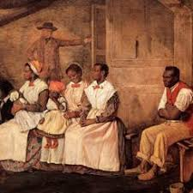
PLEASE REGISTER BY CALLING 744-4265, EXT. 2

