FREE CHILDRENS’ MIXED MEDIA WORKSHOPS WITH INSTRUCTOR/ARTIST “MEADOW”
AT THE PINE BUSH AREA LIBRARY COMMUNITY CENTER
_______________________________________________
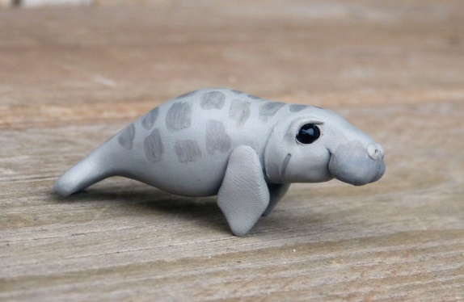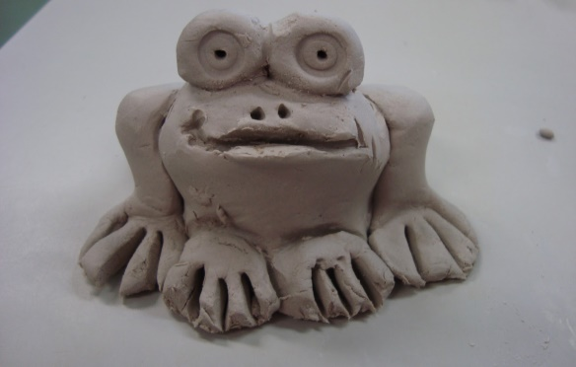
IMAGINARY CLAY ANIMALS:
THURSDAY, JULY 11TH AT 1:00 PM

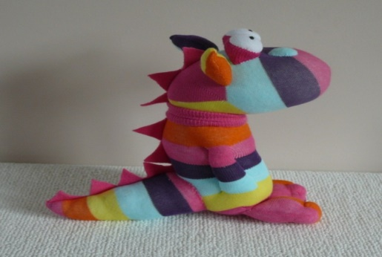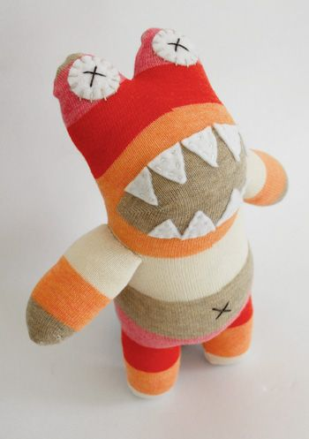
SOCK DOLLS: THURSDAY, JULY 25TH AT 1:00 PM
____________________________________________
EACH WORKSHOP IS A GREAT WAY FOR KIDS TO LET THEIR IMAGINATIONS RUN WILD! NO PREVIOUS EXPERIENCE NEEDED! ALL SUPPLIES PROVIDED. AGES 7 AND UP!
SIGN-UP REQUIRED AS SPACE AND SUPPLIES ARE LIMITED.
PLEASE CALL: 744-4265, EXT. 2

