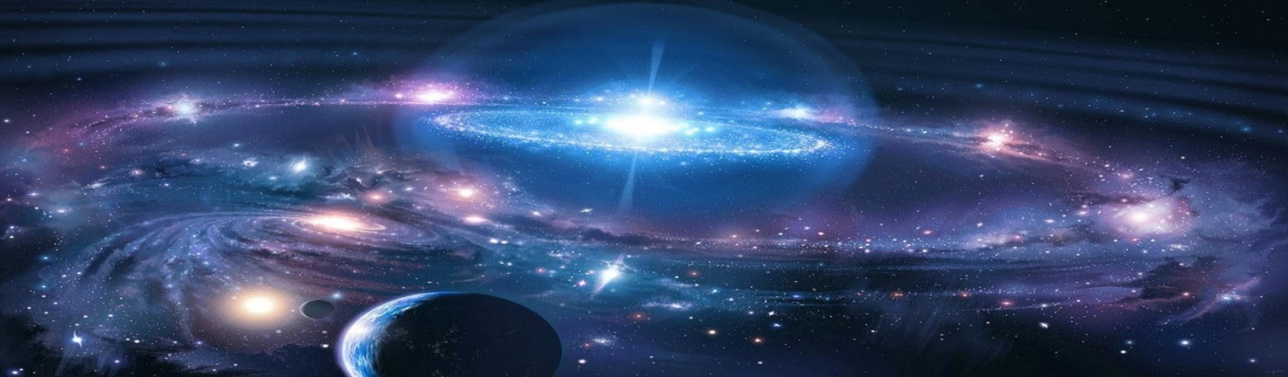
“A UNIVERSE OF STORIES”
THE ADULT READING PROGRAM THEME AT THE PINE BUSH AREA LIBRARY
CALLING ALL CREATIVE WRITERS!!

WE’RE LOOKING FOR ORIGINAL SHORT STORIES ABOUT LIFE ON ANOTHER PLANET, ON A DISTANT ASTEROID, ON A FAR OFF GALAXY, OR ON ANY OTHER WORLD BEYOND OUR OWN SOLAR SYSTEM
THAT EXISTS IN THE WRITER’S IMAGINATION. WE WANT YOU TO DEFINE YOUR CHARACTERS,
PROVIDE NAMES, EXPLAIN LIFE FORMS, ATMOSPHERE, COLORS, LANGUAGE, INTELLIGENCE, FOOD, ACTIVITIES, MODE OF TRAVEL, LEALDERSHIP, ETC. ….. ALL THE THINGS THAT EXIST ON YOU
IMAGINARY WORLD……..AND, OF COURSE, EMBELLISH WHEREVER AND WHENEVER POSSIBLE!

RULES:
- WRITE YOUR NAME AND CONTACT INFORMATION ON A SEPARATE PIECE OF PAPER AND
ATTACH IT TO YOUR FINISHED STORY
- SUBMIT YOUR STORY IN A SEALED ENVELOPE TO KAREN FOX AT THE PINE BUSH AREA LIBRARY
- STORIES MUST BE TYPE WRITTEN OR LEGIBLY HAND WRITTEN, DOUBLE SPACED, FRONT AND BACK, ON NO MORE THAN THREE 8 ”X 10” WHITE PAGES
- ONLY ADULTS AGE 18 AND OLDER ARE ELIGIBLE TO SUBMIT ENTRIES
- DEADLINE FOR SUBMISSION IS MONDAY, JULY 22, 2019 BEFORE 7:00 PM AT THE PINE BUSH
MAIN LIBRARY BUILDING

STORIES WILL BE REVIEWED BY A SELECT GROUP OF JUDGES WHO WILL NOT KNOW THE NAME OF THE WRITERS OF THE SHORT STORIES. THIS IS TO ASSURE THAT THE BEST STORY CHOSEN IS BASED ON MERIT. ONLY ONE STORY AND WRITER WILL BE SELECTED FOR A FIRST PLACE PRIZE, YET TO BE DETERMINED. AFTER THE JUDGING, A BOOKLET ENTITLED, “A UNIVERSE OF STORIES” CONTAINING ALL SUBMITTED STORIES WITH THE NAME OF THE WRITER WILL BE AVAILABLE AT THE LIBRARY FOR EVERYONE’S READING ENJOYMENT.
THIS IS A FUN PROJECT …NOT A CREATIVE WRITING CLASS! NO GRADES AND NO CRITIQUES…. JUST A PROJECT TO SEE WHO CAN IMAGINE THE MOST UNIQUE
“OTHER” WORLD IN THE UNIVERSE!

