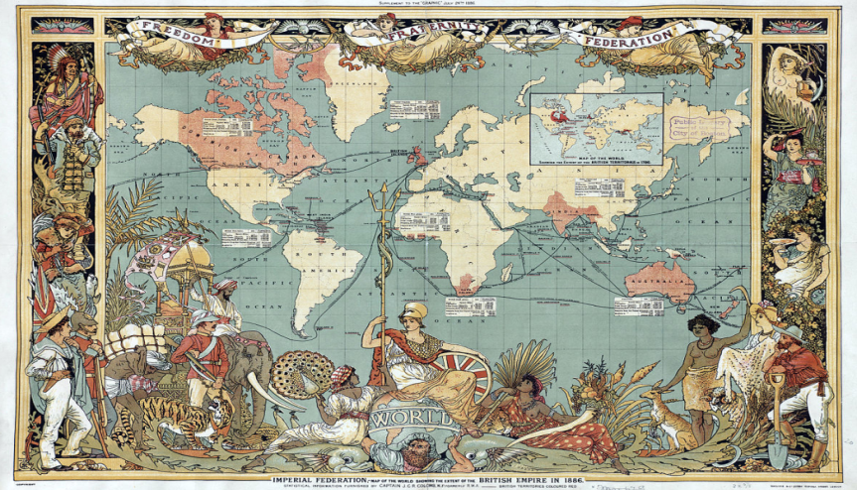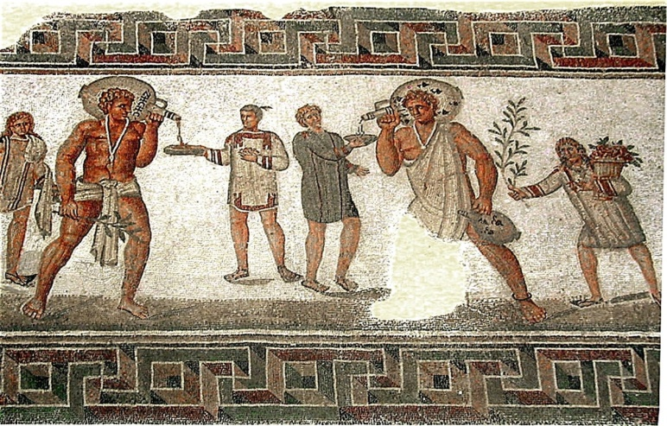
SLAVERY AND WORLD HISTORY
SLAVERY HAS EXISTED FOR NEARLY THE ENTIRE SPAN OF
HUMAN HISTORY. IT CAN BE TRACED AS FAR BACK AS 6,000 YEARS AGO.
PLEASE JOIN US FOR AN 8-WEEK LECTURE SERIES PRESENTED BY
JOSEPH BRITTO, ADJUNCT LECTURER SUNY/ORANGE AND PROFESSOR
EMERITUS SUNY/NEW PALTZ.

SLAVERY THROUGH THE CENTURIES WILL BE COVERED. 2 OR 3 SESSIONS WILL BE DEVOTED TO AFRICAN SLAVERY IN AMERICA.

LOCATION: PINE BUSH AREA LIBRARY
DATES: TUESDAYS STARTING MAY 28, JUNE 4, 11, 18,
JULY 9, 16, 23 & 30
TIME: 6:30 PM TO 8:00 PM

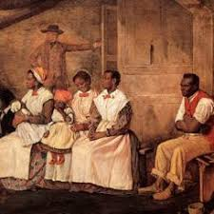
PLEASE REGISTER BY CALLING 744-4265, EXT. 2

