WALKING TOUR OF HISTORIC HOMES IN PINE BUSH
SATURDAY, JUNE 1, 2019
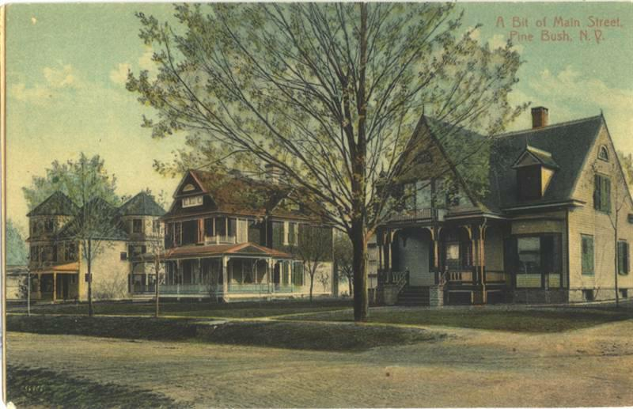
PRESENTATION BY JOANNE KEILLOR, TOWN OF CRAWFORD HISTORIAN
AT THE PINE BUSH AREA PUBLIC LIBRARY – 11:00 AM
223 MAPLE AVENUE

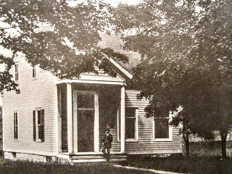
AFTER THE PRESENTATION, PICK UP YOUR HISTORIC HOME SELF-GUIDED
TOUR MAP TO START YOUR JOURNEY AROUND PINE BUSH

