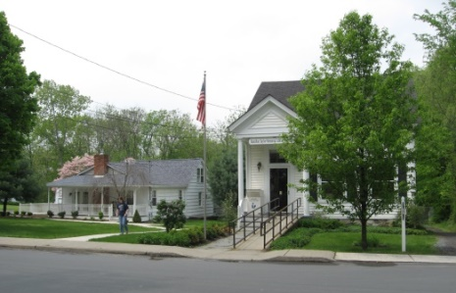
PINE BUSH AREA PUBLIC LIBRARY
NEWSLETTER – May 2019
‘WHERE THE COMMUNITY CONNECTS’
223-227 Maple Ave, PO Box 63, Pine Bush, NY 12566
845-744-3375 Fax 845-744-3377 Director 744-4265
Adult Services – Ext. 1
Community Center – Ext. 2
Children’s Services – Ext. 3
www.pinebusharealibrary.org

LIBRARY HOURS:
MON & WED 9-7
TUE & THUR 11-7
FRI 9-5 SAT 10-2

COMMUNITY CENTER:
MON - THURS 10 AM – 6 PM
FRI 10 AM-5PM
SAT 10 AM-2 PM

BOARD OF TRUSTEES – MEETING TIME - SECOND WEDNESDAY OF EACH MONTH 7:00 PM
IN THE LIBRARY COMMUNITY CENTER
BOARD OF TRUSTEES - Sharon Tarolli-President, Lisa Cannon-Vice President,
Gloria Winter-Secretary, Matthew Watkins –Treasurer
TRUSTEES - Peter Eriksen, Senta Curran, John Russell, Joseph Britto, Coby Low.
Director- Doris Callan

May is:
“GET CAUGHT READING” MONTH
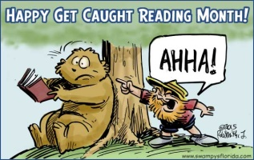
May 5th – Cinco de Mayo
May 12th – Mother’s Day
May 27th – Memorial Day
(Library is closed May 25th thru May 27th
to commemorate Memorial Day)
**********************************************************
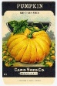Once again in celebration of NATIONAL CHILDREN'S BOOK WEEK, 
the COMMUNITY GARDEN CLUB OF PINE BUSH has donated seeds, soil and peat pots with the book, "THE SAVED SEED" for the TAKE HOME GARDEN BACKPACKS available for check-out in the
Children's Section of the library. Two stocked backpacks are available for circulation and patrons can check the backpacks out with the book and all supplies to plant your own pumpkins,
including a seed chart to document their growth.

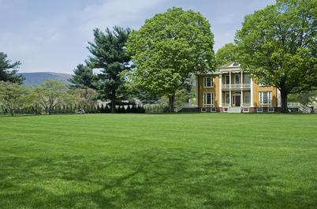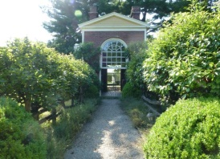
The Pine Bush Area Public Library now has a free pass to Boscobel!
Boscobel is a beautifully reassembled 1800’s neoclassical house in Garrison, NY. There are lush gardens, trails and magnificent Hudson Valley views. Boscobel is open for tours from April to December 2019.
Please come the library to reserve the pass:
(845) 744-4265 ext. 1 to learn more info.
YOU MUST BE A PINE BUSH AREA PUBLIC LIBRARY CARD HOLDER!
(You will be responsible for your own transportation to visit Boscobel House)
************************************************************************************************************


We now have a One-day Empire Pass for use by our Pine Bush Area Public Library cardholders that can be shared. It's a family-friendly alternative to the traditional window decal and not assigned to a specific vehicle. The Empire Pass is your key to all-season enjoyment at New York State Parks. It provides unlimited day-use for one carload to most facilities operated by New York State Parks and the State Dept. of Environmental Conservation including forests, beaches, trails and more. For more information, please call the Library at 845 744-3375 ext. 1. or check their website: http://www.dec.ny.gov
To reserve your pass, you must come into the Library; no phone reservations will be taken.
(This pass can be checked out for 3 days at a time only!)

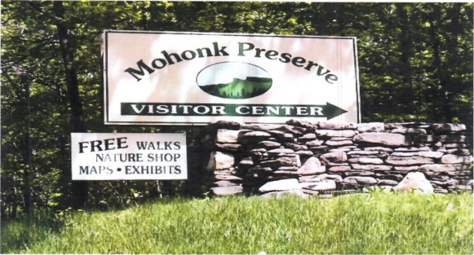

FREE MOHONK PRESERVE PASSES

Available to Patrons of the Pine Bush Area Public Library

Ask For More Information at the Main Library!

Ukulele Strumming: Tuesday, May 14th at 7:00 pm – 9:00 pm 
No experience necessary, extra ukes on hand!


FREE INDIVIDUAL CAREER HELP WITH
A PROFESSIONAL CAREER COUNSELOR AT THE
PINE BUSH AREA LIBRARY COMMUNITY CENTER
THURSDAY, MAY 16TH
GET ONE-ON-ONE TIPS ON RESUME WRITING, HOW TO PUT YOUR BEST FOOT FORWARD DURING THE INTERVIEW AND OTHER HELPFUL INFORMATION TO ACHIEVE SUCCESS! (A $175 VALUE…. FREE TO YOU.)
MAKE YOUR APPOINTMENT NOW! APPOINTMENTS
START AT 5 PM.
CALL 744-4265, EXT. 2.


DIVIDING PERENNIALS
DIVIDING PERENNIAL PLANTS KEEPS THE GARDEN TIDY AND HEALTHY AND ENCOURAGES THEM
TO BLOOM AND FLOURISH ELSEWHERE.
LEARN THE BEST TECHNIQUES FROM THE CORNELL COOPERATIVE EXTENSION MASTER GARDENERS
PINE BUSH AREA LIBRARY COMMUNITY CENTER
FRIDAY, MAY 17, 2019 AT 11:30 AM
Register By Calling 744-4265, Ext. 2


SATURDAY MAH JONG
JOIN US FOR “ONCE-A-MONTH” SATURDAY, May 18th
MAH JONG AT THE
PINE BUSH AREA LIBRARY COMMUNTY CENTER SATURDAY - 10 AM TO 12 PM
*BRING YOUR OWN MAH JONG SET OR USE ONE OF OURS!
*INSTRUCTION AVAILABLE FOR BEGINNERS*
Please Register. Call 744-4265, Ext. 2.

YARD SALE YARD SALE YARD SALE
Our annual yard sale and the Town-wide yard sale is on Saturday, May 25th starting 9:00 am. Items in good, clean, usable condition will be accepted as donations starting
Monday, May 20th.
Space available along Maple Avenue for your own sales - $20.00 per spot.
To reserve your spot, please call 845 744-4265 ext. 2
Checks must be brought to the Community Room prior to the sale!
****************************************
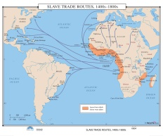 Slavery and World History
Joseph Britto, Adjunct Lecturer SUNY/Orange & Professor Emeritus SUNY/New Paltz, begins an 8 week history series starting on Tuesday, May 28th at 6:30 PM.
The series continues on June 4th, 11th, 18th, July 9th, 16th, 23rd and 30th.
Please contact the Library (845 744-4265 ext. 2) to reserve your spot!



AARP SMART DRIVER CLASS
GET A DISCOUNT ON YOUR AUTO INSURANCE AND/OR LOWER POINTS ON YOUR LICENSE!
SIGN UP NOW!!!
Wednesday, May 29th @ 9 AM TO 4:30 PM
PINE BUSH AREA LIBRARY COMMUNITY CENTER
$20 FOR AARP MEMBERS - $25 FOR
NON-AARP MEMBERS
(MUST REGISTER. CALL 744-4265 ext. 2)
Additional Smart Driver Classes coming up:
Saturday, June 29th
Wednesday, August 28th
Wednesday, September 25th
Saturday, October 19th


PLEASE CHECK OUR WEBSITE (www.pinebusharealibrary.org)
FOR A NEW MONTHLY BOOK REVIEW
BY OUR OWN
JEAN E. EUSTANCE!

ART ON THE LIBRARY WALLS
Exhibiting Artist: Sylvia Houston
Sylvia Houston began her watercolor journey in the summer of 2010 when she retired after thirty years of teaching elementary school both in PA. and NY. She started painting at the Desmond Center OF Mt. St. Mary’s College in Newburgh, N.Y. with instructor, Len DeVirgilio.
She now paints regularly in classes at The Wallkill River School in Montgomery, NY. with the gifted artist/teacher Lana Privitera. Sylvia has taken many workshops in Hummelstown, PA. sponsored by the Pennsylvania Watercolor Society and she has also participated in numerous workshops at Riverside Art Workshops in Newburgh, NY. She has travelled to Las Vegas, NV, San Antonio, TX. and Boone, NC to study with artists whose work she admires.
Her painting style, which includes starting with exact drawings, using multiple layers of color and paying attention to details, has been strongly influenced by years of realistic painting with Lana Privitera. Sylvia’s favorite subjects are landscapes, animals and still life with special focus on achieving textural effects. She appreciates the use of vivid color and being surrounded by the beauty of the Hudson Valley.
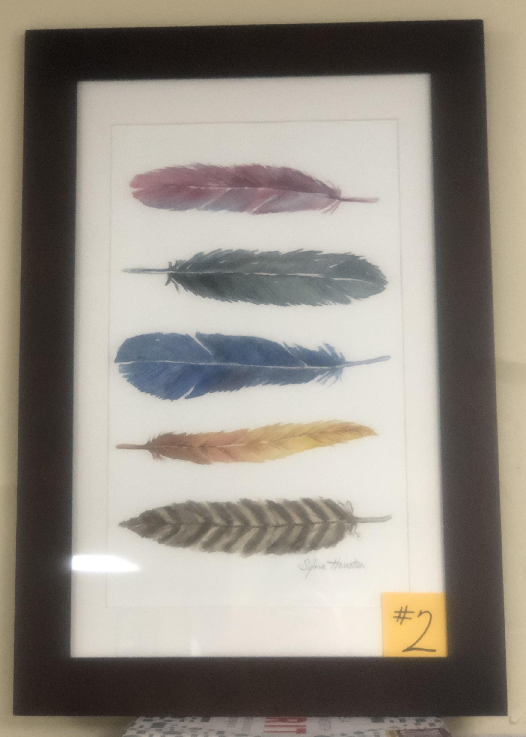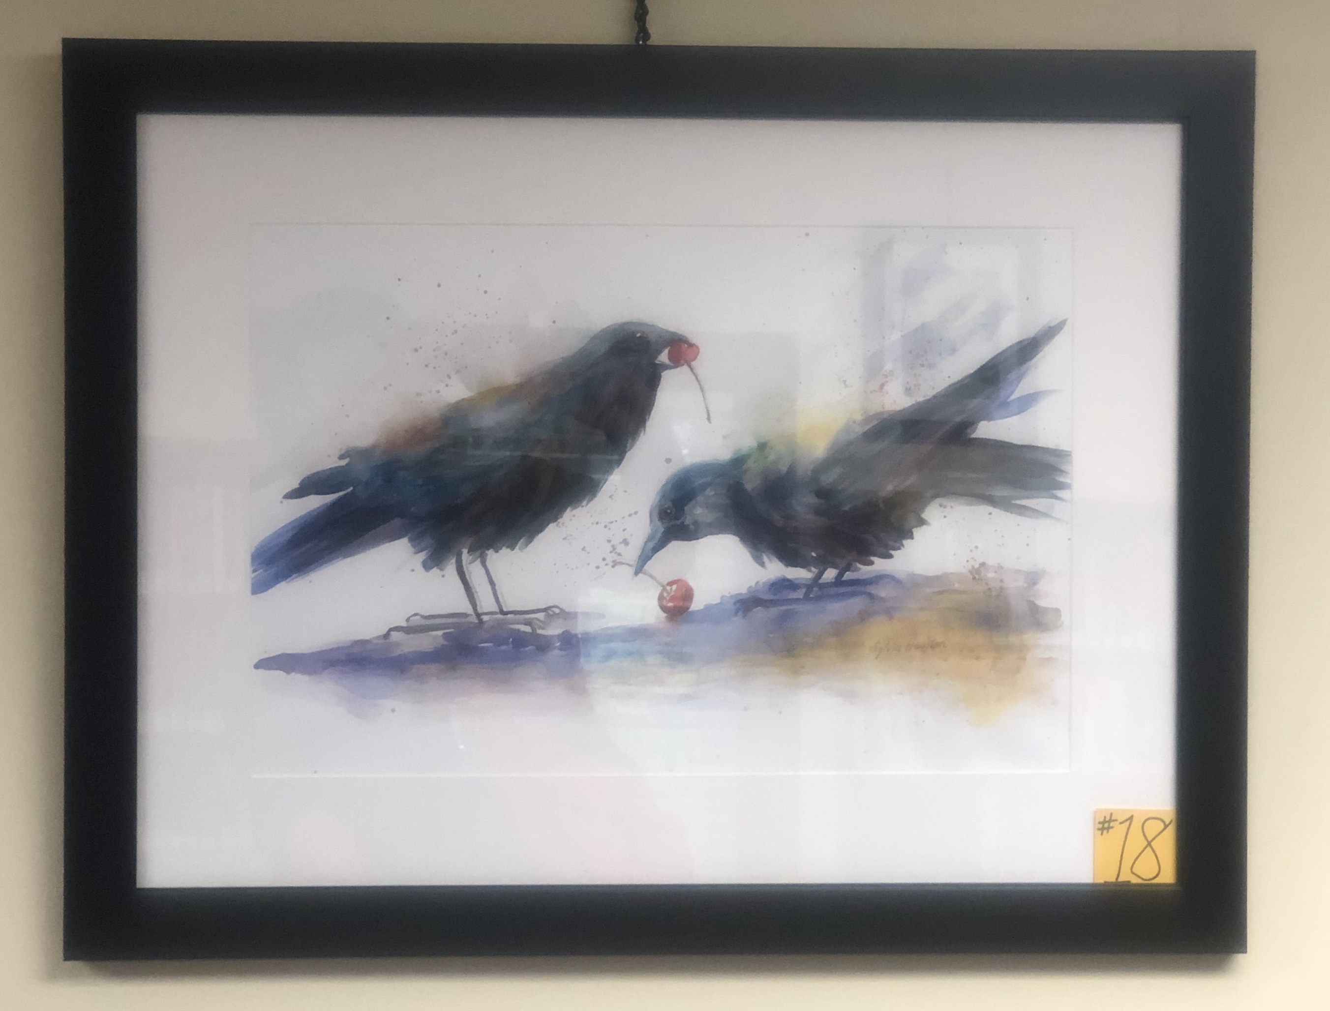

The Pine Bush Area Arts Council is calling all artists:
If you would like to exhibit your artwork in the Pine Bush Library,
Please contact Dick Reich
845 744-3781
****************************************************************************



The Friends of the Library thanked all the Library Board members and volunteers with a tea on Saturday, April 27th. Volunteers include our cake sale bakers and library volunteers who help with yard sales, story times, filing, sorting and cleaning. 56 volunteers attended. All enjoyed delicious treats and conversation.
The Library thanks the Friends for the following contributions and more:
Blinds for the library
Card tables and chairs
Passes to Boscobel
Mortgage payments ($1,000.00 each year)
Gardening programs – 4 each year
Dehumidifier for the Community Room
Plants & Plaques in memory of Marge Redder and Margaret Tremper
Donations to memorials, scholarships & library advocacy
2019 portable phone installation in the Community Room
***********************************************************************

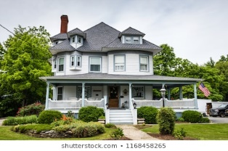
On Saturday, June 1st, the Pine Bush Chamber of Commerce is holding a
“Mind, Body & Spirit” event. The Pine Bush Area Public Library is participating in this event by hosting an Historical Home Walk in Pine Bush with Joanne Keillor, Town of Crawford Historian, narrating a video presentation at the Library at 11:00 am.
Walking Tour maps will be available at the Library
after the presentation for the self-guided tour.
****************************************************************

CHILDREN’S PROGRAMS


Screen Free Week After School Activities
May Day Plant Flower Seeds!
Wednesday, May 1 - 3:00 – 5:00 pm
Lego Building
Thursday, May 2 - 3:00 – 5:00 pm
Chess/Checkers
Friday, May 3 - 3:00 – 5:00 pm

(See the calendar for the ongoing programs)
TODDLER TIME (18-36 months) Mondays, May 6 – 20 
10:00 – 11:00 am
PRESCHOOL STORYTIME (3-5 year olds) Wednesdays, May 1, 8, 22 & 29 (no 15)
1:00 – 2:00 pm
CHESS/CHECKERS (Grades3 and up) Fridays, May 3 – 31
3:00 – 4:30 pm
MUSIC TIME WITH MISS JILL (all ages)
Sing, dance and be silly! Instruments, too!
Fridays, May 10 & 17 ONLY!!
10:00 – 11:00 am
LEGO BUILDING (all ages) 
Thursday, May 2
3:00 – 5:00 pm
Notes:
PLEASE MAKE SURE YOU REGISTER IN ADVANCE FOR ANY OF OUR PROGRAMS – YOU CAN DO THIS BY CALLING 845 744-4265
Children’s Programs – please register by calling Ext. 3
Adult Programs – please register by calling Ext. 2

PLEASE NOTE: RENEWAL OF CIRCULATION ITEMS MUST BE DONE VIA THE WEBSITE
OR IN PERSON. WE CANNOT ACCEPT VOICE MAIL MESSAGES TO RENEW YOUR ITEMS.

Used Books, DVDs’, audio tapes, puzzles, games, greeting cards and more are for sale in the Community Center. Don’t forget to check out the books on the front porch. “Reading Garden” books are FREE!!
Free - computer and electronic device help, resume writing help, and a Notary Pubic available every day in the Community Center.
Please note: A message on the Library’s phone will make you aware of library openings and closings for inclement weather.
*****************************************************************************
If you miss seeing any program flyers, go to Facebook and LIKE US (tell us why the Pine Bush Library is so great!) or, visit our webpage, www.pinebusharealibrary.org. Check out your local papers, bulletin boards in town, stop into the library for your newsletter or provide us with your email address to receive it via email.
Want to attend an event but do not have transportation?
Call Dial-A-Bus
TOWNS OF MONTGOMERY & CRAWFORD
Service provided Monday thru Friday. Hours of operation: 7:45am to 4:00pm. Reservations accepted Monday thru Friday 9:00am to 12:00pm. Regular Fare: $1.00 one-way • Children under 10 ride free when accompanied by an adult • Senior/disabled citizens and Medicare cardholders: 50¢ one-way. Please call 845-457-2622

