May 2019

Sun | Mon | Tue | Wed | Thu | Fri | Sat
 |  |  | 1 | 2 | 3 | 4
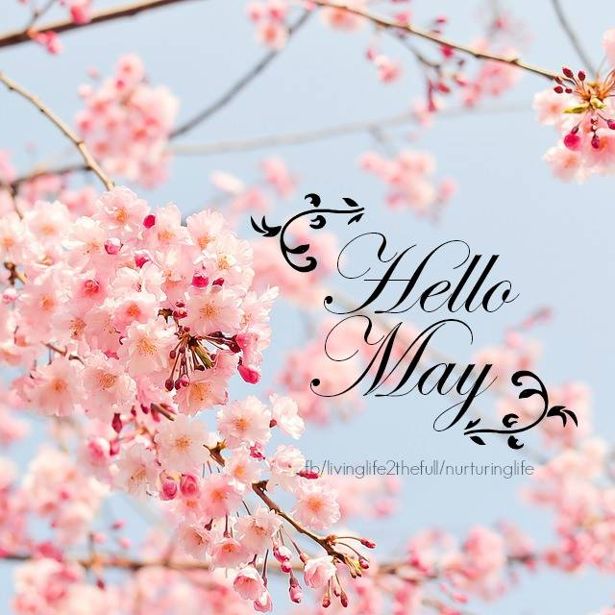 |  |  | Between the Covers 11:00 AM(CC)  Preschool story time  1:00 – 2:00 pm (ML)  Plant flower seeds 3:00 – 5:00 pm (ML) | Bridge – 10:00 am(CC)  Lego Building 3:00 – 5:00 pm (ML) | Chess/Checkers  3:00 – 4:30 pm (ML) | Next Chapter – 8:30am (CC)  Book Sales 10:00 am – 2:00 pm
5 | 6 | 7 | 8 | 9 | 10 | 11
Cinco de Mayo!  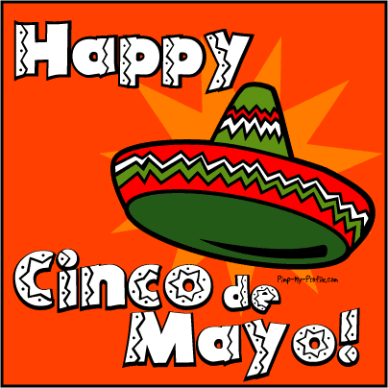 | Toddler Time 10:00 – 11:00 am (ML)  Pinochle – 10:00 am (CC) | Scrabble – 10:00 am (CC)  Chess – 1:00 pm (CC) | Preschool story time  1:00 – 2:00 pm (ML)  Library Board Mtg. 7:00 pm (CC) | Bridge – 10:00 am(CC)  Circle of Friends 1:00 pm (CC)  Friends 2:00 PM (CC) | Music w/Miss Jill  10:00 – 11:00 am (ML)  Chess/Checkers  3:00 – 4:30 pm (ML) | Next Chapter – 8:30am (CC)  Book Sales 10:00 am – 2:00 pm
12 | 13 | 14 | 15 | 16 | 17 | 18
Mother’s Day!   | Toddler Time 10:00 – 11:00 am (ML)  Pinochle – 10:00 am (CC) | Scrabble – 10:00 am (CC)  Happy Bookers 1:00 pm (CC)  Chess – 1:00 pm (CC)  Ukulele 7:00 (CC) | Bag Ladies 10:00 am (CC)  Bookies 6:00 PM) | Bridge – 10:00 am(CC)  Career Counselling Appts. Start 5:00 pm (CC) | Music w/Miss Jill  10:00 – 11:00 am (ML)  Gardening - Perennials 11:30 am (CC)  Chess/Checkers  3:00 – 4:30 pm (ML) | Next Chapter – 8:30am (CC)  Book Sales 10:00 am – 2:00 pm  Mah Jong 10:00 am (CC)
19 | 20 | 21 | 22 | 23 | 24 | 25
 | Toddler Time 10:00 – 11:00 am (ML)  Pinochle – 10:00 am (CC) | Scrabble – 10:00 am (CC)  Chess – 1:00 pm (CC) | Preschool story time  1:00 – 2:00 pm (ML) | Bridge – 10:00 am(CC)  Page Turners 1:00 PM  (CC) | Chess/Checkers  3:00 – 4:30 pm (ML) | LIBRARY IS CLOSED!  YARD SALE!!  Memorial Day!  
26 | 27 | 28 | 29 | 30 | 31
 | LIBRARY IS CLOSED!  Memorial Day! | Scrabble – 10:00 am (CC)  Chess – 1:00 pm (CC)  Slavery & World History  6:30 pm (CC) | AARP Smart Driver 9:00 – 4:30 (CC)  Preschool story time  1:00 – 2:00 pm (ML) | Bridge – 10:00 am(CC) | Chess/Checkers  3:00 – 4:30 pm (ML) | 