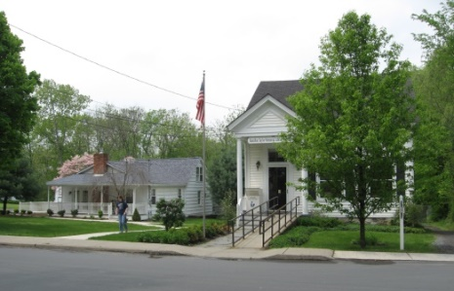
PINE BUSH AREA PUBLIC LIBRARY
NEWSLETTER – June 2019
‘WHERE THE COMMUNITY CONNECTS’
223-227 Maple Ave, PO Box 63, Pine Bush, NY 12566
845-744-3375, 845-744-5295, 845-744-4265
Fax 845-744-3377
Adult Services – Ext. 1
Community Center – Ext. 2
Children’s Services – Ext. 3
www.pinebusharealibrary.org

LIBRARY HOURS:
MON & WED 9-7
TUE & THUR 11-7
FRI 9-5 SAT 10-2

COMMUNITY CENTER:
MON - THURS 10 AM – 6 PM
FRI 10 AM-5PM
SAT 10 AM-2 PM

BOARD OF TRUSTEES – MEETING TIME - SECOND WEDNESDAY OF EACH MONTH 7:00 PM
IN THE LIBRARY COMMUNITY CENTER
BOARD OF TRUSTEES - Sharon Tarolli-President, Lisa Cannon-Vice President,
Gloria Winter-Secretary, Matthew Watkins –Treasurer
TRUSTEES - Peter Eriksen, Senta Curran, John Russell, Joseph Britto, Coby Low.
Director- Doris Callan
June is:

• 6 - D Day, WWII 
• 14 - Flag Day 

• 16 - Father's Day 
• 19 - Juneteenth Day 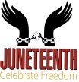
(Juneteenth day celebrates and symbolizes the end of slavery in the United States. President Abraham Lincoln issued the Emancipation Proclamation on September 22, 1862. It was not until June 19, 1865 that all slaves were finally freed.
That concluding event was when General Gordon Granger rode into Galveston, Texas with his troops and
issued Order Number 3 which finally freed the last of the slaves.
The formal end of slavery was marked by the passing of the 13th amendment of the constitution.)
• 21 - Summer Solstice - longest day of the year! 
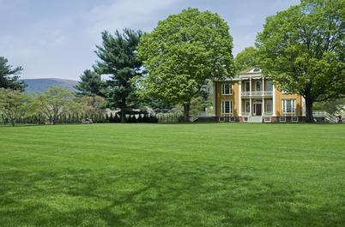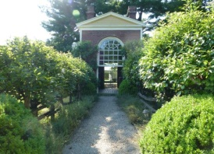
The Pine Bush Area Public Library now has a free pass to Boscobel!
Boscobel is a beautifully reassembled 1800’s neoclassical house in Garrison, NY. There are lush gardens, trails and magnificent Hudson Valley views. Boscobel is open for tours from April to December 2019.
Please come to the library to reserve the pass:
(845) 744-4265 ext. 1 to learn more info.
YOU MUST BE A PINE BUSH AREA PUBLIC LIBRARY CARD HOLDER!
(You will be responsible for your own transportation to visit Boscobel House, Garrison, NY))
************************************************************************************************************


We now have a One-day Empire Pass for use by our Pine Bush Area Public Library cardholders that can be shared. It's a family-friendly alternative to the traditional window decal and not assigned to a specific vehicle. The Empire Pass is your key to all-season enjoyment at New York State Parks. It provides unlimited day-use for one carload to most facilities operated by New York State Parks and the State Dept. of Environmental Conservation including forests, beaches, trails and more. For more information or ticket availability, please call the Library at 845 744-3375 ext. 1
or check their website: http://www.dec.ny.gov
To reserve your pass, you must come into the Library, (This pass can be checked out for 3 days at a time only!)

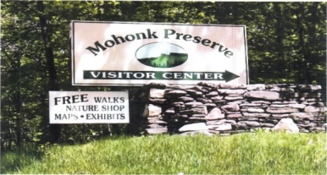

FREE MOHONK PRESERVE PASSES

(NOT THE MOHONK MOUNTAIN HOUSE!)

Available to Patrons of the Pine Bush Area Public Library

Ask For More Information at the Main Library!

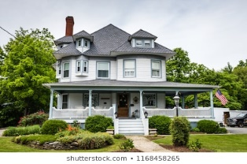
On Saturday, June 1st,
The Pine Bush Chamber of Commerce is holding an
“Mind, Body & Spirit” event. The Pine Bush Area Public Library is participating in this event by hosting an Historical Homes Walk in Pine Bush with Joanne Keillor, Town of Crawford Historian, narrating a video presentation at the Library at 11:00 am.
Self-guided walking tour maps will be available at the Library
after the presentation.

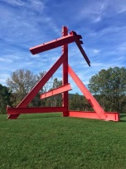 The Pine Bush Library now has 2 free passes to:
Storm King Art Center.
1 Museum Rd
New Windsor, NY 12553

Each pass is for 1 adult and 2 children under the age of 18.
There are many programs and activities for families and individuals of all ages!!
Please call the library at 845 744-3375 ext. 1 for ticket availability and more info. You must come into the library to reserve the tickets!

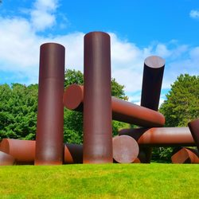
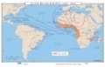
Slavery and World History
Joseph Britto, Adjunct Lecturer SUNY/Orange & Professor Emeritus SUNY/New Paltz, continues the
8 week history series on
Tuesday,
June 4th, 11th, 18th, July 9th, 16th, 23rd and 30th
@ 6:30 pm
Please contact the Library (845 744-4265 ext. 2) to reserve your spot
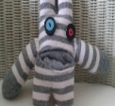The Pine Bush Area Arts Council is offering a “Sock Monster” craft project with Meadow, 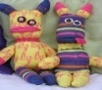
our multi-media artist. This class will be held at 3:30 pm on Thursday, June 6th in the Community Center. All students aged 7 and up are welcome to attend. Materials will be supplied by the PBAAC.
Bring your imaginations!!
To reserve your spot, please call 845 744-4265 ext. 2.

SATURDAY MAH JONG
JOIN US FOR “ONCE-A-MONTH” SATURDAY,
MAH JONG AT THE
PINE BUSH AREA LIBRARY COMMUNTY CENTER SATURDAY, June 15th - 10 AM TO 12 PM
*BRING YOUR OWN MAH JONG SET OR USE ONE OF OURS!
*INSTRUCTION AVAILABLE FOR BEGINNERS*
Please Register. Call 744-4265, Ext. 2.
Ukulele Strumming: Tuesday, June 18th at 7:00 pm – 9:00 pm 
No experience necessary, extra ukes on hand!

COMMUNITY ROCK PAINTING
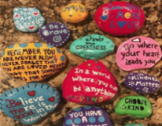
COME TO THE PINE BUSH AREA LIBRARY COMMUNITY CENTER ON
THURSDAY, JUNE 20TH AT 1:00 PM.
JOIN US FOR AN AFTERNOON OF CREATIVE AND
COLORFUL INSPIRATIONAL ROCK PAINTING.
ONCE FINISHED, OUR WHIMSICAL ROCKS WILL BE
PLACED THROUGHOUT OUR COMMUNITY.
BE PART OF THE FUN AND HELP US SPREAD
SOME HAPPY MESSAGES.
*******************************************************
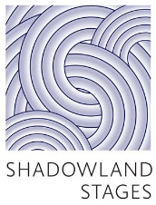
157 Canal Street, Ellenville, NY
Discount Tickets are available at The Pine Bush Area Library
For Sunday, June 23rd 2:00 pm performance of
“THE ROOMMATE”
A dark comic tale about two female roommates who find themselves on an exciting exploration to transform their lives completely, even if it requires a turn into dangerous territory….an “Odd Couple” story that shifts towards “Breaking Bad”!
Ticket price: $33.00 per person
(Center Row Seating)
Stop by the Pine Bush Area Library at 223 Maple Ave. Pine Bush, to purchase tickets or call 744-4265, ext. 2 for more info on this discounted offer!

AARP SMART DRIVER CLASS
GET A DISCOUNT ON YOUR AUTO INSURANCE AND/OR LOWER POINTS ON YOUR LICENSE!
SIGN UP NOW!!!
Saturday, June 29th @ 9 AM TO 4:30 PM
PINE BUSH AREA LIBRARY COMMUNITY CENTER
$20 FOR AARP MEMBERS - $25 FOR
NON-AARP MEMBERS
(MUST REGISTER. CALL 744-4265 ext. 2)
Additional Smart Driver Classes coming up:
Wednesday, July 31st
Wednesday, August 28th
Wednesday, September 25th
Saturday, October 19th

PLEASE CHECK OUR WEBSITE (www.pinebusharealibrary.org)
FOR A NEW MONTHLY BOOK REVIEW
BY OUR OWN
JEAN E. EUSTANCE!
******************************************
The Pine Bush Area Arts Council is calling all artists:
If you would like to exhibit your artwork in the Pine Bush Library,
Please contact Dick Reich
845 744-3781

PLEASE NOTE: THE LIBRARY WILL CLOSE AT 5:00 PM ON WEDNESDAY, JUNE 5th FOR STAFF DEVELOPMENT!
*****************************

“The Pals of the Library”.
Wanted: Middle and High Schoolers!
Have nothing to do this Summer??
How about joining a new Library group…. “The Pals of the Library”.
The “Pals” would meet monthly and discuss various ways to aide and provide support to the Pine Bush Area Library. They would conduct their own fundraisers, plan parties and themed meetings for themselves. They would be a self-governing group under the advice and counsel of Library staff. “Pal” members would benefit by performing community service, learning teamwork skills and
socializing and making new friends.
If your Middle Schooler or High Schooler is interested in joining or for more information about
“The Pals of the Library”
Please contact Miss Vicki at 744-5295 ext. 3.
CHILDREN’S PROGRAMS



(See the calendar for the ongoing programs)

TODDLER TIME (18-36 months) Mondays, June 3, 10 and 17th ONLY! 
10:00 – 11:00 am
PRESCHOOL STORYTIME (3-5 year olds) Wednesdays, June 5 and 12th ONLY!
1:00 – 2:00 pm
AFTER SCHOOL CHESS/CHECKERS (Grades3 and up) Fridays, June 7 and 14th ONLY!
3:00 – 4:30 pm
MUSIC TIME WITH MISS JILL (all ages)
Sing, dance and be silly! Instruments, too!
Fridays, June 21st ONLY!!
10:00 – 11:00 am
*********************************************************
Family Fishing Day! Saturday, June 15th 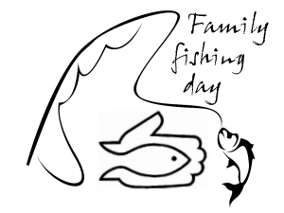
10:00 am – 1:00 pm
Southern Catskill Anglers are inviting you to fish! Bring a chair, fishing equipment, if you have it and a camera - you WILL catch a fish!! We have fishing equipment to share. The cost is $5.00 per person, including lunch. Family discounts available!
Contact: scanglers@gmail.com for more information, location and to reserve!


SUMMER READING PROGRAM
“A UNIVERSE OF STORIES”
REGISTRATION DAY KICK OFF
Saturday, June 22nd 10:00 am
Program for children ages 2 – 5
1st – 3rd grades
4th – 6th grades
PLEASE NOTE: YOU MUST HAVE A VALID PINE BUSH LIBRARY CARD FOR REGISTRATION!!
Special Celestial storytelling event with Black Dirt storyteller, Eileen Stelljes – 11:00 am
Come join the fun!!

Notes:
PLEASE MAKE SURE YOU REGISTER IN ADVANCE FOR ANY OF OUR PROGRAMS YOU CAN DO THIS BY CALLING 845 744-4265
Children’s Programs – please register by calling Ext. 3
Adult Programs – please register by calling Ext. 2
*************************
PLEASE NOTE: RENEWAL OF CIRCULATION ITEMS MUST BE DONE
VIA THE WEBSITE OR IN PERSON. WE CANNOT ACCEPT VOICE MAIL MESSAGES TO RENEW YOUR ITEMS.
Used Books, DVDs’, audio tapes, puzzles, games, greeting cards and more are for sale in the Community Center. Don’t forget to check out the books in our “FREE LITTLE LIBRARY!” on the front porch….the books are FREE!!
Free - computer and electronic device help, resume writing help, and a Notary Pubic available every day in the Community Center.
Please note: A message on the Library’s phone will make you aware of the library openings and closings.
*******************************************************************
If you miss seeing any program flyers, go to Facebook and LIKE US
(tell us why the Pine Bush Library is so great!) or,
visit our webpage at www.pinebusharealibrary.org.
Check out your local papers, bulletin boards in town, stop into the library for your newsletter or provide us with your email address to receive it via email.
Want to attend an event but do not have transportation?
Call Dial-A-Bus
TOWNS OF MONTGOMERY & CRAWFORD
Service provided Monday thru Friday. Hours of operation: 7:45am to 4:00pm. Reservations accepted Monday thru Friday 9:00am to 12:00pm. Regular Fare: $1.00 one-way • Children under 10 ride free when accompanied by an adult • Senior/disabled citizens and Medicare cardholders: 50¢ one-way. Please call 845-457-2622

