PINE BUSH LIBRARY June 2019

Sun | Mon | Tue | Wed | Thu | Fri | Sat
 |  |  |  |  |  | 1
 |  |  |  |  |  | Next Chapter – 8:30am (CC)  Book Sales 10:00 am – 2:00 pm  Historic Homes Tour 11:00 am (CC)
2 | 3 | 4 | 5 | 6 | 7 | 8
 | Toddler Time 10:00 – 11:00 am (ML)  Pinochle – 10:00 am (CC) | Scrabble – 10:00 am (CC)  Chess – 1:00 pm (CC)  Slavery & World History  6:30 pm (CC) | Between the Covers 11:00 AM(CC)  Preschool story time  1:00 – 2:00 pm (ML) | Bridge – 10:00 am(CC)  Sock Monster Project with Meadow 3:30 pm (CC)  D DAY | Chess/Checkers  3:00 – 5:00 pm (ML) | Next Chapter – 8:30am (CC)  Book Sales 10:00 am – 2:00 pm
9 | 10 | 11 | 12 | 13 | 14 | 15
 | Toddler Time 10:00 – 11:00 am (ML)  Pinochle – 10:00 am (CC) | EJR Visits 9:30 am  Scrabble – 10:00 am (CC)  Chess – 1:00 pm (CC)  Happy Bookers 1:00 pm (CC)  Slavery & World History  6:30 pm (CC) | EJR Visits 9:30 am Preschool story time  1:00 – 2:00 pm (ML)  Library Board Mtg. 7:00 pm (CC) | EJR Visits 9:30 am  Bridge – 10:00 am(CC)  Circle of Friends 1:00 pm (CC) | EJR Visits 9:30 am Chess/Checkers  3:00 – 5:00 pm (ML)  Flag Day   | Next Chapter – 8:30am (CC)  Book Sales 10:00 am – 2:00 pm  Family Fishing Day 10:00 am – 1:00 pm  Mah Jong 10:00 (CC)
16 | 17 | 18 | 19 | 20 | 21 | 22
Father’s Day   | Toddler Time 10:00 – 11:00 am (ML)  Pinochle – 10:00 am (CC) | Scrabble – 10:00 am (CC)  Chess – 1:00 pm (CC)  Ukulele Strumming  7:00 – 90 pm  Slavery & World History  6:30 pm (CC) | Bag Ladies 10:00 am (CC)  Bookies 6:00 PM)  Juneteenth Day   | Bridge – 10:00 am(CC)  Community Rock Painting 1:00 pm (CC) | Music w/Miss Jill  10:00 – 11:00 am (ML)  Summer Solstice   | Next Chapter – 8:30am (CC)  Book Sales 10:00 am – 2:00 pm  Summer Reading Prog. Kick-off  10:00 am (ML)
23 | 24 | 25 | 26 | 27 | 28 | 29
Shadowland Stages presents “The Roommate” 2:00 pm | Pinochle – 10:00 am (CC) | Scrabble – 10:00 am (CC)  Chess – 1:00 pm (CC) |  | Bridge – 10:00 am(CC)  Page Turners 1:00 PM  (CC) |  | AARP Smart Driver 9:00 – 4:30 (CC)
30
 | 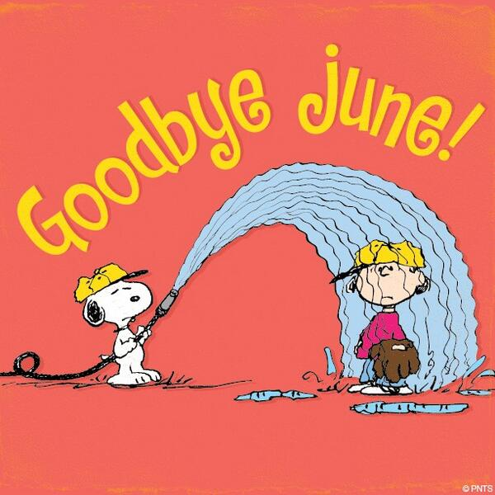

Get these printable calendars for any dates you need with CalendarsThatWork.com Full Access.

