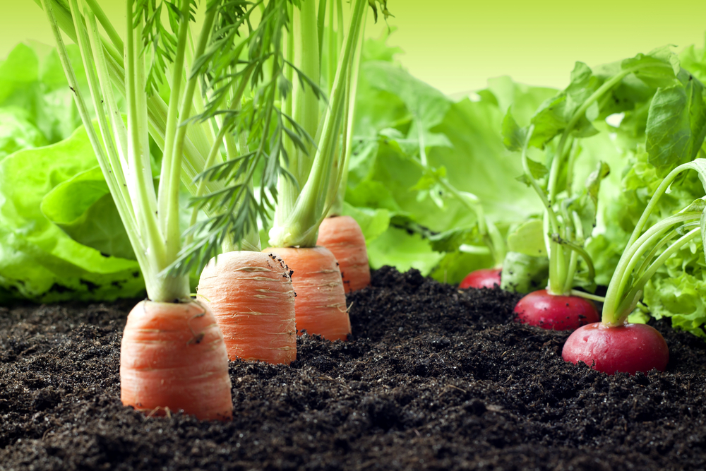
VEGETABLE GARDENING
The Cornell Cooperative Extension Master Gardeners are back again in April!
PINE BUSH AREA LIBRARY
COMMUNITY CENTER
Thursday, APRIL 18TH - 11:30 AM
The Master Gardeners will provide helpful tips for starting a vegetable garden and maintaining its healthy growth throughout the season.

Please Register by Calling 744-4265, Ext. 2

