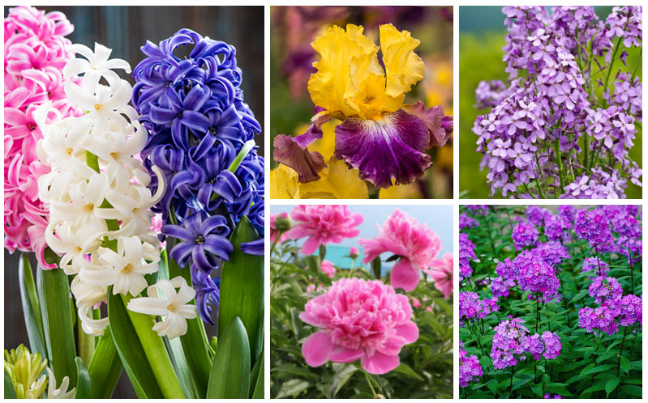
DIVIDING PERENNIALS
DIVIDING PERENNIAL PLANTS KEEPS THE GARDEN TIDY AND HEALTHY, AND ENCOURAGES THEM TO BLOOM AND FLOURISH ELSEWHERE.
LEARN THE BEST TECHNIQUES FROM THE CORNELL COOPERATIVE EXTENSION MASTER GARDENERS
PINE BUSH AREA LIBRARY COMMUNITY CENTER
FRIDAY, MAY 17, 2019 AT 11:30 AM
Register By Calling 744-4265, Ext. 2

