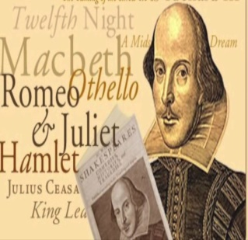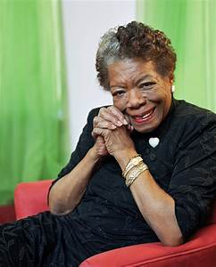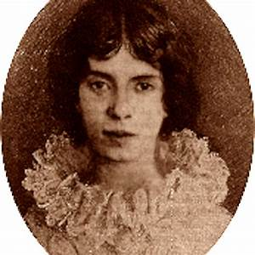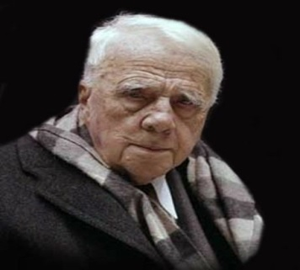
POETS ALIVE! SPRING POETRY READING
HOSTED BY GLORIA WINTER
JOIN US FOR A UNIQUE TWO-PART EVENING OF GREAT POETRY AS WE CELEBRATE
“NATIONAL POETRY MONTH”.
DURING PART 1, YOU WILL MEET RENOWNED POETS, PAST AND PRESENT, “ALIVE” AT THE PODIUM READING THEIR FAMOUS WORKS. YOU MAY SEE SHAKESPEARE OR EVEN EDGAR ALLAN POE, BUT ONE NEVER REALLY KNOWS WHO WILL DROP IN!
DURING PART 2, LOCAL POETS AND NON-POETS WILL READ THEIR OWN ORIGINAL
SPRING-INSPIRED POEMS. ALL ARE WELCOME TO COME, LISTEN AND BE ENTERTAINED!
TRULY AN ENJOYABLE EVENING NOT TO BE MISSED!
PINE BUSH AREA LIBRARY COMMUNITY CENTER
THURSDAY, APRIL 25TH AT 6 PM
Please Call to Let Us Know You’re Coming! 744-4265, Ext. 2

