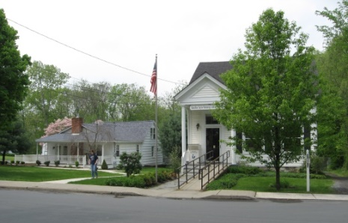
PINE BUSH AREA PUBLIC LIBRARY
NEWSLETTER – MARCH 2019
‘WHERE THE COMMUNITY CONNECTS’
223-227 Maple Ave, PO Box 63, Pine Bush, NY 12566
845-744-3375 Fax 845-744-3377 Director 744-4265
Adult Services – Ext. 1
Community Center – Ext. 2
Children’s Services – Ext. 3
www.pinebusharealibrary.org

LIBRARY HOURS:
MON & WED 9-7
TUE & THUR 11-7
FRI 9-5, SAT 10-2
COMMUNITY CENTER:
MON - THURS 10 AM – 6 PM
FRI 10 AM-5PM
SAT 10 AM-2 PM

BOARD OF TRUSTEES – MEETING TIME - SECOND WEDNESDAY OF EACH MONTH 7:00 PM
IN THE LIBRARY COMMUNITY CENTER
BOARD OF TRUSTEES - Sharon Tarolli-President, Lisa Cannon-Vice President,
Gloria Winter-Secretary, Matthew Watkins –Treasurer
TRUSTEES - Peter Eriksen, Senta Curran, John Russell, Joseph Britto, Coby Low.
Director- Doris Callan


THE LIBRARY COMMUNITY CENTER WILL BE CLOSED UNTIL 2:00 PM ON FRIDAYS DUE TO TAX PREPARATION BY AARP TAX-AIDE VOLUNTEERS. IF YOU NEED TO SCHEDULE AN APPOINTMENT TO HAVE YOUR TAXES DONE, PLEASE CALL “211”.
THIS IS A FREE PROGRAM AND IS AVAILABLE TO EVERYONE!
March is:
National Women in History Month
March 1 st – Employee Appreciation Day
March 5th – Mardi Gras/Fat Tuesday
March 6th – Ash Wednesday
March 8th – International Working Women’s Day
March 20th – World Storytelling Day

Ukulele Strumming: Tuesday, March 12th at 7:00 pm – 9:00 pm
in the Pine Bush Library’s Community Center

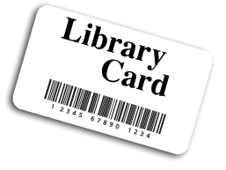 “WHAT YOUR LIBRARY CARD CAN DO FOR YOU!”
March 14th @ 6:30 PM
Do you know what you can do with your Pine Bush Library card?
You can access:
47 libraries in Rockland, Ulster, Orange & Sullivan Counties
- Ebooks & audio books
- Job Now
- Magazines
- Rosetta Stone
- Consumer Reports
- And much, much more!!
Join us at the Community Center to learn how else you can benefit by using your Pine Bush Public Area Public Library card!
Please call 845 744-4265 ext. 2 to reserve your spot!
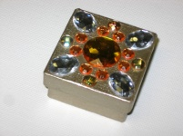MAKING A DECOUPAGE TRINKET BOX
Come to the Pine Bush Library Community Center on Friday, March 15th @ 3:30 pm. Make your own Decoupage Trinket Box…all supplies provided
but please bring your own scissors.
The cost is $3.00 per person.
Must reserve your spot by calling (845) 744-4265 ext. 2
Space is limited!
NO WALK INS!
******************************
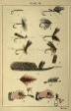The Southern Catskill Anglers Advanced fly tying classes will continue on March 3rd through March 17th. Cost is $20. Spread the news, bring a friend or two.
You will have a fun time learning and creating!
Email Donna at: scanglers@gmail.com if you are interested!!
If you can’t commit to the 4 weeks but want to try it, the cost is just $5 a class. Payment is collected at the first class!

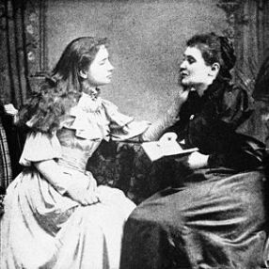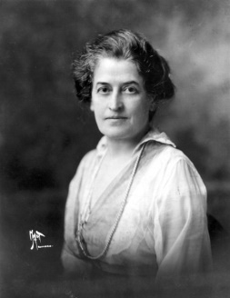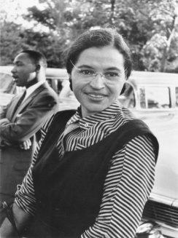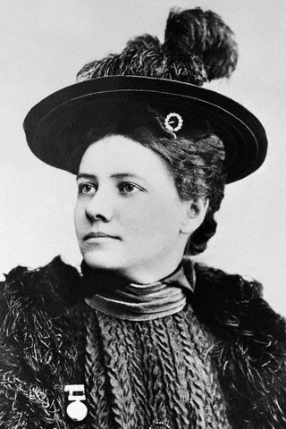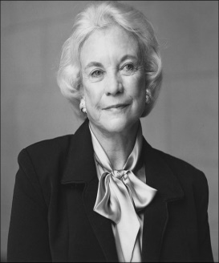
Anne Sullivan & Helen Keller Juliette Gordon Low Rosa Parks Nellie Bly Sandra Day O’Conner

FAMOUS WOMEN IN HISTORY
IN HONOR OF “NATIONAL WOMEN IN HISTORY MONTH” DURING THE MONTH OF MARCH, WE ARE HONORING SIX AMAZING WOMEN OF THE PAST WHO MADE THEIR MARK IN AMERICAN HISTORY. YOU ARE CORDIALLY INVITED TO “MEET” THESE WOMEN AND HEAR THEIR STORIES THROUGH THE VOICES OF SIX LOCAL, AMAZING WOMEN OF THE PRESENT: DORIS CALLAN, REBECCA CANNON, DANIELLE PAPPALARDO, GAYLE FISHER, JOANNE KEILLOR AND KELLY ESKEW.
LOCATION: Pine Bush Area Library Community Center
Date & Time: Tuesday, March 19 at 4:00 PM
(YOU MUST REGISTER by Calling the Library at 744-4265, Ext. 2.
SEATING IS LIMITED.


SATURDAY MAH JONGG
JOIN US FOR “ONCE-A-MONTH” SATURDAY
MAH JONGG AT THE
PINE BUSH AREA LIBRARY COMMUNTY CENTER SATURDAY, MARCH 23rd - 10 AM TO 12 PM
*BRING YOUR OWN MAH JONGG SET OR USE ONE OF OURS.
INSTRUCTION AVAILABLE FOR BEGINNERS*
Please Register. Call 744-4265, Ext. 2.
************************************************************

THE ORIGINS OF THE WORLD’S RELIGIONS

JOSEPH BRITTO, adjunct lecturer SUNY/Orange & Professor Emeritus SUNY/New Paltz provides a fascinating six (6) week overview of the origins of pre-history to present day religions, formal and informal, in global perspective.

Location: Pine Bush Area Public Library Community Center
Dates: Tuesdays, March 26, April 2, 9, 16, 23 & 30th
Time 6:30 to 8:00 PM
Please register for this program by calling (845) 744-4265 ext. 2
*******************************************************************

AARP SMART DRIVER CLASS
GET A DISCOUNT ON YOUR AUTO INSURANCE AND/OR LOWER POINTS ON YOUR LICENSE!
SIGN UP NOW!!!
WEDNESDAY, MARCH 27TH – 9 AM TO 4 PM
PINE BUSH AREA LIBRARY COMMUNITY CENTER
$20 FOR AARP MEMBERS - $25 FOR
NON-AARP MEMBERS
(MUST REGISTER. CALL 744-4265 ext. 2)


PLEASE CHECK OUR WEBSITE (www.pinebusharealibrary.org)
FOR A NEW MONTHLY BOOK REVIEW
BY OUR OWN
JEAN E. EUSTANCE!

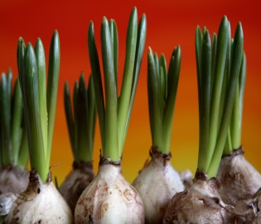FORCING BULBS AND BRANCHES 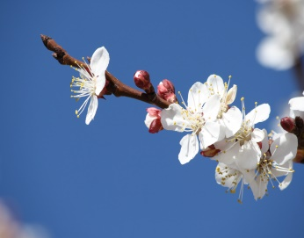
The Cornell Cooperative Extension Master Gardeners are back! The first of (4) programs at the Library will begin on March 28th at 11:30 am.
The Gardeners will demonstrate how to force the
inside blooming process of bulbs and branches by imitating what nature does outside.
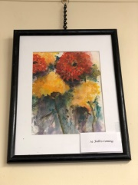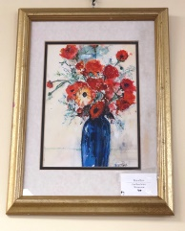
ART ON THE LIBRARY WALLS
Exhibiting Artist: GINI ROSE SIVILLI
Being a native of the Hudson Valley has always been a blessing. Painting is a way for me to express this beauty. I started painting when my kids left the nest. Learning through classes, art groups and workshops given by artists worldwide has helped me develop my skills and style. I love impressionistic watercolors. The spontaneity of unexpected beauty that can happen as the paint “does its thing” is very exciting.
I have found my passion and my Zen.
The Pine Bush Area Arts Council is calling all artists:
If you would like to exhibit your artwork in the Pine Bush Library,
please contact Dick Reich
845 744-3781

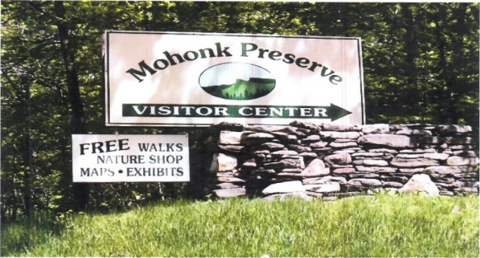

FREE MOHONK PRESERVE PASSES

Available to Patrons of the Pine Bush Area Library

Ask For More Information at the Main Library


CHILDREN’S PROGRAMS


(See the calendar for the ongoing programs)

TODDLER TIME (18-36 months) Mondays, March 4 – 25th
10:00 – 11:00 AM

PRESCHOOL STORYTIME (3-5 year olds) Wednesdays, March 6 – 27th
1:00 – 2:00 PM

AFTERSCHOOL CHECKERS/CHESS Fridays, March 1 – 22nd
3:00 – 4:30 PM

MUSIC TIME WITH MISS JILL (all ages) Fridays, March 15th and 22nd
10:00 – 11:00 AM
DROP IN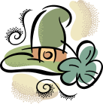
FAMILY FUN DAY (CC )
Let’s celebrate St. Patrick’s Day!
Saturday, March 16th
10:30 am – 12:30 pm
Tea time and Irish Soda Bread….children can make and take their own “Leprechaun Trap”.

“The Pals of the Library”.
We are looking for Middle School and High School students to join a new Library group,
“The Pals of the Library”.
The “Pals” would meet monthly and discuss various ways to aide and provide support to the Pine Bush Area Library. They would conduct their own fundraisers, plan parties and themed meetings for themselves. They would be a self-governing group under the advice and counsel of Library staff. “Pal” members would benefit by performing community service, learning teamwork skills and socializing and making new friends.
If your Middle Schooler or High Schooler is interested in joining, or for more information about “The Pals of the Library”
Please contact Miss Vicki at 744-5295 ext. 3.

The Pals of the Library Informational Meeting
Friday, March 29th 4:00 – 5:00 PM

PLEASE CALL AHEAD FOR WEATHER RELATED CLOSINGS AND DELAYS!

Notes:
PLEASE MAKE SURE YOU REGISTER IN ADVANCE FOR ANY OF OUR PROGRAMS – YOU CAN DO THIS BY CALLING 845 744-4265
Children’s Programs – please register by calling Ext. 3
Adult Programs – please register by calling Ext. 2

PLEASE NOTE: RENEWAL OF CIRCULATION ITEMS MUST BE DONE VIA THE WEBSITE
OR IN PERSON. WE CANNOT ACCEPT VOICE MAIL MESSAGES TO RENEW YOUR ITEMS.

Used Books, DVDs’, audio tapes, puzzles, games, greeting cards and more are for sale in the Community Center. Don’t forget to check out the books on the front porch. “Reading Garden” books are FREE!!
Free - computer and electronic device help, resume writing help, and a Notary Pubic available every day in the Community Center.
Please note: A message on the Library’s phone will make you aware of library openings and closings for inclement weather.
*****************************************************************************
If you miss seeing any program flyers, go to Facebook and LIKE US (tell us why the Pine Bush Library is so great!) or, visit our webpage, www.pinebusharealibrary.org. Check out your local papers, bulletin boards in town, stop into the library for your newsletter or provide us with your email address to receive it via email.
Want to attend an event but do not have transportation?
Call Dial-A-Bus
TOWNS OF MONTGOMERY & CRAWFORD
Service provided Monday thru Friday. Hours of operation: 7:45am to 4:00pm. Reservations accepted Monday thru Friday 9:00am to 12:00pm. Regular Fare: $1.00 one-way • Children under 10 ride free when accompanied by an adult • Senior/disabled citizens and Medicare cardholders: 50¢ one-way. Please call 845-457-2622

**PLEASE NOTE: For those of you who depend on
The Valley Times Newspaper for
The Pine Bush Library programs, etc.,
Please be advised……
The Valley Times will only publish Pine Bush news
on the 3rd Wednesday of each month instead of weekly.

