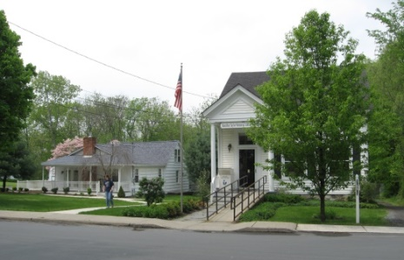
PINE BUSH AREA PUBLIC LIBRARY
NEWSLETTER – April 2019
‘WHERE THE COMMUNITY CONNECTS’
223-227 Maple Ave, PO Box 63, Pine Bush, NY 12566
845-744-3375 Fax 845-744-3377 Director 744-4265
Adult Services – Ext. 1
Community Center – Ext. 2
Children’s Services – Ext. 3
www.pinebusharealibrary.org

LIBRARY HOURS:
MON & WED 9-7
TUE & THUR 11-7
FRI 9-5, SAT 10-2
COMMUNITY CENTER:
MON - THURS 10 AM – 6 PM
FRI 10 AM-5PM
SAT 10 AM-2 PM

BOARD OF TRUSTEES – MEETING TIME - SECOND WEDNESDAY OF EACH MONTH 7:00 PM
IN THE LIBRARY COMMUNITY CENTER
BOARD OF TRUSTEES - Sharon Tarolli-President, Lisa Cannon-Vice President,
Gloria Winter-Secretary, Matthew Watkins –Treasurer
TRUSTEES - Peter Eriksen, Senta Curran, John Russell, Joseph Britto, Coby Low.
Director- Doris Callan


THE LIBRARY COMMUNITY CENTER WILL BE CLOSED UNTIL 2:00 PM ON FRIDAYS DUE TO TAX PREPARATION BY AARP TAX-AIDE VOLUNTEERS. IF YOU NEED TO SCHEDULE AN APPOINTMENT TO HAVE YOUR TAXES DONE, PLEASE CALL “211”.
THIS IS A FREE PROGRAM AND IS AVAILABLE TO EVERYONE!
April is:
- Mathematics Awareness Month
- National Child Abuse Prevention Month
- National Poetry Month
- Autism Awareness Month
- National Volunteer Month
- Sexual Assault Awareness Month

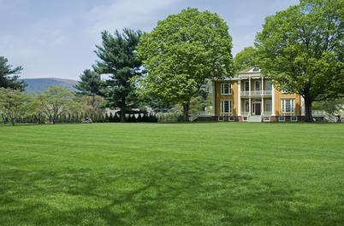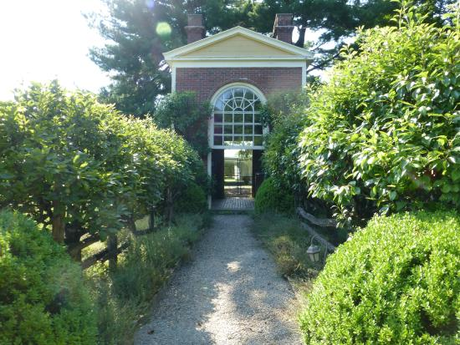
Would you be interested in visiting Boscobel House And Gardens with free passes from The Pine Bush Area Public Library?
Boscobel is a beautifully reassembled 1800’s neoclassical house in Garrison, NY. There are lush gardens, trails and magnificent Hudson Valley views. We are surveying our patrons to find out how many library cardholders would be interested in obtaining a free pass (for 4 individuals) to visit this historic site. Boscobel is open for tours from April to December 2019. Please call the library at
(845) 744-4265 to add your name to the list of patrons who would like to take advantage of this library card benefit!
(You will be responsible for your own transportation to visit Boscobel House)
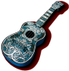Ukulele Strumming: Tuesday, April 16th at 7:00 pm – 9:00 pm 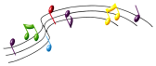
in the lower level (Children’s Library) at the Pine Bush Library
No experience necessary, extra ukes on hand!


SATURDAY MAH JONG
JOIN US FOR “ONCE-A-MONTH” SATURDAY
MAH JONG AT THE
PINE BUSH AREA LIBRARY COMMUNTY CENTER SATURDAY, APRIL 13TH - 10 AM TO 12 PM
*BRING YOUR OWN MAH JONG SET OR USE ONE OF OURS!
*INSTRUCTION AVAILABLE FOR BEGINNERS*
Please Register. Call 744-4265, Ext. 2.


THE ORIGINS OF THE WORLD’S RELIGIONS
JOSEPH BRITTO, adjunct lecturer SUNY/Orange & Professor Emeritus SUNY/New Paltz provides a fascinating six (6) week overview of the origins of pre-history to present day religions, formal and informal, in global perspective.

Location: Pine Bush Area Public Library Community Center
Dates: Tuesdays, April 2, 9, 16, 23 & 30th
Time 6:30 to 8:00 PM
Please register for this program by calling (845) 744-4265 ext. 2

ANNUAL FRIENDS OF THE LIBRARY EASTER BAKE SALE APRIL 20TH
9:00 am – sold out!


AARP SMART DRIVER CLASS
GET A DISCOUNT ON YOUR AUTO INSURANCE AND/OR LOWER POINTS ON YOUR LICENSE!
SIGN UP NOW!!!
WEDNESDAY, APRIL 24TH – 9 AM TO 4 PM
PINE BUSH AREA LIBRARY COMMUNITY CENTER
$20 FOR AARP MEMBERS - $25 FOR
NON-AARP MEMBERS
(MUST REGISTER. CALL 744-4265 ext. 2)

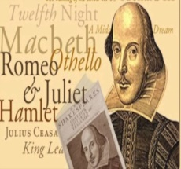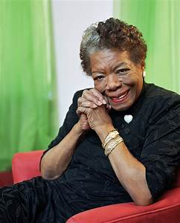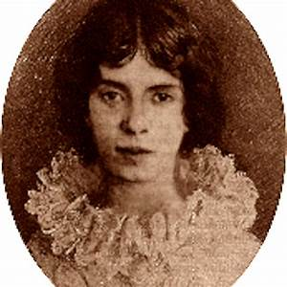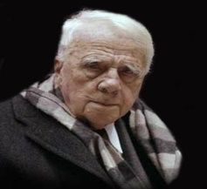
POETS ALIVE! SPRING POETRY READING
HOSTED BY GLORIA WINTER
JOIN US FOR A UNIQUE TWO-PART EVENING OF GREAT POETRY AS WE CELEBRATE
“NATIONAL POETRY MONTH”.
DURING PART 1, YOU WILL MEET RENOWNED POETS, PAST AND PRESENT, “ALIVE” AT THE PODIUM READING THEIR FAMOUS WORKS. YOU MAY SEE SHAKESPEARE OR EVEN EDGAR ALLAN POE, BUT ONE NEVER REALLY KNOWS WHO WILL DROP IN!
DURING PART 2, LOCAL POETS AND NON-POETS WILL READ THEIR OWN ORIGINAL
SPRING-INSPIRED POEMS. ALL ARE WELCOME TO COME, LISTEN AND BE ENTERTAINED!
TRULY AN ENJOYABLE EVENING NOT TO BE MISSED!
PINE BUSH AREA LIBRARY COMMUNITY CENTER
THURSDAY, APRIL 25TH AT 6 PM
Please call to let us know you are coming! 744-4265 x2

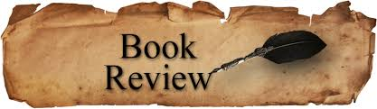
PLEASE CHECK OUR WEBSITE (www.pinebusharealibrary.org)
FOR A NEW MONTHLY BOOK REVIEW
BY OUR OWN
JEAN E. EUSTANCE!

ART ON THE LIBRARY WALLS
Exhibiting Artist: Joan Garrison
Paintings by Joan
68 Railroad Avenue
Montgomery, NY 12549
845 457-4205
I started out at Hoboken New Jersey High School with art classes. I ventured in pastels, charcoal drawings and advertising posters. I took oil classes in 1954 – 1956, which was my favorite medium to paint in. Later on, went into acrylic classes for about 5 years doing mainly landscapes of all kinds in Pine Bush, New York. Then took pen and ink, pencil drawings and charcoal classes in Middletown, New York and went back to oil on canvas in Newburgh, New York painting all kinds from flowers, balloons,, seascapes, birds, etc. and my favorite, landscapes. Painting is very relaxing and rewarding with a personal feeling of accomplishment.
The Pine Bush Area Arts Council is calling all artists:
If you would like to exhibit your artwork in the Pine Bush Library,
please contact Dick Reich
845 744-3781

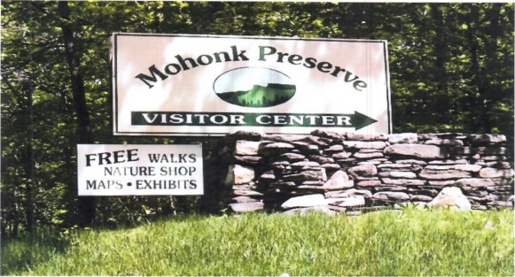

FREE MOHONK PRESERVE PASSES

Available to Patrons of the Pine Bush Area Public Library

Ask For More Information at the Main Library!


CHILDREN’S PROGRAMS

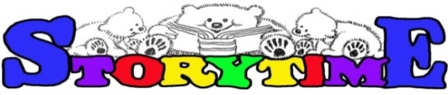
(See the calendar for the ongoing programs)

TODDLER TIME (18-36 months) Mondays, April 1st – 29th
10:00 – 11:00 am

PRESCHOOL STORYTIME (3-5 year olds) Wednesdays, April 3rd – 24th
1:00 – 2:00 pm

CHESS/CHECKERS (Grades3 and up) Fridays, April 5th – 26th
3:00 – 4:30 pm

MUSIC TIME WITH MISS JILL (all ages)
Sing, dance and be silly! Instruments, too!
Fridays April 5th and 12th only
10:00 – 11:00 am

LEGO BUILDING (all ages)
Wednesday, April 17th and Friday, April 19th
Drop in any time between 11:00 am – 2:00 pm

“PALS” POSTER CONTEST
Grades 6 and up
Tuesday, April 16
12:00 – 2:00 pm

Junior friends of the Library group, “PALS”, will create posters to promote the upcoming ANNUAL FRIENDS OF THE LIBRARY EASTER BAKE SALE held on Saturday, April 20th.
3 winners will be chosen by the FRIENDS OF THE LIBRARY for prizes.
A few “PALS” are needed to help on bake sale day to greet patrons and hand out bookmarks.
You must sign up in advance.
All members of “PALS” must have a signed membership form on file at the library.
Call or see Miss Vicki for more information at 744-5295 ext. 3.

Notes:
PLEASE MAKE SURE YOU REGISTER IN ADVANCE FOR ANY OF OUR PROGRAMS – YOU CAN DO THIS BY CALLING 845 744-4265
Children’s Programs – please register by calling Ext. 3
Adult Programs – please register by calling Ext. 2

PLEASE NOTE: RENEWAL OF CIRCULATION ITEMS MUST BE DONE VIA THE WEBSITE
OR IN PERSON. WE CANNOT ACCEPT VOICE MAIL MESSAGES TO RENEW YOUR ITEMS.

Used Books, DVDs’, audio tapes, puzzles, games, greeting cards and more are for sale in the Community Center. Don’t forget to check out the books on the front porch. “Reading Garden” books are FREE!!
Free - computer and electronic device help, resume writing help, and a Notary Pubic available every day in the Community Center.
Please note: A message on the Library’s phone will make you aware of library openings and closings for inclement weather.
*****************************************************************************
If you miss seeing any program flyers, go to Facebook and LIKE US (tell us why the Pine Bush Library is so great!) or, visit our webpage, www.pinebusharealibrary.org. Check out your local papers, bulletin boards in town, stop into the library for your newsletter or provide us with your email address to receive it via email.
Want to attend an event but do not have transportation?
Call Dial-A-Bus
TOWNS OF MONTGOMERY & CRAWFORD
Service provided Monday thru Friday. Hours of operation: 7:45am to 4:00pm. Reservations accepted Monday thru Friday 9:00am to 12:00pm. Regular Fare: $1.00 one-way • Children under 10 ride free when accompanied by an adult • Senior/disabled citizens and Medicare cardholders: 50¢ one-way. Please call 845-457-2622

