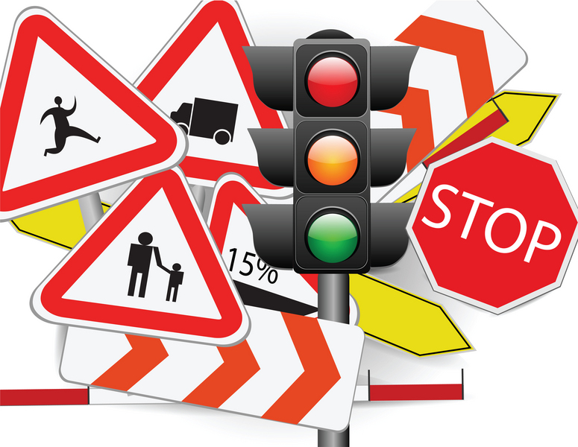
AARP SMART DRIVER CLASS
GET A DISCOUNT ON YOUR AUTO INSURANCE AND/OR LOWER POINTS ON YOUR LICENSE
SIGN UP NOW!!!
WEDNESDAY MARCH 27TH - 9 AM - 4 PM
PINE BUSH AREA LIBRARY COMMUNITY CENTER
$20 FOR AARP MEMBERS
$25 FOR NON-AARP MEMBERS
(MUST REGISTER. CALL 744-4265, EXT. 2)

