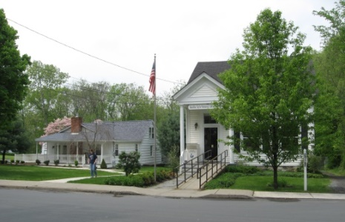
PINE BUSH AREA PUBLIC LIBRARY
NEWSLETTER – FEBRUARY 2019
‘WHERE THE COMMUNITY CONNECTS’
223-227 Maple Ave, PO Box 63, Pine Bush, NY 12566
845-744-3375 Fax 845-744-3377 Director 744-4265
www.pinebusharealibrary.org

LIBRARY HOURS:
MON & WED, 9-7 TUE & THUR 11-7 FRI 9-5, SAT 10-2
COMMUNITY CENTER HOURS: MON. - THURS. 10 AM – 6 PM, FRI. 10 AM-5PM,
SAT. 10 AM-2 PM
BOARD OF TRUSTEES – MEETING TIME - SECOND WEDNESDAY OF EACH MONTH 7:00 PM IN THE
LIBRARY COMMUNITY CENTER
BOARD OF TRUSTEES - Sharon Tarolli-President, Lisa Cannon-Vice President, Gloria Winter-Secretary, Matthew Watkins –Treasurer
TRUSTEES - Peter Eriksen, Senta Curran, John Russell, Joseph Britto, Coby Low.
Director- Doris Callan
*****************************************************************************
^{Library Closings:}
^{February 18th – Presidents Day}
February is Black History Month
Come into the Library and view our great selection of books!
THE LIBRARY COMMUNITY CENTER WILL BE CLOSED UNTIL 2:00 PM ON FRIDAYS DUE TO AARP TAX -AIDE. IF YOU NEED TO SCHEDULE AN APPOINTMENT TO HAVE YOUR TAXES DONE BY AARP TAX-AIDE, PLEASE CALL 211.
THIS FREE AARP TAX-AIDE PROGRAM IS AVAILABLE TO EVERYONE!
Please note: We are holding our first AARP Smart Driver course March 27th,
9:00 am – 4:00 pm in the Community Center.
Please call 744-4265 ext. 2 to reserve your spot.
***********************************************************************************

PLEASE CHECK OUR WEBSITE (www.pinebusharealibrary.org)
FOR A NEW MONTHLY BOOK REVIEW
BY OUR OWN
JEAN E. EUSTANCE!

**PLEASE NOTE: For those of you who depend on
The Valley Times Newspaper for
The Pine Bush Library programs, etc.,
please be advised……
The Valley Times will only publish Pine Bush news on
the 3rd Wednesday of each month instead of weekly.
 ART ON THE LIBRARY WALLS!
Nancy Reed Jones is exhibiting her artwork.
Have you used your Pine Bush Area Public Library card recently? Did you know you can access:
- Ebooks & audio books
- Job Now
- Rosetta Stone
- Consumer Reports
- And much, much more!!
********************************
ADULT PROGRAMS
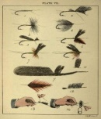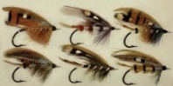
The Southern Catskill Anglers will be starting their fly tying program on Sunday, Jan 13th (20, 27 and Feb. 3) for beginners, Ages 9 to adults. This program will run for 4 Sundays at the Pine Bush Library Community Center from 1-3pm. Making your own flies to fish with us is not hard at all. All you need to learn is a few basic steps and you will be successful. If you have never tied before, try it out!! This is a great activity for Fathers/Son/Daughters/Mother or even Grandparents to tie with a child. The first 4 Sundays will be for those who have not tied before.
Cost is youth $5 and adults $10 for the 4 weeks. You will leave each class with 2 flies that are usable for fishing. Come the springtime, we will offer fly casting lessons on our pond for a different experience in fishing!! Sign up to join us. We have all materials and equipment needed for you. Email me at scanglers@gmail.com.
Advanced classes will also be held starting in Feb (10, 17, 24 and March 3rd) also for 4 weeks. Cost is $20. Spread the news, bring a friend or two. You will have a fun time learning and creating! Email scanglers@gmail.com if you are interested!!
If you can’t commit to the 4 weeks but want to try it, the cost is just $5 a class. Payment is collected at the first class!
Please show up 10 minutes early. Hope you can join us!!

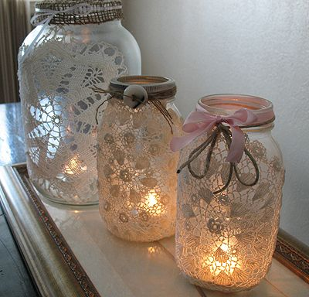

LACE MASON JARS

MAKE A BEAUTIFUL VALENTINE’S DAY GIFT FOR YOURSELF OR FOR SOMEONE SPECIAL.
PINE BUSH AREA LIBRARY
COMMUNITY CENTER
WEDNESDAY, FEBRUARY 6th - 3:30 PM
Must Register. Call 744-4265, Ext. 2. Space is Limited.
*****************************************

CELEBRATING CHINESE NEW YEAR:
“THE YEAR OF THE PIG”
with MAH JONG & “MUNCHIES”
SATURDAY, FEBRUARY 23, 2019 – 10 AM TO 12 NOON
PINE BUSH AREA LIBRARY COMMUNITY CENTER

*BRING YOUR OWN MAHJONG SET OR USE ONE OF OURS*
*INSTRUCTION AVAILABLE FOR BEGINNERS*
Must Register. Call 744-4265, Ext. 2


THE GREATEST PRESIDENTS - WASHINGTON & LINCOLN
What do you think?
JOSEPH BRITTO, ADJUNCT LECTURER - SUNY ORANGE
&
PROFESSOR EMERITUS - SUNY NEW PALTZ

DISCUSSES THE LIVES, POLICIES AND LEGACIES OF
GEORGE WASHINGTON AND ABRAHAM LINCOLN
AND THE IMPACT THEY EACH HAD ON AMERICA AND THE WORLD.
PINE BUSH AREA LIBRARY COMMUNITY CENTER
TUESDAY, FEBRUARY 26TH AT 6:30 PM
To register, call the Library @ 744-4265 Ext. 2

WINTER POETRY READING
ALL POETS ARE INVITED TO READ ORIGINAL OR OTHER WORKS.
WINTER-INSPIRED POEMS ARE ENCOURAGED!
NON-POETS ARE INVITED TO COME, LISTEN, ENJOY
AND BE ENTERTAINED!
HOSTED BY GLORIA WINTER
Pine Bush Area Library Community Center
Thursday, February 28th – 7:00 to 9:00 PM
Please reserve your spot by calling (845) 744-4265 x 2
(Refreshments Served. No Cover)

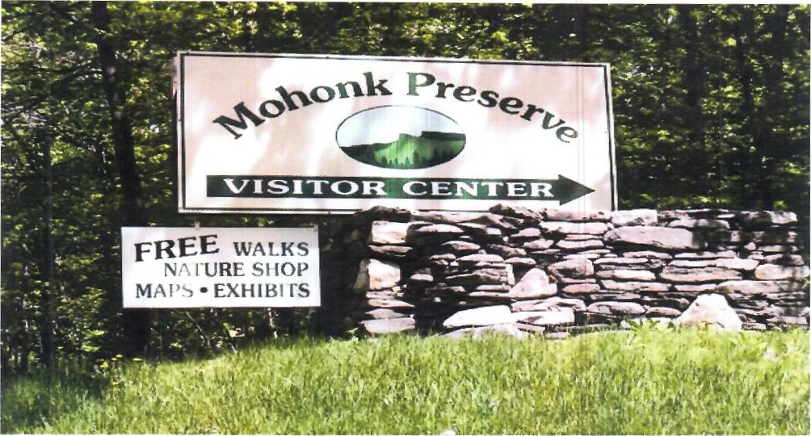

FREE MOHONK PRESERVE PASSES
Available to Patrons of the Pine Bush Area Library.
Ask For More Information at the Main Library
*********************************************************
We are looking for Middle School and High School students to join a new Library group,
“The Pals of the Library”.
The “Pals” would meet monthly and discuss various ways to aide and provide support to the Pine Bush Area Library. They would conduct their own fundraisers, plan parties and themed meetings for themselves. They would be a self-governing group under the advice and counsel of Library staff. “Pal” members would benefit by performing community service, learning teamwork skills and socializing and making new friends.
If your Middle Schooler or High Schooler is interested in joining, or for more information about “The Pals of the Library”, please contact Miss Vicki at 744-5295 ext. 3.
**********************************************

CHILDREN’S PROGRAMS


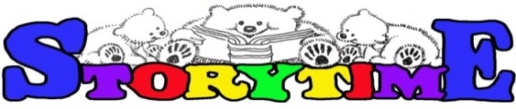
(See the calendar for the ongoing programs)

TODDLER TIME (18-36 months) Mondays, February 4 – 25th (Closed Feb. 18th – Presidents Day)
10:00 – 11:00 AM

PRESCHOOL STORYTIME (3-5 year olds) Wednesdays, February 6 – 27th
1:00 – 2:00 PM

AFTERSCHOOL CHECKERS/CHESS (Grades 3 and Up) Fridays, February 1st – 22nd
3:00 – 4:30 PM

 LEGO BUILDING (All ages) February 5th – 26th 2:00 – 5:00 PM
DROP IN MAKE & TAKE VALENTINES (All Ages) 
Tuesday, February 12TH 11:00 AM – 5:00 PM

PLEASE CALL AHEAD FOR WEATHER RELATED CLOSINGS AND DELAYS!


Notes:
PLEASE MAKE SURE YOU REGISTER IN ADVANCE FOR ANY OF OUR PROGRAMS – YOU CAN DO THIS BY CALLING 845 744-4265
Children’s Programs – please register by calling Ext. 3
Adult Programs – please register by calling Ext. 2

PLEASE NOTE: RENEWAL OF CIRCULATION ITEMS MUST BE DONE VIA THE WEBSITE
OR IN PERSON. WE CANNOT ACCEPT VOICE MAIL MESSAGES TO RENEW YOUR ITEMS.

Used Books, DVDs’, audio tapes, puzzles, games, greeting cards and more are for sale in the Community Center. Don’t forget to check out the books on the front porch. “Reading Garden” books are FREE!!
Free - computer and electronic device help, resume writing help, and a Notary Pubic available every day in the Community Center.
Please note: A message on the Library’s phone will make you aware of library openings and closings for inclement weather.
*****************************************************************************
If you miss seeing any program flyers, go to Facebook and LIKE US (and tell us why the Pine Bush Library is so great!) or, visit our webpage, www.pinebusharealibrary.org. Check out your local papers, bulletin boards in town, stop into the library for your newsletter or provide us with your email address to receive it via email.
Want to attend an event but do not have transportation?
Call Dial-A-Bus
TOWNS OF MONTGOMERY & CRAWFORD
Service provided Monday thru Friday. Hours of operation: 7:45am to 4:00pm. Reservations accepted Monday thru Friday 9:00am to 12:00pm. Regular Fare: $1.00 one-way • Children under 10 ride free when accompanied by an adult • Senior/disabled citizens and Medicare cardholders: 50¢ one-way. Please call 845-457-2622

