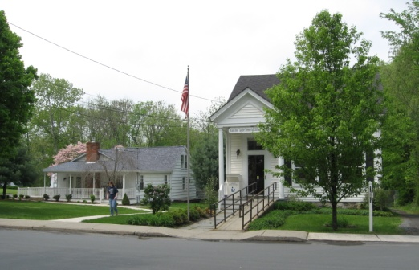
PINE BUSH AREA PUBLIC LIBRARY
NEWSLETTER - MAY 2018
‘WHERE THE COMMUNITY CONNECTS’

223-227 Maple Ave, PO Box 63, Pine Bush, NY 1256 845-744-3375 Fax 845-744-3377 Director 744-4265

www.pinebusharealibrary.org

BOARD OF TRUSTEES – MEETING TIME - SECOND WEDNESDAY OF EACH MONTH. 7 pm in the Library Community Center –
Trustees: Sharon Tarolli-President, Lisa Cannon-Vice President, Gloria Winter- Secretary, Matthew Watkins –Treasurer, Peter Eriksen, Senta Curran, Coby Low, John Russell, Joseph Britto. Director- Doris Callan

LIBRARY HOURS:
MON & WED, 9-7 TUE & THUR 11-7 FRI 9-5, SAT 10-2
COMMUNITY CENTER HOURS: MON. - THURS. 10 AM – 6 PM, FRI. 10 AM-5PM, SAT. 10 AM-2 PM


 SPRING FLING!!
Annual Dinner Dance May 5th “Cinco de Mayo!” Tickets available at the main Library and the Library Community Center.
Call to reserve your tickets now @ 744-4265 - $30.00 in advance or $35.00 at the door.
888888888888888888888888888888
can callMAY IS:
Gifts from your Garden Month
May 5th – Cinco de Mayo
May 6th – National Nurses Day
May 8th – National Teacher’s Day
May 8th – V-E Day
May 13th – Mother’s Day
May 19th – Armed Forces Day
May 26th – Pine Bush Library Yard Sale
May 26th – Library Building closed for Memorial Day weekend
May 28th – Library closed - Memorial Day -
ADULT PROGRAMS FOR May 2018
 Ukulele Meetup – May 1st at 7:00 – 9:00 PM in the Children’s Section. Beginners always welcomed. Strum on in.

WORLD HISTORY THROUGH ART
Please note: Progam extended through May 8th
Join us for a unique five (5) week history program that demonstrates how art through the ages has been influenced by the historical significance of world events. The program covers art and history spanning from the ancient world through the present time.
Dates: May 1, 2018, ** May 8th** Program Extended
Time: 6:30 PM – 8:00 PM
Presented by: Joseph Britto, Adjunct Lecturer, SUNY Orange & Professor Emeritus, SUNY New Paltz
To register please call: (845) 744-4265

INDIVIDUAL CAREER COUNSELING
OUR PROFESSIONAL CAREER COUNSELOR WILL PROVIDE A 45-MINUTE ONE-ON-ONE CONSULTATION
AND ASSIST YOU WITH YOUR JOB SEARCH, JOB INTERVIEW, AND ANY OTHER JOB-RELATED QUESTIONS.
(A $175 VALUE, FREE TO YOU!)
PINE BUSH AREA LIBRARY
COMMUNITY CENTER
THURSDAY, MAY 3 & MAY 10
APPOINTMENTS START AT 5:00 PM
Sponsored by RCLS (Ramapo Catskill Library System. This program is partly funded by the New York State Library’s Adult Literacy Library Services grant program.
(MUST MAKE AN APPOINTMENT BY CALLING 744-4265
Saturday, May 12th @ 9:00 am – 4:00 pm: AARP Driver’s Safety Class
Get a discount on your auto insurance and/or lower points on your license.
SIGN UP NOW!!
Pine Bush Library Community Center $20.00 for AARP members, $25.00 for non-members
Must register by calling: (845) 744-4265
Additional classes to be held on:
Wednesday, June 13th
NO JULY CLASS
Wednesday, August 8th

Free Movie Matinee: May 17th @ 12:30 pm
BLUE JASMINE
A New York socialite deeply troubled and in denial, arrives in San Francisco to impose upon her sister. She looks a million, but isn't bringing money, peace, or love...featuring Alec Baldwin, Cate Blanchett. Bring lunch, we will provide coffee, tea and dessert! Stay afterwards for the Movie trivia questions.



Gifts From Nature 
Learn Unique and Creative Ways to Make and Use Nature’s Abundant Raw Materials
Presented by Cornell Cooperative Extension’s Master Gardeners
Pine Bush Area Public Library
Community Center
Friday, May 18, 2018 at 11:30 AM
(Please Register By Calling 744-4265)

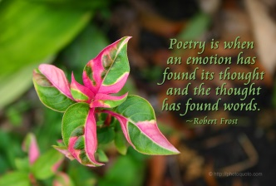
SPRING POETRY READING
ALL POETS ARE INVITED TO READ ORIGINAL OR OTHER WORKS. SPRING-INSPIRED POEMS ARE ENCOURAGED!
NON-POETS ARE INVITED TO COME, LISTEN, ENJOYAND BE ENTERTAINED!
HOSTED BY GLORIA WINTER
Pine Bush Area Library Community Center
Thursday, May 24th – 7:00 to 9:00 PM
(Refreshments Served. No Cover)
Legal and Financial Planning for Alzheimer’s disease May 22, 2018 Join us from 6:30 pm – 7:30 pm
If you or someone you know is affected by Alzeimer’s disease or dementia, the time for legal and financial planning is now. Legal and Financial Planning for Alzheimer’s Disease is a workshop presented by the Alzheimer’s Association, for anyone who would like to know more about what legal and financial issues to consider and how to put plans in place. An Elder Law Attorney will be on hand to answer all your questions. Please register @ 845 744-3375.
PINE BUSH LIBRARY YARD SALE
MAY 26TH
9:00 AM – 3:00 PM
Good, clean, unbroken items will be accepted at the Pine Bush Library Community Center
starting May 21st during regular hours.

CHILDREN’S PROGRAMS


TODDLER TIME (ages 18 - 36 months)
(Mondays, May 7th, 14th & 21st) 10:00 – 10:45 am

PRESCHOOL STORYTIME (ages 3 - 5 years)
(Thursdays, May 3rd, 10th, 17th, 24th & 31st) 1:00 – 2:00 pm

MUSIC TIME WITH MISS JILL (Family fun for all ages!)
Fridays, May 18th & 25th)) 10:00 – 11:00 am

Drop in for Mother’s Day Craft – Saturday, May 12th 10:00 am – 1:30 pm

Used Books, DVDs’, audio tapes and more are for sale every day in the Community Center. Don’t forget to check out the books on the front porch. Your choice at $1.00 a bag.

If you miss seeing any program flyers, go to Facebook and like us or, visit our webpage, www.pinebusharealibrary.org. Also, check out your local papers or bulletin boards in town. Or…stop into the library for your newsletter.
A
Coming in June:
June 9 – Summer Reading Kick-off!
June 9 – Birds of Prey & Reptiles sponsored by the Pine Bush Library and funded by Stewarts Holiday Match Program
June 13 – AARP Driver’s Safety Class
June 15 – Intro to Food Preservation
Want to attend an event but do not have transportation? Call Dial-A-Bus
TOWNS OF MONTGOMERY & CRAWFORD
Service provided Monday thru Friday. Hours of operation: 7:45am to 4:00pm. Reservations accepted Monday thru Friday 9:00am to 12:00pm. Regular Fare: $1.00 one-way • Children under 10 ride free when accompanied by an adult • Senior/disabled citizens and Medicare cardholders: 50¢ one-way. Please call 845-457-2622

************************************************************************

