MAY 2018
PINE BUSH AREA PUBLIC LIBRARY
Sun | Mon | Tue | Wed | Thu | Fri | Sat
 |  | 1 | 2 | 3 | 4 | 5
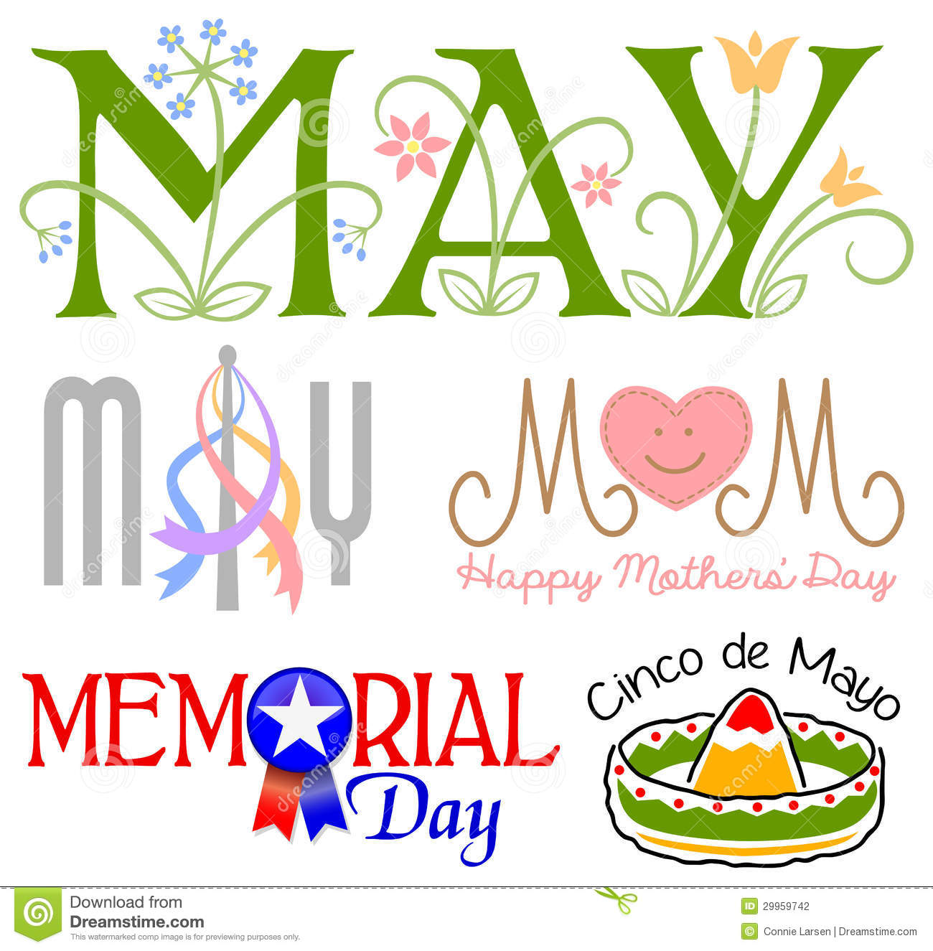 |  | Scrabble – 10:00 am (CC)  Chess – 1:00 pm (CC)  World History Through Art 6:30 PM (CC)  Ukulele Meet up – 7:00 pm (Children’s Section - ML) | Between the Covers 11:00 am | Bridge – 10:00 am(CC)  Preschool Story Time  1:00 - 2:00 pm(ML)  Individual job Consults  5:00 – 8:00 PM (CC) |  | Next Chapter – 8:30am (CC)  Book Sales 10:00 – 2:00 pm  SPRING FLING!  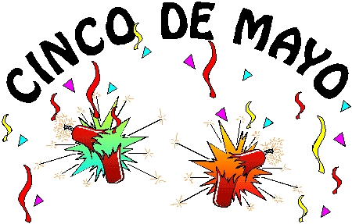
6 | 7 | 8 | 9 | 10 | 11 | 12
National Nurses Day!  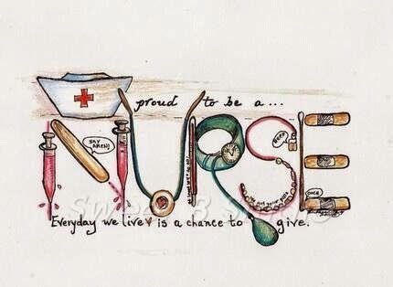 | Pinochle – 10:00 am (CC)  Toddler Time (ML)  10:00 am – 10:45 am | Scrabble – 10:00 am (CC)  Happy Bookers 1:00 pm (CC)  Chess – 1:00 pm (CC  Ukulele Meet up 7:00 – 9:00 pm (ML)  NATIONAL TEACHER’S DAY! | Pine Bush Library Board of Directors  Meeting 7:00 pm | Bridge – 10:00 am(CC)  Preschool Story Time  1:00 - 2:00 pm(ML)  Circle of Friends 1:00 pm  (cc)  Friends – 2:00 pm (cc)  Individual job Consults  5:00 – 8:00 PM (CC) |  | Next Chapter – 8:30am (CC)  Book Sales 10:00 – 2:00 pm  AARP Safe Driver 9:00 am – 4:00 pm (CC)  Drop in for Mother’s Day Craft 10:00 am – 1:30 pm (ML)
13 | 14 | 15 | 16 | 17 | 18 | 19
MOTHER’S DAY  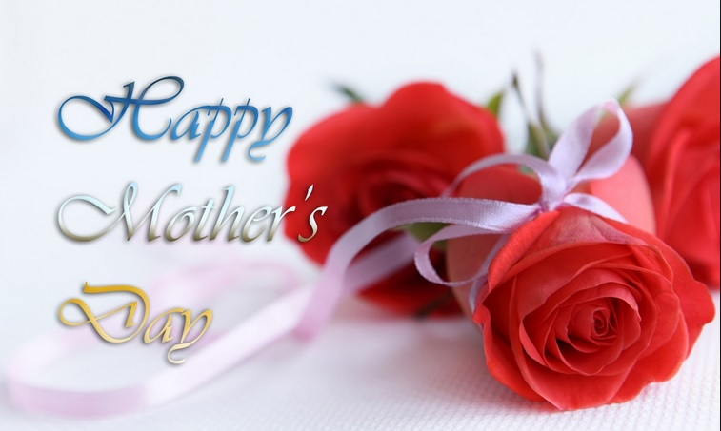 | Pinochle – 10:00 am (CC)  Toddler Time (ML)  10:00 am – 10:45 am | Scrabble – 10:00 am (CC)  Chess – 1:00 pm (CC) | Bag Ladies 10:00 am  (CC) | Bridge – 10:00 am(CC)  Preschool Story Time  1:00 - 2:00 pm(ML)  Movie Matinee(CC) | Music Time with Miss Jill 10:00 – 11:00 am (ML)  Gifts From Nature 11:30 am (CC) | Next Chapter – 8:30am (CC)  Book Sales 10:00 – 2:00 pm  UFO FESTIVAL!
20 | 21 | 22 | 23 | 24 | 25 | 26
 | Pinochle – 10:00 am (CC)  Toddler Time (ML)  10:00 am – 10:45 am | Scrabble – 10:00 am (CC)  Chess – 1:00 pm (CC)  Legal & Financial Planning for Alzheimer’s  6:30 pm (CC) | Bookies 7:00 pm | Bridge – 10:00 am(CC)  Preschool Story Time  1:00 - 2:00 pm(ML)  Spring Poetry 7:00 – 9:00 pm (CC) | Music Time with Miss Jill 10:00 – 11:00 am (ML) | ANNUAL LIBRARY YARD SALE!  Library closed for Memorial Day weekend!
27 | 28 | 29 | 30 | 31 |  | \
 | LIBRARY CLOSED!  Memorial day!   | Scrabble – 10:00 am (CC)  Chess – 1:00 pm (CC) |  | Preschool Story Time  1:00 - 2:00 pm(ML) |  | 