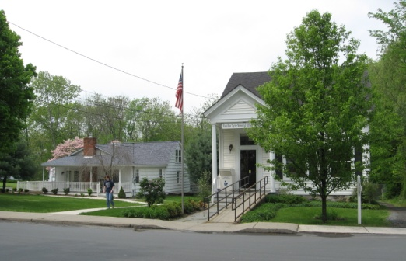
PINE BUSH AREA PUBLIC LIBRARY
NEWSLETTER - APRIL 2018
‘WHERE THE COMMUNITY CONNECTS’

223-227 Maple Ave, PO Box 63, Pine Bush, NY 1256 845-744-3375 Fax 845-744-3377 Director 744-4265

www.pinebusharealibrary.org

BOARD OF TRUSTEES – MEETING TIME - SECOND WEDNESDAY OF EACH MONTH. 7 pm in the Library Community Center –
Trustees: Sharon Tarolli-President, Lisa Cannon-Vice President, Gloria Winter- Secretary, Matthew Watkins –Treasurer, Peter Eriksen, Senta Curran, Coby Low, John Russell, Joseph Britto. Director- Doris Callan

LIBRARY HOURS:
MON & WED, 9-7 TUE & THUR 11-7 FRI 9-5, SAT 10-2
COMMUNITY CENTER HOURS: MON. - THURS. 10 AM – 6 PM, FRI. 10 AM-5PM, SAT. 10 AM-2 PM

AARP Tax Aide at the Pine Bush Library - 2 more sessions at the Pine Bush Library Community Center.

*******************************************************************************************
SAVE THE DATE: Annual Dinner Dance May 5th “Cinco de Mayo!” Tickets available at the main Library and the Library Community Center - call to reserve your tickets now @ 744-4265 - $30.00 in advance or $35.00 at the door.
8888888888888888888888888888888888888
**************************************************************************************
The Friends of the Pine Bush Library would like to thank all those who donated baked goods and all those who supported the bake sale. The bake sale was a great success!! The Friends meet the 2nd Thursday of every month at the Pine Bush Library Community Room at 2:00 pm. The Friends always welcome new members.
Feel free to join us at a meeting!
can call
April is:
National Poetry Month
National Library Week - April 8th – 14th
Volunteer Appreciation Week – April 15th – 21st
April 10th – National Library Workers Day
April 17th – Tax Day
April 25th – Administrative Professional’s Day
April 27th – Arbor Day
ADULT PROGRAMS FOR April 2018

WORLD HISTORY THROUGH ART
Join us for a unique five (5) week history program that demonstrates how art through the ages has been influenced by the historical significance of world events. The program covers art and history spanning from the ancient world through the present time.
Dates: April 3, 10, 17, 24 and May 1, 2018
Time: 6:30 PM – 8:00 PM
Presented by: Joseph Britto, Adjunct Lecturer, SUNY Orange & Professor Emeritus, SUNY New Paltz
To register please call: (845) 744-4265

Ukulele Meetup – (Children’s Section) April 10th at 7:00 – 9:00 PM. Beginners always welcomed. Strum on in.
Free Movie Matinee: April 19th @ 12:30 pm
Movie to be announced


VINES: VERTICAL GARDENING
FLOWER, FRUIT AND VEGETABLE VINES ACCOMPLISH WHAT OTHER PLANT FORMS CAN’T DO…….
THEY SOFTEN AND ADD HEIGHT IN THE GARDEN AND IN NARROW BEDS.
* PROGRAM PRESENTED BY THE CORNELL COOPERATIVE EXTENSION MASTER GARDENERS*
PINE BUSH AREA LIBRARY
COMMUNITY CENTER
FRIDAY, APRIL 20, 2018 AT 11:30 AM
(Call 744-4265 to Register.)
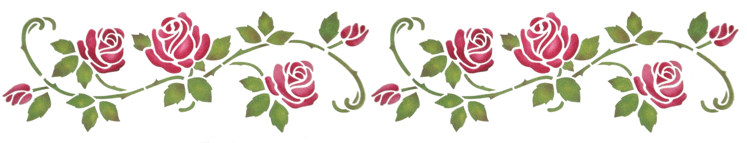
Wednesday, April 25th 9:00 am – 4:00 pm: AARP Driver’s Safety Class
Get a discount on your auto insurance and/or lower points on your license.
SIGN UP NOW!!
Pine Bush Library Community Center $20.00 for AARP members, $25.00 for non-members
Must register by calling: (845) 744-4265
Additional classes to be held on:
Saturday, May 12th
Wednesday, June 13th
NO JULY CLASS
Wednesday, August 8th

CHILDREN’S PROGRAMS

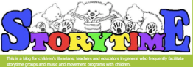
TODDLER TIME (ages 18 - 36 months)
(Mondays, April 2 – April 30) 10:00 – 11:00 am

PRESCHOOL STORYTIME (ages 3 - 5 years)
(Thursdays, April 5 – April 26) 1:00 – 2:00 pm

MUSIC TIME WITH MISS JILL (Family fun for all ages!)
Fridays, April 13 & April 20 only)) 10:00 – 11:00 am
**********************************************************

CULTIVATING A LOVE OF READING AND GARDENING
The Community Garden Club of Pine Bush and the Pine Bush Area Library are collaborating on a program to encourage kids between the ages of 5 to 12 to
READ and GARDEN and ENJOY BOTH!!
Come to the Pine Bush Library Community Center on Saturday, April 14, 2018 at 12:30 pm and learn about “our borrowing bags” filled with fun items to get the kids started!
Call 744-4265 to let us know you are coming!
Used Books, DVDs’, audio tapes and more are for sale every day in the Community Center. Don’t forget to check out the books on the front porch. Your choice at $1.00 a bag.

If you miss seeing any program flyers, go to Facebook and like us or, visit our webpage, www.pinebusharealibrary.org. Also, check out your local papers or bulletin boards in town. Or…stop into the library for your newsletter.
A
Coming in May
May 5 – Spring Fling – Cinco de Mayo 6:30 – 10:30 pm
May 3 & 10 - Individual job Consults
May 13th – Mother’s Day
May 18 – Gardening
May 22 – Legal & Financial Planning for Alzheimer’s
May 24 – Spring Poetry Reading
May 26 – Annual Library Yard Sale
Want to attend an event but do not have transportation? Call Dial-A-Bus
TOWNS OF MONTGOMERY & CRAWFORD
Service provided Monday thru Friday. Hours of operation: 7:45am to 4:00pm. Reservations accepted Monday thru Friday 9:00am to 12:00pm. Regular Fare: $1.00 one-way • Children under 10 ride free when accompanied by an adult • Senior/disabled citizens and Medicare cardholders: 50¢ one-way. Please call 845-457-2622

************************************************************************

