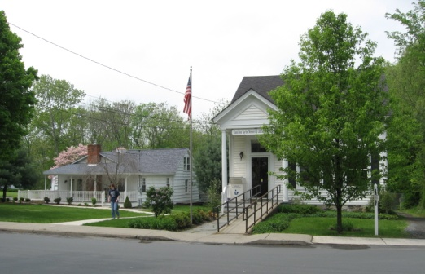
PINE BUSH AREA PUBLIC LIBRARY
NEWSLETTER - NOVEMBER 2017
‘WHERE THE COMMUNITY CONNECTS’
223-227 Maple Ave, PO Box 63, Pine Bush, NY 12566
Main Library 845-744-3375 Fax 845-744-3377 Director 744-4265
Children’s Library 845-744-5295

www.pinebusharealibrary.org
LIBRARY HOURS:
MON & WED, 9-7 TUE & THUR 11-7 FRI 9-5, SAT 10-2
COMMUNITY CENTER HOURS: MON. - THURS. 10 AM – 6 PM, FRI. 10 AM-5PM, SAT. 10 AM-2 PM

BOARD OF TRUSTEES – MEETING TIME - SECOND WEDNESDAY OF EACH MONTH 7:00 PM IN THE
LIBRARY COMMUNITY CENTER
BOARD OF TRUSTEES - Sharon Tarolli-President, Lisa Cannon-Vice President, Gloria Winter-Secretary, Matthew Watkins –Treasurer
TRUSTEES - Peter Eriksen, Senta Curran, JoAnn Schneider, John Russell, Joseph Britto. Director- Doris Callan
COMPUTER CLASSES 
We are scheduling computer classes for Fridays, for all levels. Classes will vary depending on your experience. They will range from beginners to using Microsoft Office. If you have your own portable laptop, we encourage you to bring it. Please call 744-4265 for more information or to sign up!
Be sure to visit our “Reading Garden” for a peaceful place to read and free books!
 The lucky winner of our October “2017 Reading Challenge” raffle drawing on the 1st of November will be a gift certificate to
Larry’s Chinese Restaurant

The next drawing for November will take place on December 1st. – The winner will receive a gift certificate.
NOVEMBER IS:
November 5th - Daylight Savings Time Ends – Turn your clocks back1 hour!
November 6th is the 100th anniversary of Women gaining the right to vote in New York
November 7th - Election Day
November 11th – Veteran’s Day - Closed
November 16th – Great American Smoke Out
November 23rd – Thanksgiving - Closed 23rd & 24th
November 24th – Black Friday
November 25th – Small Business Saturday
November 27th – Cyber Monday
PROGRAMS
ADULT PROGRAMS FOR NOVEMBER 2017

NEW LIBRARY PROGRAMS
Free Mohonk Preserve passes are available at the library – sign out the passes as you would a book. Passes can be reserved on a first come, first served basis. This program encourages people to spend time in nature, increasing nature’s relevance to their lives. More information regarding the passes will be available at the main desk. To participate in this program, you must be a Pine Bush Library card holder in good standing.
We are also a member of the Hudson Highlands Nature Museum, located on Angola Road in Cornwall, a premier nature center with a focus on Environmental Education. This is an excellent outdoor experience for families with children. Free passes are for weekends only and will be available for library card holders in good standing. You can visit their website at: https://www.hhnm.org/
These programs support local libraries by adding value and diversity to the benefits of library membership and increasing access to community resources.
Continue the 2017 Pine Bush Area Library Reading Challenge in November - Come in to the Main Library Building and learn how easy it is to read and qualify for a monthly prize drawing. Simply read four books each month based on the categories contained on the category grid card. Before each month ends, have your card stamped and then fill out a raffle prize form to be eligible for the monthly drawing. Don’t waste time….stop by the Library to find out more!! In December, we will hold another raffle drawing! Good luck to everyone! You still have one more chance to win! Just complete four more categories on your grid card by the end of this month, get it stamped and then fill out another raffle form. New challengers are always able to join each month. Be part of the fun!

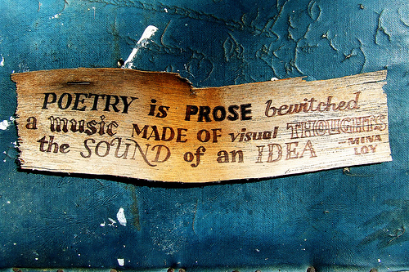
Fall poetry reading
HOSTED BY FRANCINE D’ALESSANDRO, LOCAL POET AND WRITER
THURSDAY, NOVEMBER 2 - 7:00 PM
READ YOUR OWN FALL-INSPIRED, HALLOWEEN AND/OR “SPOOKY” POEMS AND/OR PROSE.
READ POEMS AND/OR PROSE BY YOUR FAVORITE POET,
OR, JUST COME AND LISTEN…..IF YOU DARE!!
OPEN MIC * TEENS AND ADULTS WELCOME * REFRESHMENTS
PINE BUSH AREA LIBRARY
COMMUNITY CENTER
(Call the Library at 744-4265 to Sign Up)

“IT’S ALL ABOUT YOU!”
MEMOIR/WRITING WORKSHOP
HOSTED BY FRANCINE D’ALESSANDRO,
LOCAL WRITER AND POET
THIS IS AN ONGOING, MONTHLY WORKSHOP TO DEVELOP TOOLS AND STRATEGIES TO COLLECT AND RECORD YOUR STORIES.
AND, OF COURSE, EVERYONE HAS A STORY TO TELL! NEW-COMERS ALWAYS WELCOME.
WHY NOT PRESERVE YOUR MEMORIES NOW?
COME TO THE PINE BUSH AREA LIBRARY COMMUNITY CENTER on
Saturday, November 4th, 2017 AT 11:00 am …AND START YOUR JOURNEY.
Please register by calling 845 744-4265

November 6th is the 100th anniversary of Women gaining the right to vote in New York

New York was one of the first states in the country to pass legislation giving women the right to vote in 1917, three years before the 19th Amendment was passed!

Artist Salons with Meadow, Multi-Media Artist
Fridays in November & December
November 10th
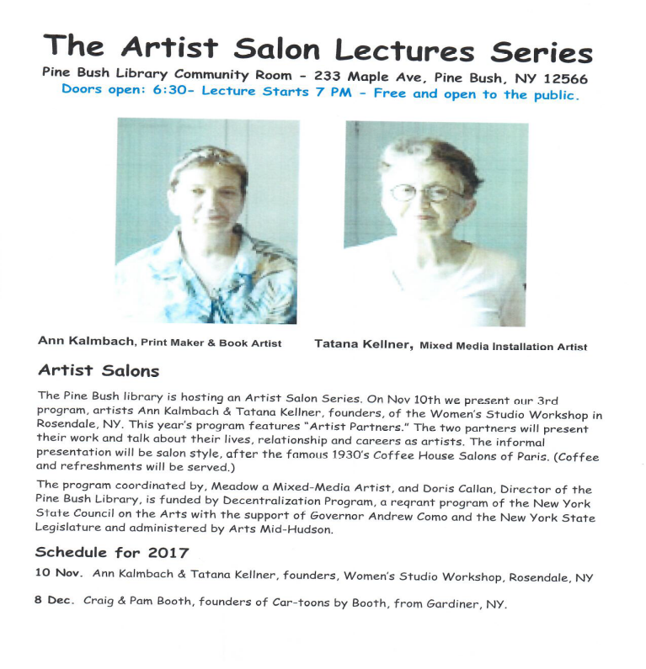
arts
Mid-Hudson
This project is made possible with funds from the
Decentralization Program, a reqrant program of the
New York State Council on the Arts with the support of
Governor Andrew Cuomo and the New York State
Legislature and administered by Arts Mid-Hudson
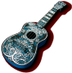 Tuesday, November 14th at 7:00 pm in the Main Library - Ukulele Meetup: Meet ups are on-going each month! Beginners always welcome. Strum on in!
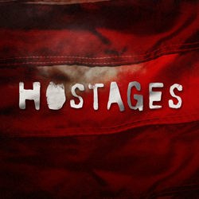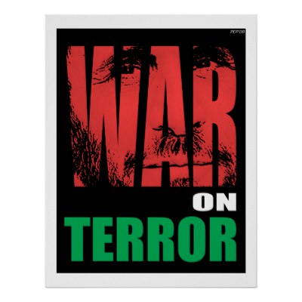
HOSTAGES: HISTORY & MYTH
A 4-WEEK LECTURE SERIES COVERING A HISTORIAL ANALYSIS OF THE ORIGINS OF TERRORISM AND HOSTAGE-TAKING FROM THE PERIOD OF THE 1860’S
TO THE PRESENT. LEARN WHAT TO DO IN A
HOSTAGE SITUATION AND HOW TO SURVIVE!
___________________________________________________________________
BY: JOSEPH BRITTO, ADJUNCT LECTURER,
SUNY ORANGE &
PROFESSOR EMERITUS AT SUNY NEW PALTZ
TUESDAYS: November 14, 21, 28 and December 5
Starting at 6:30 PM
PINE BUSH AREA LIBRARY COMMUNITY CENTER
(SIGN UP BY CALLING 744-4265.)
 Free Movie Matinee: Thursday, November 16th @ 12:30 pm - 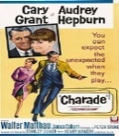 “CHARADE” Romance and suspense ensue in Paris as a woman is pursued by several men who want
the fortune her murdered husband had stolen.
Who can she trust?
Stars: Cary Grant, Audrey Hepburn, Walter Matthau
Stay afterwards for the movie trivia questions. Be the winner!
(Refreshments will be served)
Individual Career Counseling – November 16th at
the Pine Bush Area Library Community Center
Our professional career counselor will provide a 45 minute, one on one, consultation and assist you with your job search, job interview and any other job-related questions. A $175.00 value FREE to you! Appointments start at 5:00 PM.
You MUST make an appointment by calling 744-4265!
(Sponsored by RCLS (Ramapo Catskill Library System). This program is partly funded by the New York State Library’s Adult Library Services grant program.
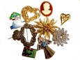Jewelry Sale – Saturday, November 18th – 10:00 am – 2:00 pm
Visit our Community Center to and find new and unwanted costume, as well as, some finer jewelry….all priced to sell!! Start your holiday shopping early!
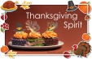Wednesday, November 22nd, 9:00 am - Thanksgiving Bake Sale and pre-Christmas gift sale
at the Pine Bush Library Community Center
 Chess Players needed for our weekly group - Tuesday at 1:00 PM in the Community Center. If you play, or if you know someone else who does, you are all invited to stop by and play a game or two. Beginners welcome!
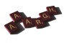We have on-going weekly games including Scrabble, Bridge, Pinochle, Chess, etc. If you are interested in joining any of the groups, please call us. If you would like to start your own game day, just give us a call at 845 744-4265. 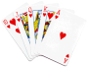
CHILDREN’S PROGRAMS
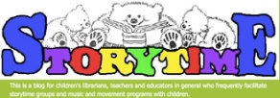
(See the calendar for the ongoing programs)
MUST BE REGISTERED FOR ALL CHILDREN’S PROGRAMS
PLEASE CALL 845 744-5295


Toddler Time (18-36 months) Mondays 10:00 – 10:45 AM

Pre-school Story time (3-5 year olds) Fridays 10:00 – 11:00 am
(November 3rd, 10th and 17th only.)

Music Time with Miss Jill (3 -5 year olds) Wednesdays 10:00 – 11:00 AM
(November 1st, 8th and 15th only.)


Crazy 8’s Math Club (Grades 3 – 5) Mondays 4:00 – 5:00 PM
November 6th – 27th
Painting Classes by Deborah for Mommy & Me! 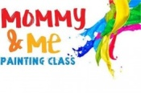
Come Saturday, November 18th and/or December 9th at 10:30 am with your child and learn to paint together. Space is limited to 10 so please call (845) 744-4265 to register. A fun time for both!!
Coming in December

December 2nd - Sights, Sounds & Tastes
December 5th - Hostage – Joe Britto
December 8th – Santa Bread
December 8th - Artist Salon
December 9th - Mommy & Me painting
December 16th – Cookie Walk
PLEASE REGISTER NOW FOR THESE WONDERFUL PROGRAMS BY CALLING 744-4265
Used Books, DVDs’, audio tapes, puzzles, games, greeting cards and more are for sale every day in the Community Center. Don’t forget to check out the books on the front porch. “Reading Garden” books are FREE!!
Free - computer and electronic device help, resume writing help, and a Notary Pubic available most days in the Community Center.
If you miss seeing any program flyers, go to Facebook and like us (and tell us why the Pine Bush Library is so great!) or, visit our webpage, www.pinebusharealibrary.org. Also, check out your local papers or bulletin boards in town. Or…stop into the library for your newsletter.
Want to attend an event but do not have transportation? Call Dial-A-Bus
TOWNS OF MONTGOMERY & CRAWFORD
Service provided Monday thru Friday. Hours of operation: 7:45am to 4:00pm. Reservations accepted Monday thru Friday 9:00am to 12:00pm. Regular Fare: $1.00 one-way • Children under 10 ride free when accompanied by an adult • Senior/disabled citizens and Medicare cardholders: 50¢ one-way. Please call 845-457-2622

