November 2017
PINE BUSH AREA PUBLIC LIBRARY – ADULT & CHILDREN’S PROGRAMS April 2017
Children’s Room (845)744-5295 Adult Services (845)744-3375 Community Center (845)744-4265

Sun | Mon | Tue | Wed | Thu | Fri | Sat
 |  |  | 1 | 2 | 3 | 4
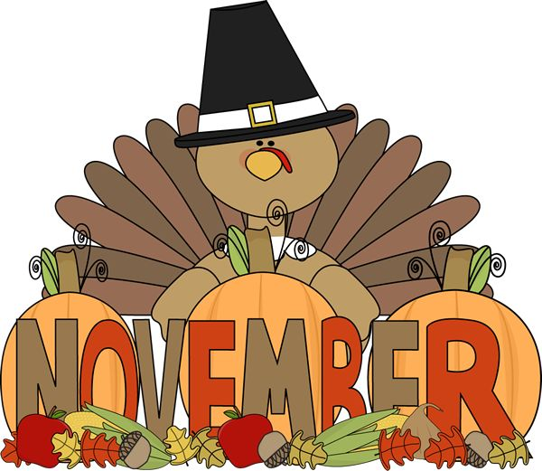 | November 6th celebrates the 100th anniversary of women’s suffrage in NYS |  | MUSIC TIME with MISS JILL (AGES 3 - 5)  10:00 - 11:00 am (ML)  Between the Covers Book Group – 11:00 am (CC) | Bridge – 10:00 am(CC)  Fall Poetry – 7:00 PM (CC) | Preschool Story Time 10:00 – 11:00 am (ML) | Next Chapter – 8:30am (CC)  Book Sales 10:00 am – 2:00 pm  Memoir Writing 11:00 am (CC)
5 | 6 | 7 | 8 | 9 | 10 | 11
 | Pinochle – 10:00 am (CC)  Toddler Time 10:00 – 10:45 am (ML)  Crazy 8’s Math Club 4:00 – 5:00 PM (ML) | Election Day!  Scrabble – 10:00 am (CC)  Chess – 1:00 pm (CC) | MUSIC TIME with MISS JILL (AGES 3 - 5) | Bridge – 10:00 am(CC)  Circle of Friends 1:00 PM (CC)  Friends 2:00 PM | Preschool Story Time 10:00 – 11:00 am (ML)  Artists Salon with Meadow 6:30 – 9:00 pm (CC) | LIBRARY IS CLOSED VETERAN’S DAY!  
12 | 13 | 14 | 15 | 16 | 17 | 18
 | Pinochle – 10:00 am (CC)  Toddler Time 10:00 – 10:45 am (ML)  Crazy 8’s Math Club 4:00 – 5:00 PM (ML) | Scrabble – 10:00 am (CC)  Happy Bookers 1:00 PM (CC)  Chess – 1:00 pm (CC)  Hostages 6:30 pm (CC)  Ukulele 7:00 pm (ML) | MUSIC TIME with MISS JILL (AGES 3 - 5)  10:00 - 11:00 am (ML)  Bag Ladies 10:00 am (CC)  Bookies 7:00 pm (CC) | Bridge – 10:00 am(CC)  Movie Matinee 12:30 PM (CC)  Individual Career Counseling – 5:00 PM (CC) | Preschool Story Time 10:00 – 11:00 am (ML) | Next Chapter – 8:30am (CC)  Book Sales 10:00 am – 2:00 pm  Jewelry Sale – 10:00 am – 2:00 pm (CC)  Mommy & Me Painting 10:30 am (CC)
19 | 20 | 21 | 22 | 23 | 24 | 25
 | Pinochle – 10:00 am (CC)  Toddler Time 10:00 – 10:45 am (ML)  Crazy 8’s Math Club 4:00 – 5:00 PM (ML) | Scrabble – 10:00 am (CC)  Chess – 1:00 pm (CC)  Hostages 6:30 pm(CC) | Bake sale and pre-Christmas sale 9:00 am (CC) | 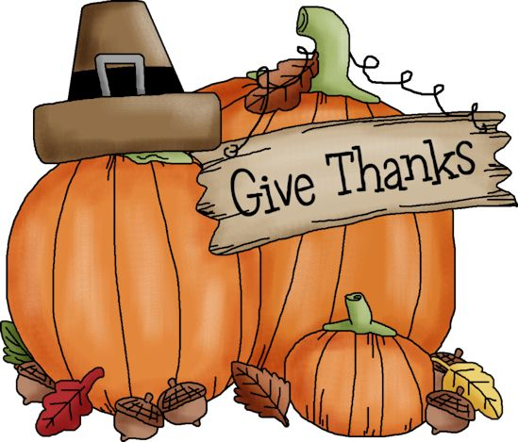  Happy Thanksgiving!  LIBRARY IS CLOSED! | LIBRARY IS CLOSED FOR THANKSGIVING! | Next Chapter – 8:30am (CC)  Book Sales 10:00 am – 2:00 pm
26 | 27 | 28 | 29 | 30
 | Pinochle – 10:00 am (CC)  Toddler Time 10:00 – 10:45 am (ML)  Crazy 8’s Math Club 4:00 – 5:00 PM (ML) | Scrabble – 10:00 am (CC)  Chess – 1:00 pm (CC)  Hostages 6:30 pm (CC) |  | Bridge – 10:00 am(CC) |  | 

Get these printable calendars for any dates you need with CalendarsThatWork.com Full Access.

