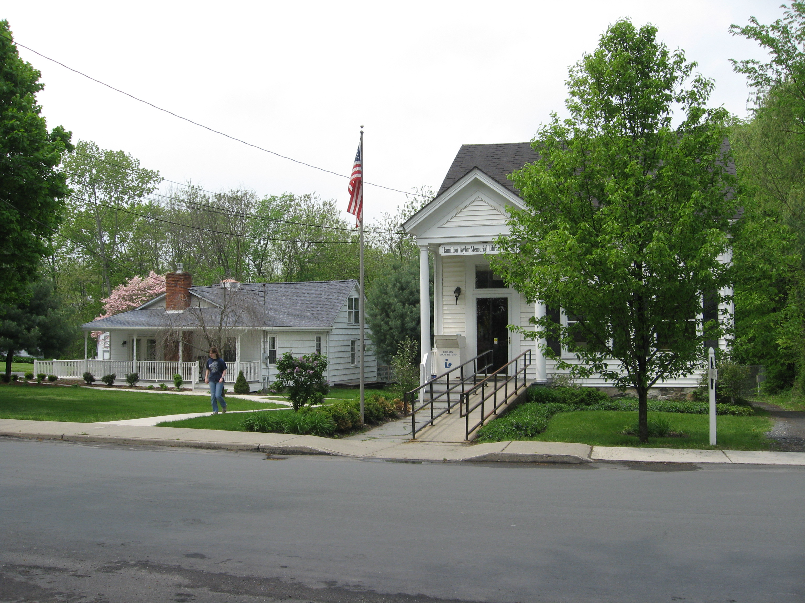PINE BUSH AREA PUBLIC LIBRARY
NEWSLETTER - MAY 2017
‘WHERE THE COMMUNITY CONNECTS’

223-227 Maple Ave, PO Box 63, Pine Bush, NY 12566
845-744-3375 Fax 845-744-3377 Director 744-4265

www.pinebusharealibrary.org

BOARD OF TRUSTEES – MEETING TIME - SECOND WEDNESDAY OF EACH MONTH 7:00 PM IN THE LIBRARY COMMUNITY CENTER
Trustees: Sharon Tarolli-President, Lisa Cannon-Vice President, Gloria Winter- Secretary, Matthew Watkins –Treasurer, Peter Eriksen, Senta Curran, JoAnn Schneider, John Russell, Joseph Britto. Director- Doris Callan

NEW- ROSETTA STONE- LEARN A NEW LANGUAGE
If you have not tried it out yet, it is now available at this Library, too. (Since Nov 1st) Improve your English or learn another language with Rosetta Stone Library Solution. This is an effective, easy-to-use program that allows you to learn a new language on your own time .Choose from 30 languages. Go to our website, www.pinebusharealibrary.org, click on research, then databases and scroll down to Rosetta Stone. Sign in with your library card number. Please ask a member of the library staff if you have any problem. Rosetta Stone is made available through Central Library Development Aid from New York State.

Come and enjoy high speed internet at your library. We have upgraded internet access. Login on one of our computers or bring your own device and use our Wi-Fi.

Helen Gihr was the lucky winner of our third “Family Reading Challenge” raffle drawing for a gift certificate from Hermann’s Erie Hotel Restaurant. Congratulations to Helen. …And, thank you Hermann’s Erie Hotel Restaurant!
The next drawing for April will take place on May 1st – the winner will receive a gift certificate to The Bruynswyck Inn.
MAY is:
National Salad Month
National Strawberry Month
Get Caught Reading Month
May Day – May 1st
Cinco de Mayo – May 5th
^{V-E Day – May 8th}
Mother’s Day – May 14th
^{Memorial Day – May 29th}

Like us on FACEBOOK and tell us what makes the Pine Bush Area Public Library so great!!
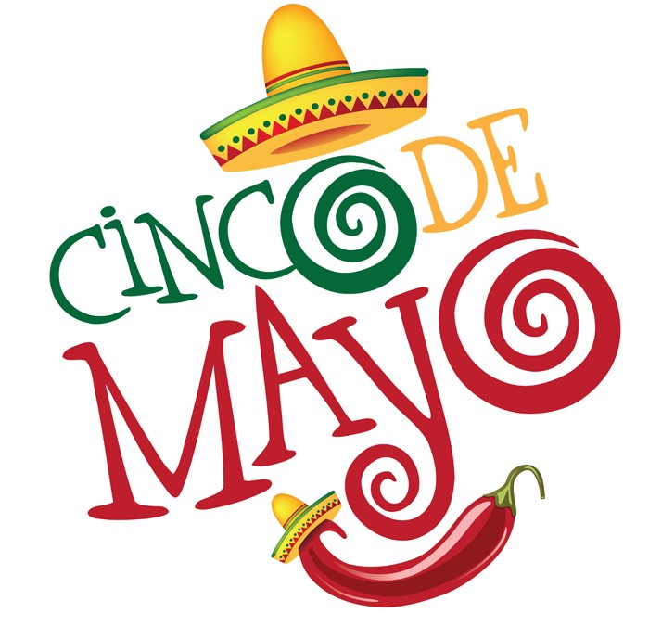^{Cinco de Mayo –May 5th}
Cinco de Mayo—or the fifth of May—commemorates the Mexican army’s 1862 victory over France at the Battle of Puebla during the Franco-Mexican War (1861-1867). A relatively minor holiday in Mexico, in the United States Cinco de Mayo has evolved into a celebration of Mexican culture and heritage, particularly in areas with large Mexican-American populations. Cinco de Mayo traditions include parades, mariachi music performances and street festivals in cities and towns across Mexico and the United States.

 ^{Celebrate Mother’s Day}
^{May 14th}
The history of Mother’s Day: During the Civil War, a woman named Ann Jarvis cared for soldiers from both sides of the conflict and in 1868, created a committee to establish a "Mother's Friendship Day," which would aim "to reunite families that had been divided during the Civil War." When Ann Jarvis passed away in 1905, her devastated daughter Anna tried to find a way to memorialize her mother and other mothers like her. So on May 10, 1908, the first Mother's Day events were held in Grafton, West Virginia, and at a department store auditorium in Philadelphia. But in lieu of attending the festivities in Grafton, Jarvis sent 500 white carnations, her mother's favorite flower, which would soon become the official symbol of Mother's Day, worn by sons and daughter to represent a mother's "pure love." "Salad, Anyone?"
May is National Salad and Strawberry Month! Why not join us on Tuesday, May 16 at 1 PM
for a free sampling of different salads made with a combination of healthy veggies and strawberries? Assorted
breads, rolls and desserts will also be served. Please call 744-4265 to make your reservation.

The Pine Bush Area Library presents
The Annual
“Spring Fling”
Benefit Dinner Dance Garden Party
Friday, May 19th
Pine Bush Fire House 6:00 pm – 11:00 pm.
Music to be provided by THE BOOKWORMS
Come spend an evening with good friends, good food and good music!
Bright colored and floral attire encouraged.
Suggested donation:
$30.00 per person before May 5th
$35.00 per person after May 5th
BYOB! Reservations required. To make reservations please contact:
The Library at (845) 744-4265 or Sharon Tarolli 845) 744-2407

PROGRAMS
ADULT PROGRAMS FOR May 2017
 Continue the 2017 Pine Bush Area Library Family Reading Challenge in May - Come in to the Main Library Building and learn how easy it is to read and qualify for a monthly prize drawing. Simply read four books each month based on the categories contained on the category grid card. Before each month ends, have your card stamped and then fill out a raffle prize form to be eligible for the monthly drawing. Don’t waste time….stop by the Library to find out more!! On May 1st, we will hold another raffle drawing! Good luck to everyone! You still have eight more chances to win! Just complete four more categories on your grid card by the end of this month, get it stamped; and then fill out another raffle form. New challengers are always able to join each month. Be part of the fun!

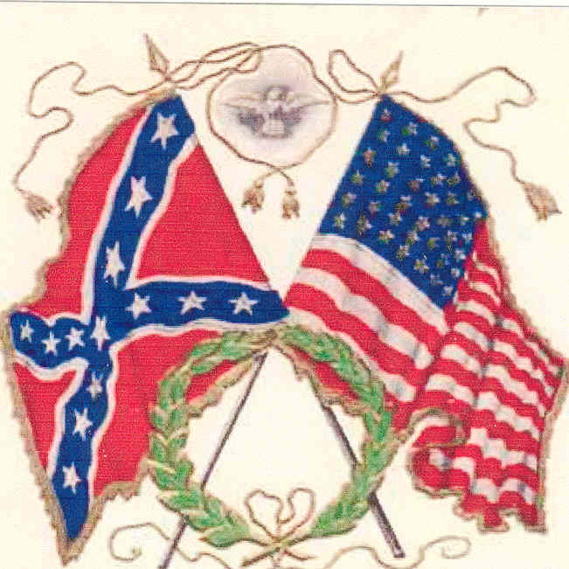 Tuesday, May 2nd - 6:30 PM “Lincoln on the Civil War” – continuation of the six week series into the mind of the 16th President of the United Sates using his own written words. Joseph Britto, Adjunct Lecturer, will facilitate these discussions.
Seating is limited so please call 744-3375 to reserve your space.
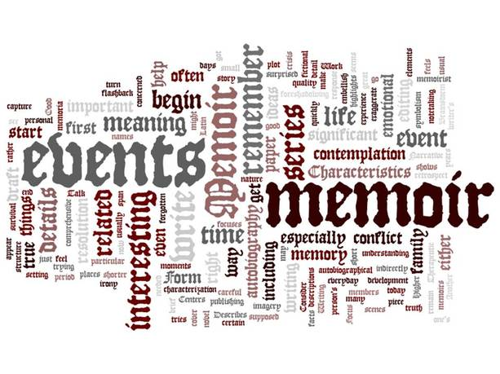Thursday, May 4th – 6:30 PM - Memoir Writing Workshop: Francine D’Alessandro will lead you through the task of formulating and writing your own stories. Please reserve your spot by calling 744-3375.

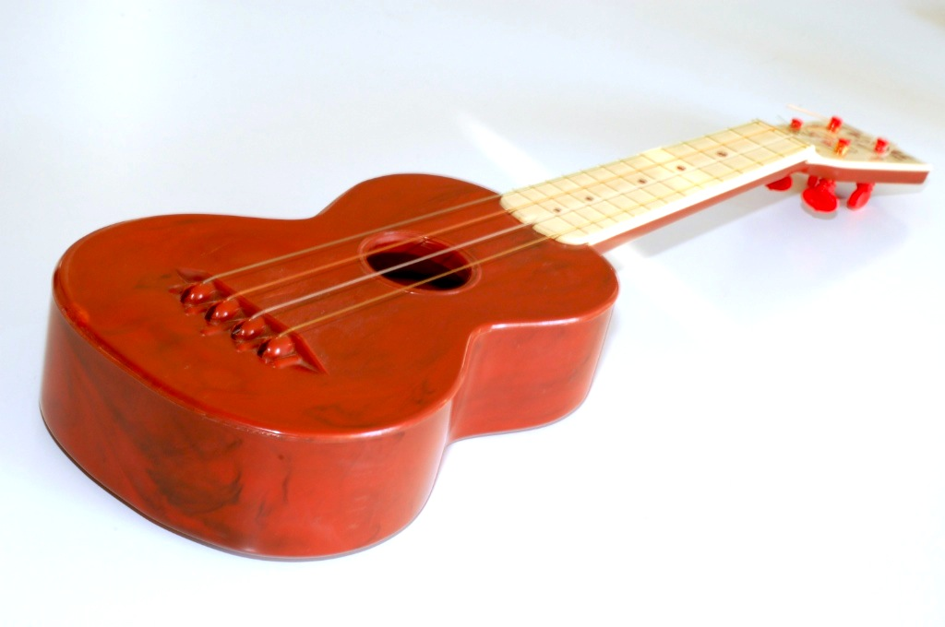Tuesday, May 9th 6:30 – 9:00 pm - Ukulele Meetup: Beginners always welcome. Strum on in!
 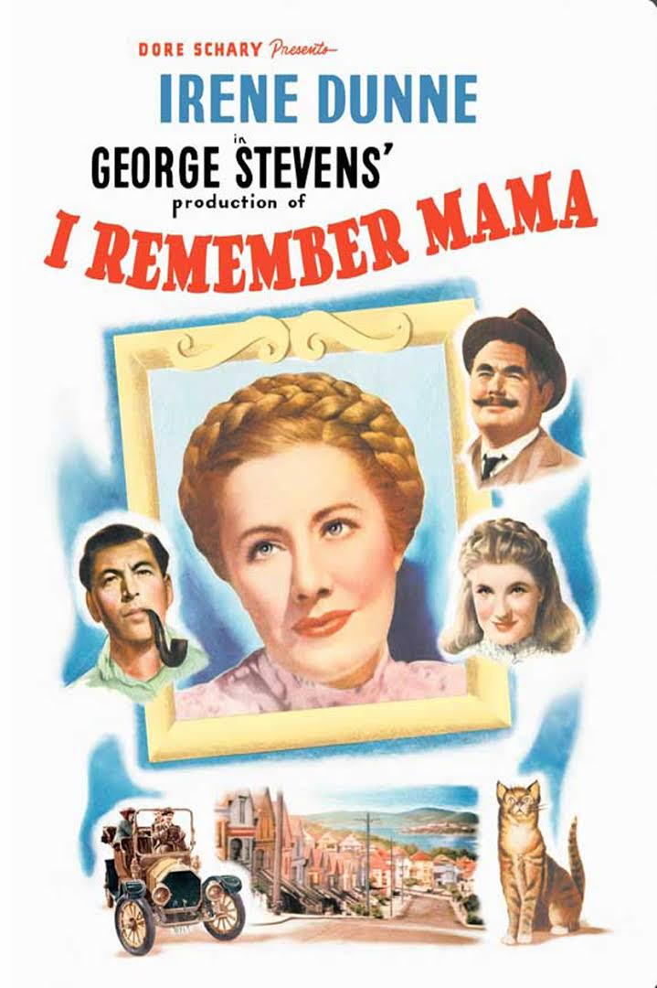 Wednesday, May 10th – Noon - Free Movie Matinee: “I Remember Mama”- Norwegian immigrant Marta Hanson (Irene Dunne) keeps a firm but loving hand on her household of four children, a devoted husband (Philip Dorn) and a highly-educated lodger (Cedric Hardwicke) who reads Charles Dickens to the family every evening. Through financial crises, illnesses and the small triumphs of everyday life, Marta maintains her optimism and sense of humor, traits she passes on to her aspiring-author daughter, Katrin (Barbara Bel Geddes).
Friday, May 12th - 2:00 pm - The Lanuage of Flowers: Presented by the Cornell Cooperative Extension Master Gardeners. Flowers have names and specific meanings. During Victorian times, flowers that were sent to the recipient held a secret, coded message to express feelings and emotions that could not be spoken out loud in proper Victorian society. Come and learn what the flowers are saying! (Please call 744-3375 to Register.)
Wednesday, May 24th - AARP SMART DRIVER - 9:00 AM – 4:00 PM – Get a discount on your auto insurance and lower the points on your license!! $20.00 for AARP members, $25.00 for non-AARP members. Please call 744-3375 to register for this class.
 Saturday, May 27th - Annual Town Wide Yard Sale – 9:00 AM – 3:00 PM on the Library lawn. Donations accepted from May 25th till the morning of the yard sale or reserve your own 10’ space for only $20.00. Clean and useable items only! Please call 744-4265.
 Chess Players needed for our weekly group - Tuesday at 2 PM in the Community Center. If you play, or if you know someone else who does, you are all invited to stop by and play a game or two.
We have on-going weekly games including Scrabble, Bridge, Pinochle, Chess, etc. If you are interested in joining any of the groups, please call us. And…If you would like to start your own game day, Just give us a call at 845 744-4265. 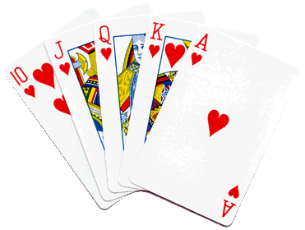
CHILDREN’S PROGRAMS

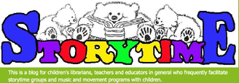
Toddler Time (18-36 months) Mondays, 10:00 - 10:45 AM, Mondays, May 1st – May 22nd

Preschool (Ages 3-5) Fridays, 10:00-11:00 AM Fridays, May 5th – May 26th
See the calendar for the ongoing programs.
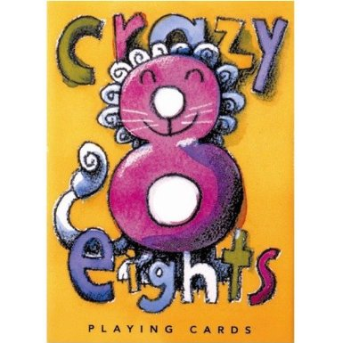 Crazy 8’s Math: (3rd – 5th Grade) Thursdays, May 4th and 11th ONLY! 4:00 – 5:00 PM. Space is available so
Please call 845 744-3375 to register.
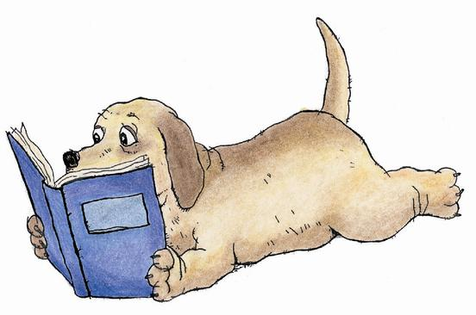 Saturday, May 6th – 10:30 – 11:30 am - We are pleased to announce that “Lucy the Therapy Dog” with Owner/Trainer Joe DeJong will be at the Library. Children can meet Lucy and read their favorite book to her with Miss Doris. Must register in advance for your 15 minute time slot.
Thursday, May 25th - 4:00 - 5:00 pm - Please join us in the library community center to R.E.A.D. to therapy dog, “Bodie” with Owner/Trainer Susan Smith. This program is designed for children to practice their read aloud skills in a one-on-one setting with a trained Reading Education Assistance Dog. Must be registered in advance for your 15 minute time slot.
THE THEME FOR THE SUMMER READING PROGRAM IS “BUILD A BETTER WORLD”. We will be creating, re-purposing and building. Through books, games and many STEAM (Science, Technology, Engineering, Art and Math) activities, summer reading participants will discover new ways of looking at the world around them. Join us and let’s go forth together to BUILD A BETTER WORLD! Registration for the Summer Reading Program opens Saturday, June 10th! Stay tuned for more information about the many programs available for the summer.

Used Books, DVDs’, audio tapes, puzzles, games, greeting cards and more are for sale every day in the Community Center. Don’t forget to check out the books on the front porch. Porch books are FREE!!

Free - one on one computer, IPad, IPhone, Kindle help or whatever, available most afternoons in the Community Center.

If you miss seeing any program flyers, go to Facebook and like us or, visit our webpage, www.pinebusharealibrary.org. Also, check out your local papers or bulletin boards in town. Or…stop into the library for your newsletter.

Coming in June!
June 10th - Summer Reading Kick Off!
June 16th - Ticks of the Hudson Valley – Cornell Master Gardeners
June 28th – How to Prevent Becoming a Victim of Fraud

LIBRARY HOURS
MON & WED, 9-7 TUE & THUR 11-7 FRI 9-5, SAT 10-2
COMMUNITY CENTER HOURS: MON. - THURS. 10 AM – 6 PM, FRI. 10 AM-5PM, SAT. 10 AM-2 PM

Want to attend an event but do not have transportation? Call Dial-A-Bus
TOWNS OF MONTGOMERY & CRAWFORD
Service provided Monday thru Friday. Hours of operation: 7:45am to 4:00pm. Reservations accepted Monday thru Friday 9:00am to 12:00pm. Regular Fare: $1.00 one-way • Children under 10 ride free when accompanied by an adult • Senior/disabled citizens and Medicare cardholders: 50¢ one-way. Please call 845-457-2622

