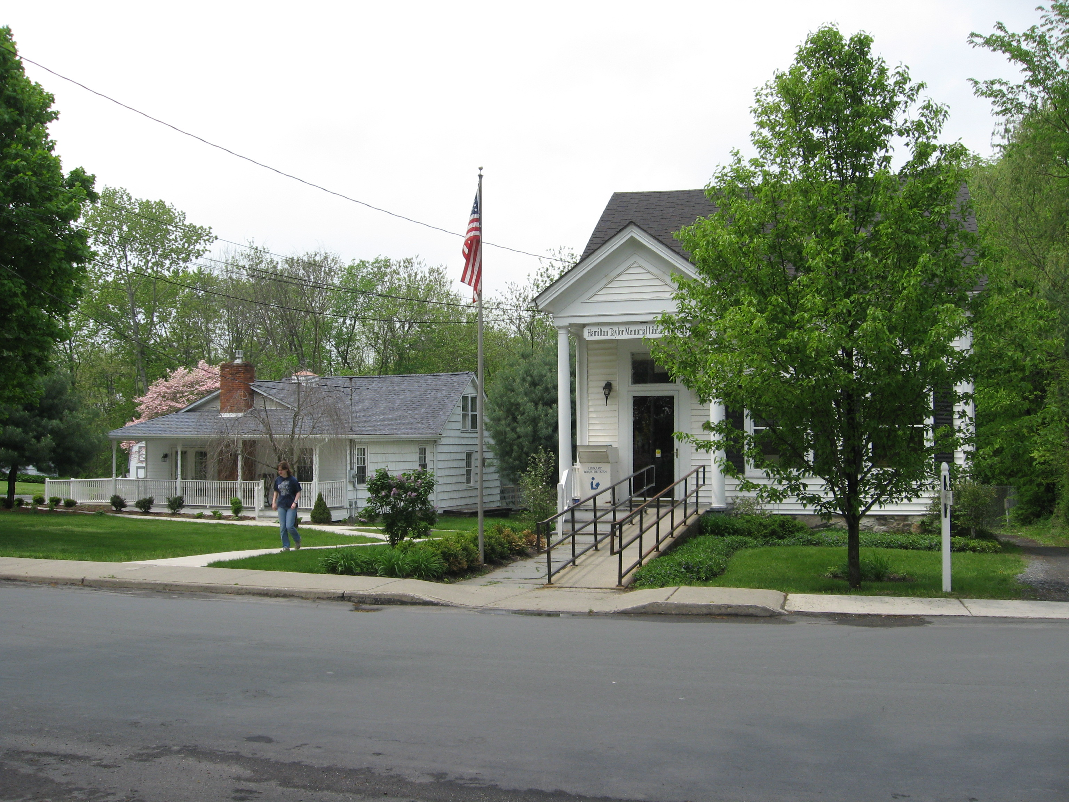PINE BUSH AREA PUBLIC LIBRARY
NEWSLETTER - MARCH 2017
‘WHERE THE COMMUNITY CONNECTS’

223-227 Maple Ave, PO Box 63, Pine Bush, NY 12566
845-744-3375 Fax 845-744-3377 Director 744-4265

www.pinebusharealibrary.com

BOARD OF TRUSTEES – MEETING TIME - SECOND WEDNESDAY OF EACH MONTH 7:00 PM IN THE LIBRARY COMMUNITY CENTER
Trustees: Sharon Tarolli-President, Lisa Cannon-Vice President, Gloria Winter- Secretary, Matthew Watkins –Treasurer, Peter Eriksen, Senta Curran, JoAnn Schneider, John Russell, Joseph Britto. Director- Doris Callan

NEW- ROSETTA STONE- LEARN A NEW LANGUAGE
If you have not tried it out yet, it is now available at this Library, too. (Since Nov 1st) Improve your English or learn another language with Rosetta Stone Library Solution. This is an effective, easy-to-use program that allows you to learn a new language on your own time .Choose from 30 languages. Go to our website, www.pinebusharealibrary.org, click on research, then databases and scroll down to Rosetta Stone. Sign in with your library card number. Please ask a member of the library staff if you have any problem. Rosetta Stone is made available through Central Library Development Aid from New York State.

Come and enjoy high speed internet at your library. We have upgraded internet access. Login on one of our computers or bring your own device and use our Wi-Fi.

AARP Tax Aide starts at the Library in February on Fridays. Please call 845 744-4265 (Community Center) for an appointment. You must bring last year’s tax returns as we can no longer access your previous tax returns,
due to a new program.

Francine D’Alessandro was the lucky winner of our first “Family Reading Challenge” raffle drawing for a gift certificate from The Town Hall Eatery. Congratulations to Francine. …And, thank you Town Hall Eatery!
The next drawing for February will take place on March 1st – the winner will receive a gift certificate to the Cup and Saucer Diner.

Valentine’s Day Gift Basket- Drawing was held on Friday, February 10th , the basket was won by Mindy Brock…congratulations!

St. Patrick’s Day Raffle – visit the main library and enter your name for a chance to win a beautiful gift basket for St. Patrick’s Day! Drawing to be held Wednesday, March 15th.
 May the luck of the Irish be with you!! 

March is:

Dr. Seuss would have been 113 years old on March 2nd!
“Today you are you! That is truer than true! There is no one alive who is you-er than you!
You have brains in your head. You have feet in your shoes. You can steer yourself any direction you choose.
The more that you read, the more things you will know. The more that you learn, the more places you'll go..”
by Dr. Seuss

National Women’s History Month


Music In Our Schools Month
National Nutrition Month



PROGRAMS
ADULT PROGRAMS FOR MARCH 2017
 Continue the 2017 Pine Bush Area Library Family Reading Challenge in March - Come in to the Main Library Building and learn how easy it is to read and qualify for a monthly prize drawing. Simply read four books each month based on the categories contained on the category grid card. Before each month ends, have your card stamped and then fill out a raffle prize form to be eligible for the monthly drawing. Don’t waste time….stop by the Library to find out more!! On March 1st we will hold another raffle drawing! Good luck to everyone! You still have ten more chances to win! Just complete four more categories on your grid card by the end of this month, get it stamped; and then fill out another raffle form. New challengers are always able to join each month. Be part of the fun!
Thursday, March 2nd 6:00 – “The DO’S and DON’T’S of BUYING and SELLING a HOUSE” – before you buy or sell a house, learn the do’s and don’ts from Michelle Genatempo, local realtor. Michelle will answer all your questions.
Please reserve your seat by calling 744-3375.
Tuesday, March 7th 6:00 PM – Introduction to “Lincoln on the Civil War” Please join us for an introductory session to learn more about the program “Lincoln on the Civil War” Space is limited so please reserve your seat by calling 744-3375
 Free Movie Matinee: March 8th at 12 noon: Featuring “Finian’s Rainbow”  starring Fred Astaire, Petula Clark, Tommy Steele. This great move is about an Irish family moving to the USA, a crock of gold, rainbows… And… Fred Astaire dancing!! We will supply dessert, coffee and/or tea.
March 9th 2:00 PM “Dementia Conversations” - tips on how to have honest and caring conversations with family members about going to the doctor, when to stop driving and making legal and financial plans. Please RSVP by calling 744-3375.
Tuesday, March 14th 6:30 - 9 PM - Ukulele Meetup: Beginners always welcomed. Strum on in.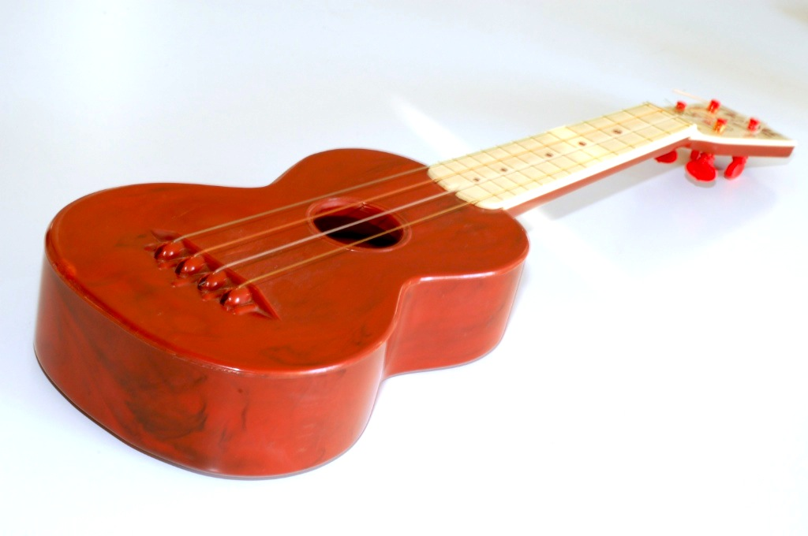
 Wednesday, March 15th 2:00 PM – 4:00 PM “St. Patrick’s Day Tea” – join us for traditional Irish refreshments and entertainment!!
Thursday, March 16th “Famous Women in History” - 4:00 PM – in honor of “National Women In History Month” we are honoring five amazing women of the past, Susan B. Anthony, Clara Barton, Sojourner Truth, Francis Perkins, Eleanor Roosevelt. Come and “meet” these women and hear their stories through the voices of five local present day women. Please reserve your seat by calling 744-3375 as space is limited.
”Oodles of Noodles” Tuesday, March 21st - 12:30 pm – Come and sample a variety of cooked noodles and assorted sauces and garnish toppings. Stay for coffee /tea and dessert!! (Please Call the Library at 744-3375 to Make Your Reservation)

“Lincoln on the Civil War” starting Tuesday, March 21st through Tuesday, April 25th at 6:30 PM – a six week series into the mind of the 16th President of the United States using his own written words. Joseph Britto, Adjunct Lecturer, will facilitate these discussions.
Seating is limited so please call 744-3375 to reserve your space.
Wednesday, March 22nd AARP SMART DRIVER - 9:00 AM – 4:00 PM – Get a discount on your auto insurance and lower the points on your license!! $20.00 for AARP members, $25.00 for non-AARP members. Please call 744-3375 to register for this class.
Wednesday, March 29^{th -} 6:30 PM – “It’s All About YOU” Memoir writing Workshop – Francine D’Alessandro will lead you through the task of formulating and writing your own stories. Please reserve your spot by calling 744-3375.
 Chess Players needed for our weekly group - Tuesday at 2 PM in the Community Center. If you play, or if you know someone else who does, you are all invited to stop by and play a game or two.

CHILDREN’S PROGRAMS

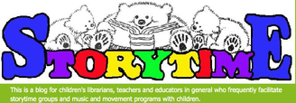

Toddler Time (18-36 months) Mondays, March 6th – 27th 10:00 - 10:45 AM
Preschool (Ages 3-5) Fridays, March 10th – 31st 10:00-11:00 AM.
See the calendar for the ongoing programs.
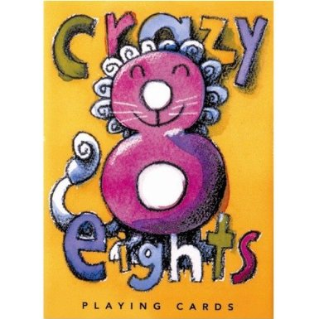 Crazy 8’s Math Club to resume on Thursday, March 16th, 23rd and 30th at 4:00 PM. You must be registered as space is limited! Please call 845 744-3375.

Thursday, March 9th 4:00 - 5:00 pm - Please join us in the library community center to R.E.A.D. to therapy dog, “Bodie” with Owner/Trainer Susan Smith. This program is designed for children to practice their read aloud skills in a one-on-one setting with a trained Reading Education Assistance Dog. Must be registered in advance for your 15 minute time slot.
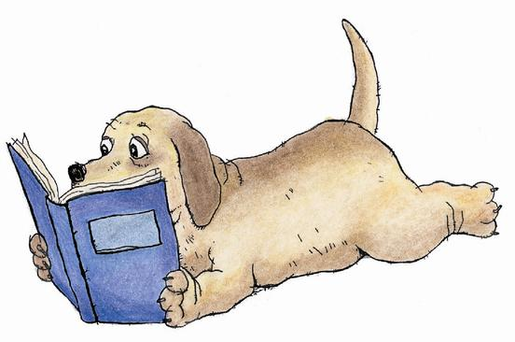 Saturday, March 18th – 10:30 – 11:30 am - We are pleased to announce that “Lucy the Therapy Dog” with Owner/Trainer Joe DeJong will also be on site Saturday, March 18th. Children can meet Lucy and read their favorite book to her with Miss Vicki the Children’s Librarian. Must register in advance for your 15 minute time slot.

Used Books, DVDs’, audio tapes, puzzles, games, greeting cards and more are for sale every day in the Community Center. Don’t forget to check out the books on the front porch. Porch books are FREE!!

Free - one on one computer, IPad, IPhone, Kindle help or whatever, available most afternoons in the Community Center.

If you miss seeing any program flyers, go to Facebook and like us or, visit our webpage, www.pinebusharealibrary.org. Also, check out your local papers or bulletin boards in town. Or…stop into the library for your newsletter.

Coming in April
Individual Job Consultations - April 6th & April 27th
Friends of the Library Easter Bake Sale – April 15th
Cornell Master Gardener - Hydrangeas – Types and Pruning
Spring Poetry Reading – April 26th
Friends of the Library Volunteer Recognition Tea – April 29th

Save the date!!!
Get ready for the “Spring Fling” Friday, May 19th with The Eric Winter Group performing!!

LIBRARY HOURS
MON & WED, 9-7 TUE & THUR 11-7 FRI 9-5, SAT 10-2
COMMUNITY CENTER HOURS: MON. - THURS. 10 AM – 6 PM, FRI. 10 AM-5PM, SAT. 10 AM-2 PM
Due to the AARP Tax Aide Program, the Community Center will open at 1:00 pm on Fridays from February 10th through April 14th.

Want to attend an event but do not have transportation? Call Dial-A-Bus
TOWNS OF MONTGOMERY & CRAWFORD
Service provided Monday thru Friday. Hours of operation: 7:45am to 4:00pm. Reservations accepted Monday thru Friday 9:00am to 12:00pm. Regular Fare: $1.00 one-way • Children under 10 ride free when accompanied by an adult • Senior/disabled citizens and Medicare cardholders: 50¢ one-way. Please call 845-457-2622

PLEASE NOTE: In case of tricky road conditions due to the weather, please call 744-3375 or 744-4265 and listen to a recording of the library’s hours for that day.

