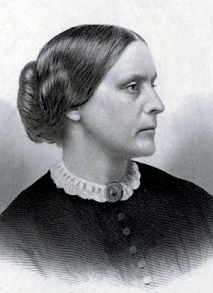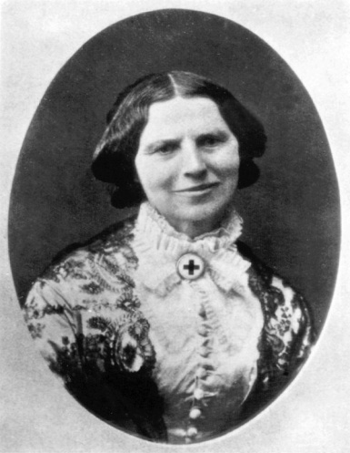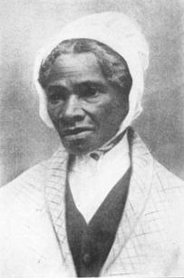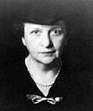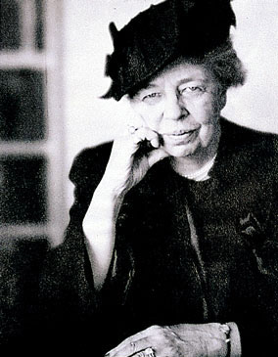
Susan B. Anthony Clara Barton Sojourner Truth Frances Perkins Eleanor Roosevelt
FAMOUS WOMEN IN HISTORY
IN HONOR OF “NATIONAL WOMEN IN HISTORY MONTH” DURING THE MONTH OF MARCH, WE ARE HONORING FIVE AMAZING WOMEN OF THE PAST WHO MADE THEIR MARK IN AMERICAN HISTORY. YOU ARE CORDIALLY INVITED TO “MEET” THESE WOMEN AND HEAR THEIR STORIES THROUGH THE VOICES OF FIVE AMAZING LOCAL WOMEN OF THE PRESENT: JOANNE KEILLOR, MARYBETH REINFRIED, SHARON MITCHELL, GLORIA WINTER & FRANCINE D’ALESSANDRO.
Location: Pine Bush Area Library Community Center
Date & Time: Thursday, March 16 at 4:00 PM
(You Must Register by Calling the Library at 744-3375, as seating is limited.)

